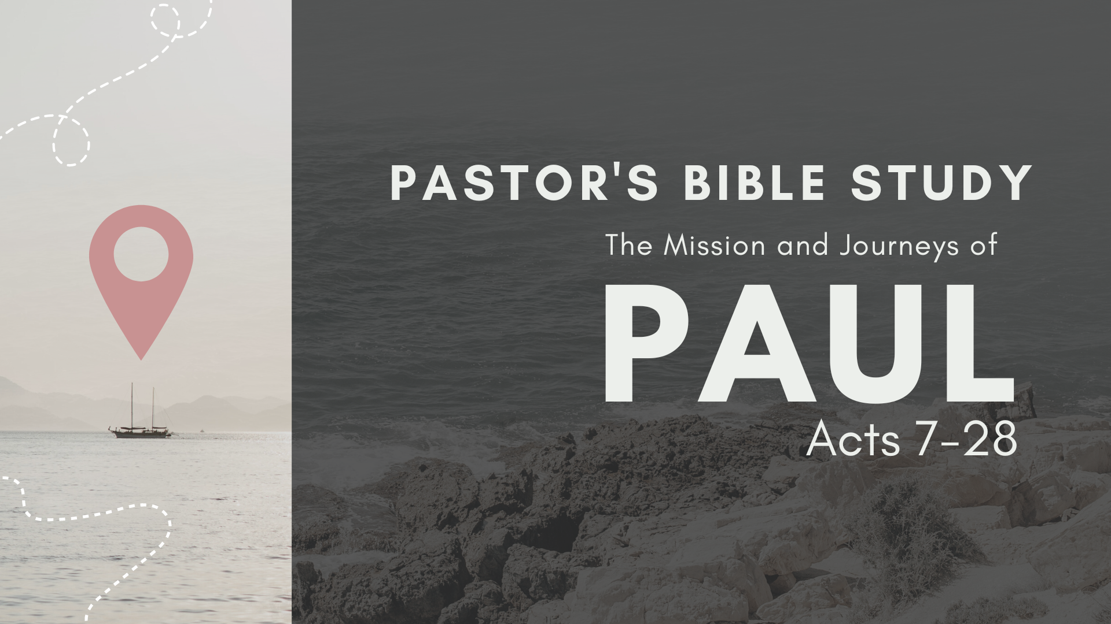

Episode 11: November 15/16
When in Rome…
Acts 28:11-31

- What reception do Paul and his companions get from the brothers at Rome? What does this teach you about the progress of the gospel in Rome? What does it teach you about the Body of Christ? (14-15)

- What does the fact that Paul was given his own home in Rome and allowed to live by himself with a soldier to guard him show about the way the Roman authorities viewed Paul? (16)

- What is Paul’s immediate concern as he arrives in Rome? Why do you think he was so concerned about the Jews? What is Paul’s initial message to the Jews? What does he claim in verses 17-18? (17-18)

- What is Paul careful to clarify in the matter of his appeal to Caesar? Why is he concerned that the Jews know he wasn’t there to bring any charges against the Jews who falsely accused him? (19)
- What does Paul mean by, “It is because of the hope of Israel that I am wearing this chain”? (20)

- What does the initial response of the Jewish leaders in Rome to Paul show about their attitude toward him? Toward Christianity? (21-22)

- Why do you think that so many people were talking against “this sect”? See Luke 2:34-35. (22)

- What was Paul’s next step with his Jewish countrymen? How did the meeting get arranged? Where was it? (23)

- What was Paul’s approach in persuading the Jews that Jesus was the Christ? How long did he spend on it? What Scriptures do you think Paul used to persuade the Jews? (23)

- How does verse 24 sum up the ministry of both Jesus and Paul to the Jews? (24)

- What is the significance of Paul’s final statement to the Jews? What does he quote? Why do you think this one passage from Isaiah 6:9-10 is so significant in the New Testament? See Matthew 13:13-15 and John 12:39-40. How does it explain the Jewish reaction to the gospel? (26-27)

- Compare Acts 28 to 2 Corinthians 3:12-16 in understanding Jewish opposition to the Scriptures that predict Christ. How does that passage explain it? How does Romans 9 seek to explain this same problem?

- What is the significance of verse 28 in the ministry of Paul and the history of the church? (28)

- What measure of freedom does Paul have in Rome? Why do you think he’s there for two years without having his care resolved by the emperor? (16, 30)

- How does the Book of Acts end? What do you make of this ending? (30-31)

“The Last Words of Paul”
Come Before Winter

⁹ Do your best to come to me soon. ¹⁰ For Demas, in love with this present world, has deserted me and gone to Thessalonica. Crescens has gone to Galatia, Titus to Dalmatia. ¹¹ Luke alone is with me. Get Mark and bring him with you, for he is very useful to me for ministry. ¹² Tychicus I have sent to Ephesus. ¹³ When you come, bring the cloak that I left with Carpus at Troas, also the books, and above all the parchments. ¹⁴ Alexander the coppersmith did me great harm; the Lord will repay him according to his deeds. ¹⁵ Beware of him yourself, for he strongly opposed our message. ¹⁶ At my first defense no one came to stand by me, but all deserted me. May it not be charged against them! ¹⁷ But the Lord stood by me and strengthened me, so that through me the message might be fully proclaimed and all the Gentiles might hear it. So I was rescued from the lion’s mouth. ¹⁸ The Lord will rescue me from every evil deed and bring me safely into his heavenly kingdom. To him be the glory forever and ever. Amen.
Final Greetings
¹⁹ Greet Prisca and Aquila, and the household of Onesiphorus. ²⁰ Erastus remained at Corinth, and I left Trophimus, who was ill, at Miletus. ²¹ Do your best to come before winter. Eubulus sends greetings to you, as do Pudens and Linus and Claudia and all the brothers.
²² The Lord be with your spirit. Grace be with you. (II Timothy 4:9-22)

- Paul was facing death and his imminent execution. What Problem or Pain are you facing?

- Paul did not like being alone, and it made him angry. Why was Paul angry? What fears or frustrations Provoke you in seasons of pain or crisis?

- With whom do you need to make Peace or reconcile (before it’s too late)? With whom did Paul want to reconcile?

- How can you spend time in Prayer and in God’s Presence?

- Are there specific Promises of God (perhaps certain passages) that really encourage you in times of grief or crisis? For example, Paul wrote— 17 But the Lord stood by me and strengthened me, so that through me the message might be fully proclaimed and all the Gentiles might hear it. So I was rescued from the lion’s mouth. 18 The Lord will rescue me from every evil deed and bring me safely into his heavenly kingdom. To him be the glory forever and ever. Amen.

- What about People? With whom do you need to be Present? With whom do you need to have important conversations? (Don’t Put them off).

- How are you communicating your needs, hope, faith and love with others? What do you need from them and what do you need to tell people?

