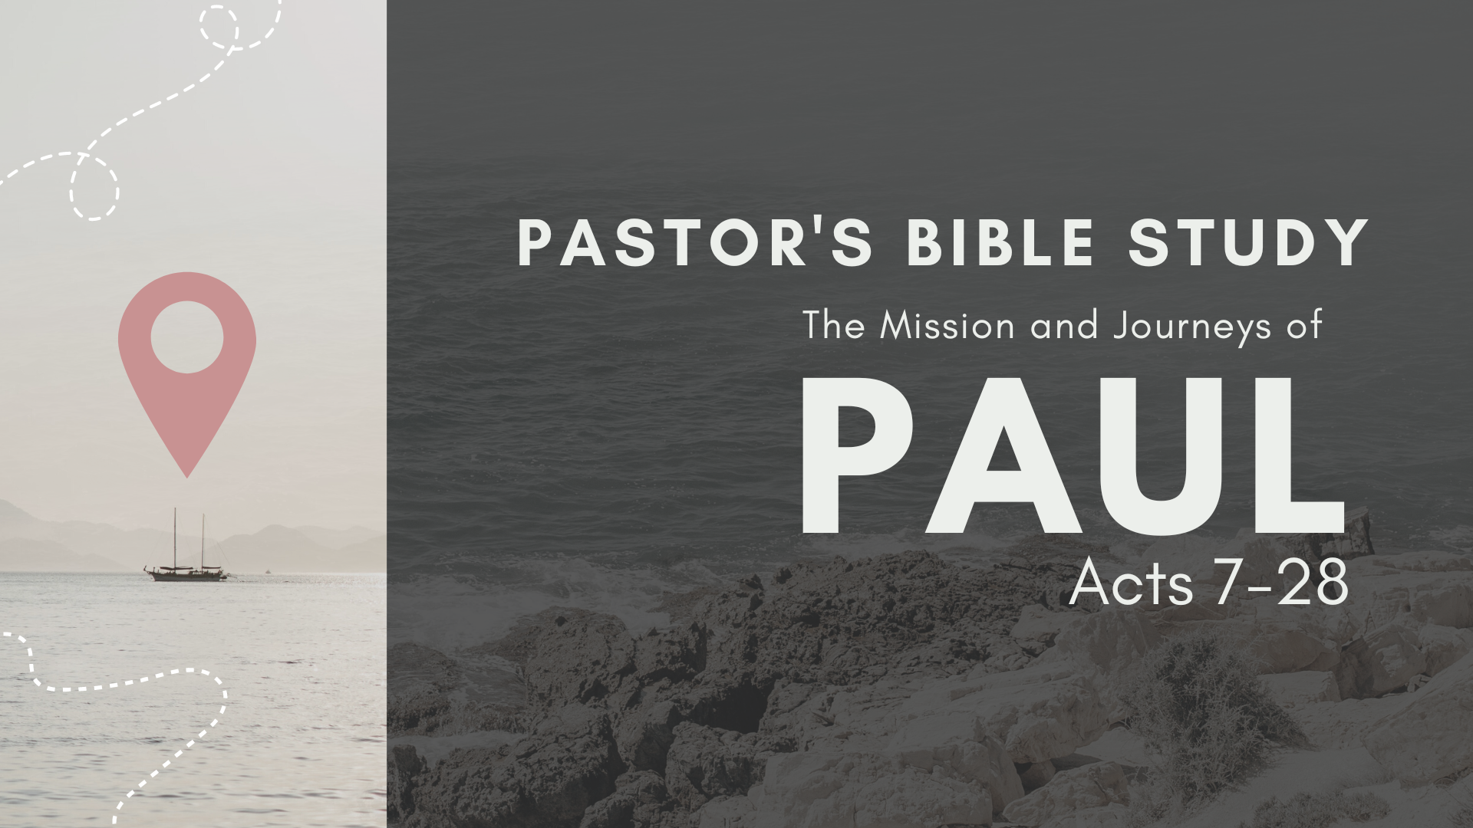

Episode 10: November 8 / 9
The Journey to Rome
Acts 27:1–28:10

- Who accompanied Paul on his journey to Rome? Acts 27:2.

- How was Paul treated by the centurion? Acts 27:3.

- At what season was this voyage?

- Why was “sailing now dangerous”?

- What did Paul advise? Acts 27:9–13.

- Why should Paul know anything about this matter? 2 Cor. 11:25

- Whose advice was taken? Acts 27:11

- Where was Paul shipwrecked? Acts 27:14; 28:1.

- Why did the soldiers advise the killing of the prisoners?

- What is the meaning of the term “barbarous,” here?

- What was Paul’s first work at Malta? Acts 28:8, 9.

- What was the result? Acts 28:10.

- What favor was granted to Paul on his arrival at Rome? Acts 28:16.

- What was his first act after a brief rest? Acts 28:17–29.

- How long did he stay at Rome at this time? Acts 28:30.

- What epistles did Paul write during these years?

