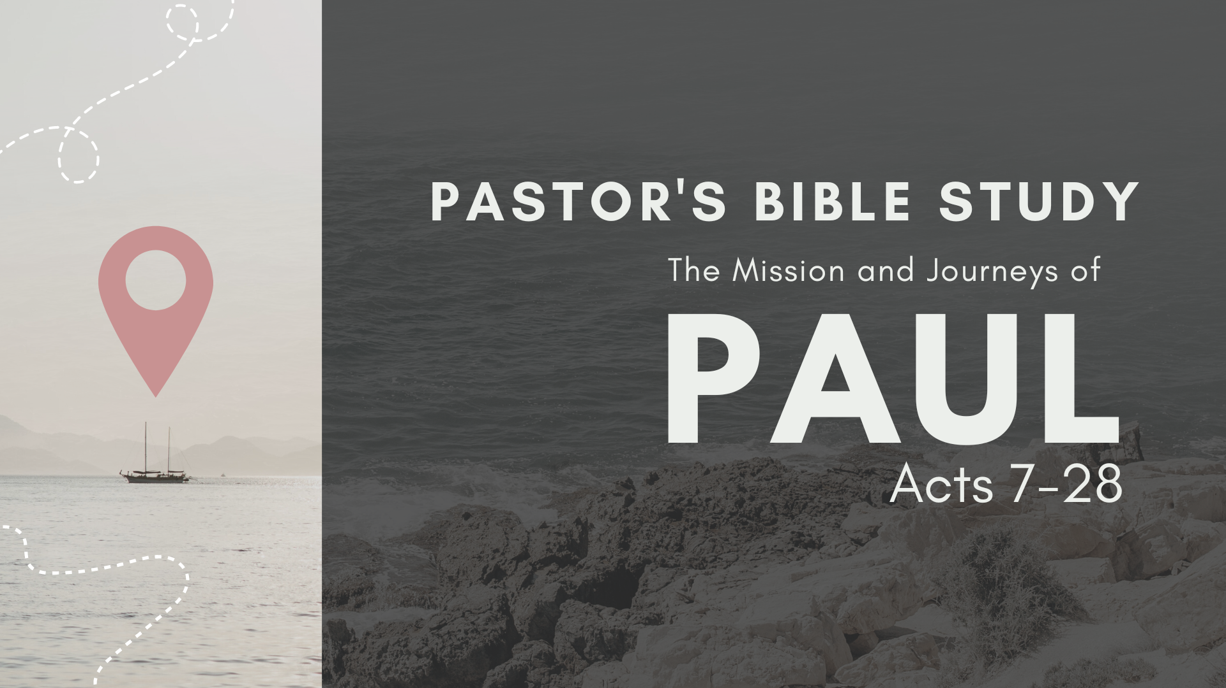

Episode 11: November 15/16
Rome and Beyond
Acts 27-28

- Phase One: from Caesarea to Sidon (27:1–3)
  - Julius the centurion (27:1–2): Paul and some other prisoners are handed over to him.
  - Paul is treated very kindly by Julius and is allowed to visit his friends at Sidon. (27:3)

- Phase Two: from Sidon to Myra (27:4–6): The prisoners are transferred to an Egyptian ship headed for Italy.

- Phase Three: from Myra to Fair Havens (27:7–12): Paul warns the centurion not to continue the voyage.
  - Paul knows it is the season for storms on the Mediterranean. (27:7–10)
  - The ship’s captain and owner determine that the voyage will continue. (27:11–12)

- Phase Four: from Fair Havens to Malta (27:13–44)
  - The storm (27:13–20) It is called a “northeaster” and refers to a treacherous wind of typhoon strength.
  - Paul stands before the terrified passengers, assuring them concerning what God had told him on the previous night: (27:21–44)
    - God says they will all be shipwrecked on an island (27:21–32).
    - God says not one person will lose his life, so all should eat and take courage (27:33–38).
    - Shipwreck (27:39–44a)
      - The ship runs aground and begins to fall apart (27:39–41).
      - The soldiers want to kill the prisoners to make sure none of them escape, but the commanding officer forbids it in order to save Paul’s life (27:42–44a).
    - All make it safely to shore (27:44b)

- Paul at Malta (28:1–10)
  - Murderer or god? (28:1–6)
    - They first look on him as a murderer (28:1–4).
      - The crisis (28:1–3): Paul is bitten by a poisonous snake.
      - The conclusion (28:4): The people say, “A murderer, no doubt! Though he escaped the sea, justice will not permit him to live.”
    - They finally look on him as a god (28:5–10):
      - When nothing happens to the apostle, they conclude that he is a god of some sort.
      - Paul meets the governor, Publius.
      - Paul heals Publius’s father (28:7–8)
      - Paul heals the other sick people on the island (28:9–10): Soon come and are also healed.

- Paul En Route to Rome (28:11–14): Paul’s ship makes three brief stops on the way to Rome. Paul is encouraged when some fellow believers meet him at one of the ports.

- Paul in Rome (28:15–31)
  - Paul is allowed to live by himself with a soldier to guard him (28:15–16).
  - Paul schedules two separate meetings with the Jewish leaders living in Rome. (28:17–29)
    - First meeting (28:17–22)
      - (28:17–20): Paul introduces himself and the message of the Cross.
      - (28:21–22): They have never heard of the messenger or his message but want to hear more.
    - Second meeting (28:23–29)
      - (28:23): Many people come to hear Paul speak about Jesus from the Old Testament Scriptures, and Paul teaches from morning till evening.
      - (28:24): Some believe, and some do not.
      - (28:25–29): Paul reminds them that their unbelief was predicted by the Old Testament prophet Isaiah (Isa. 6:9–10).
  - For the next two years, Paul remains in his rented house, under guard, witnessing to all who visit him. (28:30–31):
    - ¹² I want you to know, brothers, that what has happened to me has really served to advance the gospel, ¹³ so that it has become known throughout the whole imperial guard and to all the rest that my imprisonment is for Christ. (Php 1:12–13)
    - ²¹ Greet every saint in Christ Jesus. The brothers who are with me greet you. ²² All the saints greet you, especially those of Caesar’s household. (Php 4:21–22)

What happened to Paul after those two years?
Luke is silent.
The traditional position has been that Paul was released from his first Roman imprisonment (the one mentioned at the close of Acts; see Acts 28:16, 30–31), did further mission work, and was then imprisoned a second time, leading to his execution. This reconstruction is supported by statements from 1 Clement 5.7 and Eusebius, Ecclesiastical History 2.22.2–8.
If Paul’s arrival in Rome, as narrated in Acts, is dated about a.d. 59–61, then, allowing a couple of years for the imprisonment, he would have been released in about 62. If Paul was executed under Nero (d. a.d. 68), 1 Timothy would have been written somewhere in the mid-60s (cf. note on Acts 28:30–31). [From the ESV Study Bible]

- The Volatility of Rome
  - Emperor Claudius issued a decree to expel all the Jews who were someway associated with a figure called Chrestus (very possibly Christ):
    - Since the Jews constantly made disturbances at the instigation of Chrestus, he expelled them from Rome.Suetonius The Lives of the Twelve Caesars: Claudius.25
    - This expulsion is the reason given by Luke for the presence of Aquilla and Priscilla in Corinth (Acts 18:2).
  - Rome under Emperor Nero was volatile, suspicious and frequently violent.
    - In 64 AD, under an increasingly unstable Nero, the city of Rome was engulfed in a great fire that burned for six days.
    - The historian Tacitus, records that in order to deflect accusations away from himself, Nero placed the blame on the Christians:
      - Therefore, to scotch the rumour, Nero substituted as culprits, and punished with the utmost refinements of cruelty, a class of men, loathed for their vices, [27] whom the crowd styled Christians. [28] Christus, the founder of the name, had undergone the death penalty in the reign of Tiberius, by sentence of the procurator Pontius Pilatus. Tacitus Annals 15:44.26-27

- Traditions around Paul’s death
  - 1 Clement (thought to have been written around 96/97 CE) states: Owing to envy, Paul also obtained the reward of patient endurance, after being seven times thrown into captivity, compelled to flee, and stoned. After preaching both in the east and west, he gained the illustrious reputation due to his faith, having taught righteousness to the whole world, and come to the extreme limit of the west, and suffered martyrdom under the prefects. Thus was he removed from the world, and went into the holy place, having proved himself a striking example of patience. (I Clement 5.5-7)
  - Acts of Paul (2nd Century): Then Paul stood with his face to the east and lifted up his hands unto heaven and prayed a long time, and in his prayer he conversed in the Hebrew tongue with the fathers, and then stretched forth his neck without speaking. And when the executioner (speculator) struck off his head, milk spurted upon the cloak of the soldier. And the soldier and all that were there present when they saw it marveled and glorified God which had given such glory unto Paul: and they went and told Caesar what was done. Acts of Paul 11.5
  - Clement of Alexandria, --Stromata. For the teaching of our Lord [Jesus] at His advent, beginning with Augustus and Tiberius, was completed in the middle of the times of Tiberius. And that of the apostles, embracing the ministry of Paul, ends with Nero. Stromata. 7.17 (106.3)
  - Tertullian (2nd/3rd Century) Scorpiace: That Peter is struck, that Stephen is overwhelmed by stones, Acts 7:59 that James is slain as is a victim at the altar, that Paul is beheaded has been written in their own blood. And if a heretic wishes his confidence to rest upon a public record, the archives of the empire will speak, as would the stones of Jerusalem. We read the lives of the Cæsars: At Rome Nero was the first who stained with blood the rising faith. Then is Peter girt by another, John 21:18 when he is made fast to the cross. Then does Paul obtain a birth suited to Roman citizenship, when in Rome he springs to life again ennobled by martyrdom.

- The Spanish Question
  - Did Paul leave Rome, get to Spain and return to Rome?
  - Romans 15:24 and 28 says that he planned to go to Spain and that he suggested to his readers that when he did so he could stop off in Rome.
  - 1 Clement suggests that Paul had visited the “extreme limit of the west”, which could be a reference to Spain.
  - The second century Muratorian Canon (or Fragment), whilst endorsing Luke’s writing, notes that there are some important omissions, one of which was, …the journey of Paul, who from the city [Rome] proceeded to Spain. (Muratorian Canon lines 38-39).
  - Hippolytus (of Rome—3rd Century): And Paul entered into the apostleship a year after the assumption of Christ; and beginning at Jerusalem, he advanced as far as Illyricum, and Italy, and Spain, preaching the Gospel for five-and-thirty years. And in the time of Nero he was beheaded at Rome, and was buried there. Ante-Nicene Fathers 5.255
  - John Chrysostom (5th Century): Two years then [Paul] passed bound, in Rome; then he was set free; then, having gone into Spain, he saw Jews also in like manner; and then he returned to Rome, where he was slain by Nero. Homilies on the Epistle to the Hebrews NPNF 1.14.364.

- Paul’s Last Words: “Come Before Winter.” [II Timothy 4:9-22]
  - Problem/ Pain: (Paul is Facing Death)
  - Provocations (underlying Idols/ Triggers)
    - Fear of Being Alone (10-11)
    - Anger at Betrayal (14-16)
  - Peace— Relationships and Reconciliation (11)
  - Prayer and God’s Presence (verse 13—When you come, bring the cloak that I left with Carpus at Troas, also the books…)
  - God’s Promises (17-18)
    - 17 But the Lord stood by me and strengthened me, so that through me the message might be fully proclaimed and all the Gentiles might hear it. So I was rescued from the lion’s mouth. 18 The Lord will rescue me from every evil deed and bring me safely into his heavenly kingdom. To him be the glory forever and ever. Amen.
  - People
    - Be Present (v. 9)
    - Don’t Put Off the Conversations
    - Communicate--“Press Release.” (13, …and above [bring] all the parchments).

