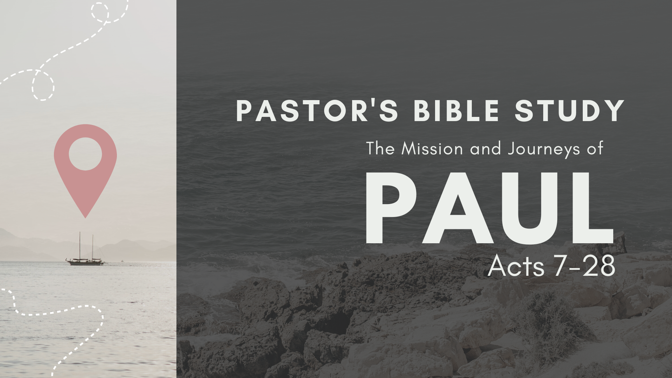

Episode 7: October 18/19
The Witness to the Ephesians
Acts 19:1-21:16
Review Ephesians

- Ephesians is often referred to as one of Paul’s “prison epistles.” What is a Prison Epistle?”

- Where is Ephesus?

- What did Paul ask the disciples at Ephesus? (19:2)

- How did the group respond to Paul? (19:2)

- What was the significance of John's baptism? (19:3-4)

- Why were the disciples rebaptized? (19:5)

- How did the Spirit come on the disciples? (19:6)

- Who received the Holy Spirit? (19:7)

- How long did Paul speak at the synagogue before confronting trouble? (19:8)

- Why did Paul stop speaking at the synagogue? (19:9)

- How did faith in Christ change the Ephesians? (19:18-19)

- What example of practical repentance is shown? What practices did the Ephesians give up? (19:18-19)

- What happened to the spread of Christianity? (19:20)

- To whom does "the Way" refer? (19:23)

- Who was the ringleader against Paul and the Christians? (19:24)

- Who / What was Artemis? (extra points for Latin name: _________________________)

- Why did the silversmith's talk create such an uproar? (19:27-29) What underlying motive did the silversmith have for his protest?

- Whom did the mob seize? (19:29)

- Where did the angry crowd take the two men? (19:29)

- How did the city clerk bring order to the crowd in the Ephesian theater? (19:35-40)

- What reasons did the city clerk give for dispersing the mob? (19:35-41)

- What battles might Paul fight if he were a missionary to our community?

- Name some contemporary, every day idols.

- What Epistle was written during this visit to Ephesus?

- Where did Paul go from Ephesus? Acts 19:21, 22; 20:1.

For discussion: Ephesians
- Why would Bob claim that Ephesians would be particularly encouraging to Presbyterian and Reformed Christians? (See Ephesians 1:1-14)

- What are some of the ways that the supernatural has been commercialized even in our contemporary culture?

- How do we uphold the supremacy of Christ and the sovereignty of God in a culture of diversity?

- What are the elements of the “Full Armor of God?” (Ephesians 6:10-20)

