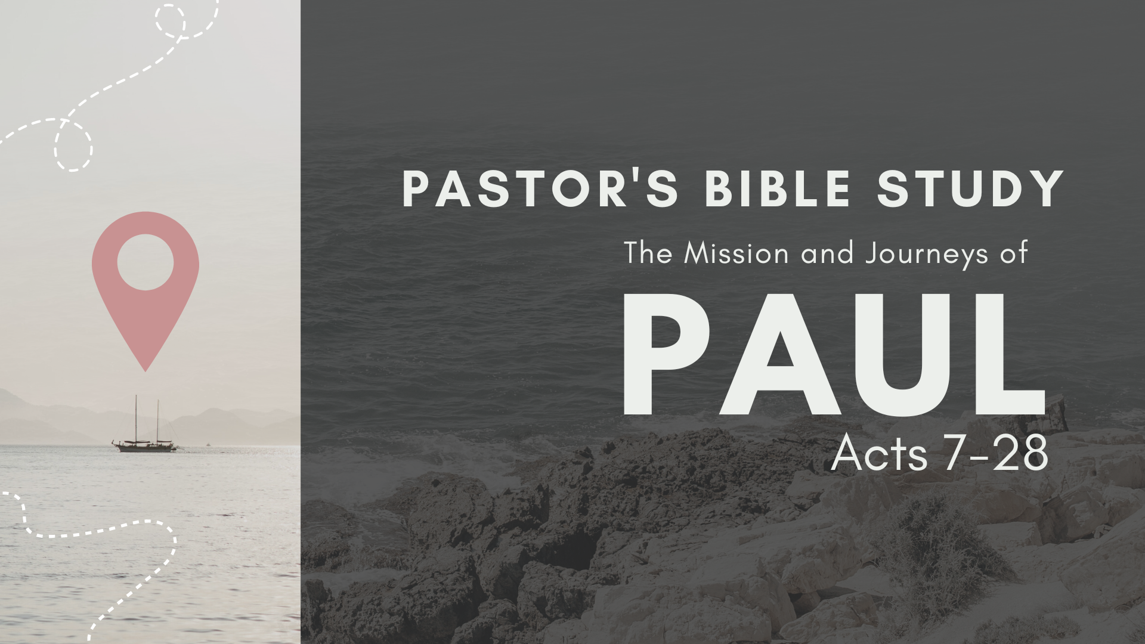

Episode 6: October 11 /12
The Witness in Corinth
Acts 18:1–28
Review I and II Corinthians

- Where is Corinth? How did its location influence the culture of the city? Acts 18:1.

- What helpers did he find there?

- Were the Jews now in favor with the Romans? Acts 18:2.

- How did Paul support himself here? Acts 18:3; 20:34.

- How was he treated here? Acts 18:6.

- What then did he do?

- How long did Paul stay in Corinth? 18:11.

- Why did the Greeks beat Sosthenes rather than Paul? Acts 18:12–17.

- What is meant by “Gallio cared for none of these things”?

- Which of Paul’s Epistles were written at this time?

- What act of Paul shows that he still kept the Jewish law? Acts 18:18.

- When was the first epistle to the Corinthians written?

- How is the message of the cross (and resurrection—the gospel) foolishness to those who are perishing, but to us who are being saved it is the power of God (1 Corinthians 1:18).

- Describe some of the challenges the Corinthians faced as Christians in a non-Christian environment.

- Over what issue is the Corinthian Church divided?

- How many of those challenges still trouble us today?

- What strong reason for purity does Paul give in this epistle?

- Who is the Apollos mentioned here? Where else is he mentioned in Scripture?

- What great renunciation does Paul make in the eighth chapter? 1 Cor. 8:13.

- Is this a model for us? It surely is.

- Which passages in I Corinthians are considered controversial now?

- What do you consider to be the most memorable and endearing passages in I Corinthians? 11:23–26, 13:1–13, 15:1–58, others?

- What kind of “love” is Paul describing in Chapter 13? Romantic love? Brotherly love?

- What is Paul’s position on the importance of the resurrection of Jesus in 1 Cor. 15?

- How does Paul picture Christ’s second coming in chapter 15?

- When was the second epistle to the Corinthians written?

- What is “the ministering to the saints”? 2 Cor. 9.

- What statement does Paul make which should influence our giving? 2 Cor. 9:7.

- What picture do we get in 2 Cor. 11?

