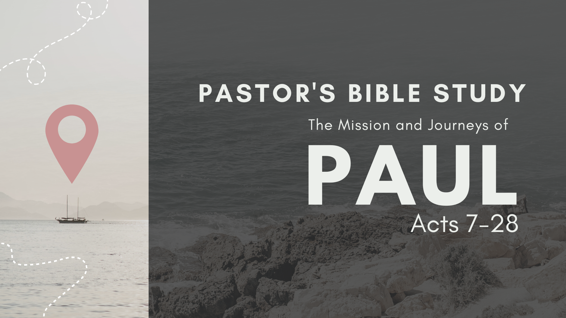
Acts 21:17-23 Gospel courage to sustain mission – Mitchell Moore

Section Outline
Paul returns to Jerusalem (21:1-36).
Paul journeys to Jerusalem (1-16).
Paul shares gold and glory of God’s work among Gentiles (17-20a).
Paul participates in a Nazarite ceremony (20b-26).
Paul is arrested in Jerusalem (22:27-36).
Paul is given permission to speak (37-40).
Paul shares his story (22:1-21).
Paul reveals his Roman citizenship (22:22-29).
Paul appeals to the Sanhedrin (22:30-23:11).
Zealous Jews plot to kill Paul (23:12-22).
Paul is delivered to the governor Felix (23:23-35).

5 Key takeaways:

- The cost of the gospel (rather than the King’s command) is the starting point for sustainable and fruitful mission. Mission begins with God’s work before our own:

Remember Paul’s passion from previous lessons: Acts 21:13 & his stated purpose in Acts 20:24.
Paul’s passion to proclaim the gospel came from Christ’s passion for him- Ephesians 5:1-2.

- Christian mission always begins with God’s work for us- NEVER our work for Him.

- Christian mission always centers on God’s work, through Christ & for life: Eph 2:8-10.

- Christ’s commission for mission (Mathew 28:18-20…) follows Christ’s work on the cross. This flow is seen throughout Scripture and is the only sustainable stream for Christian service and mission.
- The cost for unity (rather than the cost of unity) is strength for sustainable and fruitful mission.

- Unity for the Church cost Christ His life.

- Unity in the Church invites us to lose our lives to find life: Acts 2:42-47, Philippians 2:1-5.

- Paul knew going to Jerusalem to strengthen unity would be costly: Romans 15:25-32.

- Paul had taken a costly offering from Gentile Christians for suffering Christians in the city: 2 Corinthians 8:1-5. The motive for this radical generosity was the gospel: 2 Corinthians 8:9. Understanding the gospel is key to surprising generosity.
- Costly unity for Paul in Jerusalem: Acts 21:17-20a.

- The cost for contextualization (rather than seeking accommodation) is necessary for sustainable and fruitful mission.

- Jesus Christ contextualized God’s love for us: John 1:1-14, esp 14.

- Paul prioritized contextualizing the gospel to everyone, at great personal cost and for the profit of the kingdom: 1 Corinthians 12:19-22.

- Paul becomes a Jew to win Jews- and it cost him his freedom: Acts 21:20b-36.

- The cost of sharing how Jesus has transformed our lives (rather than boasting of self-righteous achievements) is catalytic for sustainable and fruitful mission.

- Jesus did not come to make bad people good- the gospel is not moral management. Jesus came to make dead people alive: Romans 5:18; 1 Corinthians 15:22.

- Paul committed his life to “testifying to the gospel of grace” Acts 20:24 and his defense in Acts 21:37-22:21 is a good paradigm for us to share our own story. Paul was not ashamed of the gospel (Romans 1:16) and gives a more succinct summary in Philippians 3:4-12. We will diagram Paul’s direction to learn to share our own story.

- Meet people where they are to quiet hearts & win an opportunity to share (21:37-22:1.)

- Make it personal. In 22:3 Paul begins with a personal introduction, highlighting the personal nature of all effective evangelism.

- Identify the real problem. In 22: 4-5 Paul (briefly) describes his rebellion against Jesus, boldly claiming his sin problem. Effective evangelism will never minimize or mask our sin problem. (See also 1 Timothy 1:15).

- Celebrate the solution. In 22: 6-9 Paul highlights the centrality of the work of God, resisting the temptation to glorify his own work. This is a big step for a recovering Pharisee! Saved by grace alone, not by works, means a personal encounter with the living God is the only solution to our sin problem. Paul emphasizes this: see Phil 3:4-11.
When we meet Jesus Christ personally, we are born again (John 3) and become a new creation in Christ (2 Corinthians 5:17). God’s transforming grace has implications for all of life. Paul’s proclamation on gospel transformation displays:
A- A new direction, (22: 10-11).
B- A new community/family, (22:12-19) and
C- A new purpose. (22: 20-21).

What does this look like diagramed?
Authentic encounter with Jesus
Gospel transformation: A new paradigm, people, and purpose
The real issues: beyond habits to the heart
Personal background
A new personal equilibrium

Inciting Incident
- The cost of courage (rather than living cowardly) will lead to capture or killing.

- Jesus had the courage to love us with His life, captured in our place and sent to the cross to die for our sins.

- Jesus meeting us personally after our failures is the foundation of moving us from cowardice to courage: John 21- the journey of Peter as an example of all the apostles.

- Paul’s courage led to a plot to-
    - A kangaroo trial before a council: 22:30-23:11.
    - A plot to kill him: Acts 23:12-22.
    - Paul’s capture and course of appeal: Acts 23:22-29.

Read Philippians 1:18b-26 and rejoice- To live is CHRIST and to die is GAIN! (excerpt below)
Acts 21:17-23 Gospel courage to sustain mission – Mitchell Moore

Small Group Study Questions

- The free grace God offers cost Jesus His life. Why is understanding the cost of the gospel important for us when we consider participation in God’s mission?

- Why is it easier to begin with and focus on our work, self-righteousness celebrating our work of obedience (even to Christ’s commission) than beginning with and celebrating God’s work in Jesus first and foremost? What does this reveal about our heart need?

- Christ’s commission for mission always follows His work for His people. Read Ephesians 2:8-10 again. How can you bring your life in line with God’s revelation?

- Christ paid the ultimate cost for unity, changing our hearts to welcome the cost of unity. Which cost for unity in the church in 21:17-20a stands out to you the most? Why?

- How does the radical generosity of the Macedonians in 2 Corinthians 8:1-5, 9 help you understand the importance of gospel centrality in participate in the cost of unity in the church? What is an application for you, today?

- Why is it difficult to become all things to all people in order to win some to Jesus?

- What do you prioritize as profit over and above winning people to Christ?

- WHO do you need to pray for, asking Jesus for an opportunity to share how Jesus has changed your life?

- Look over the points in section IV covering sharing your story. Take time to discuss each point. Which is most difficult for you? What fears do you have in sharing your story?

- How does the gospel give you more courage to stand for Christ in a world of conflict?

“Yes, and I will rejoice…²¹ For to me to live is Christ, and to die is gain… My desire is to depart and be with Christ, for that is far better. ²⁴ But to remain in the flesh is more necessary on your account. ²⁵ Convinced of this, I know that I will remain and continue with you all, for your progress and joy in the faith, ²⁶ so that in me you may have ample cause to glory in Christ Jesus…”

