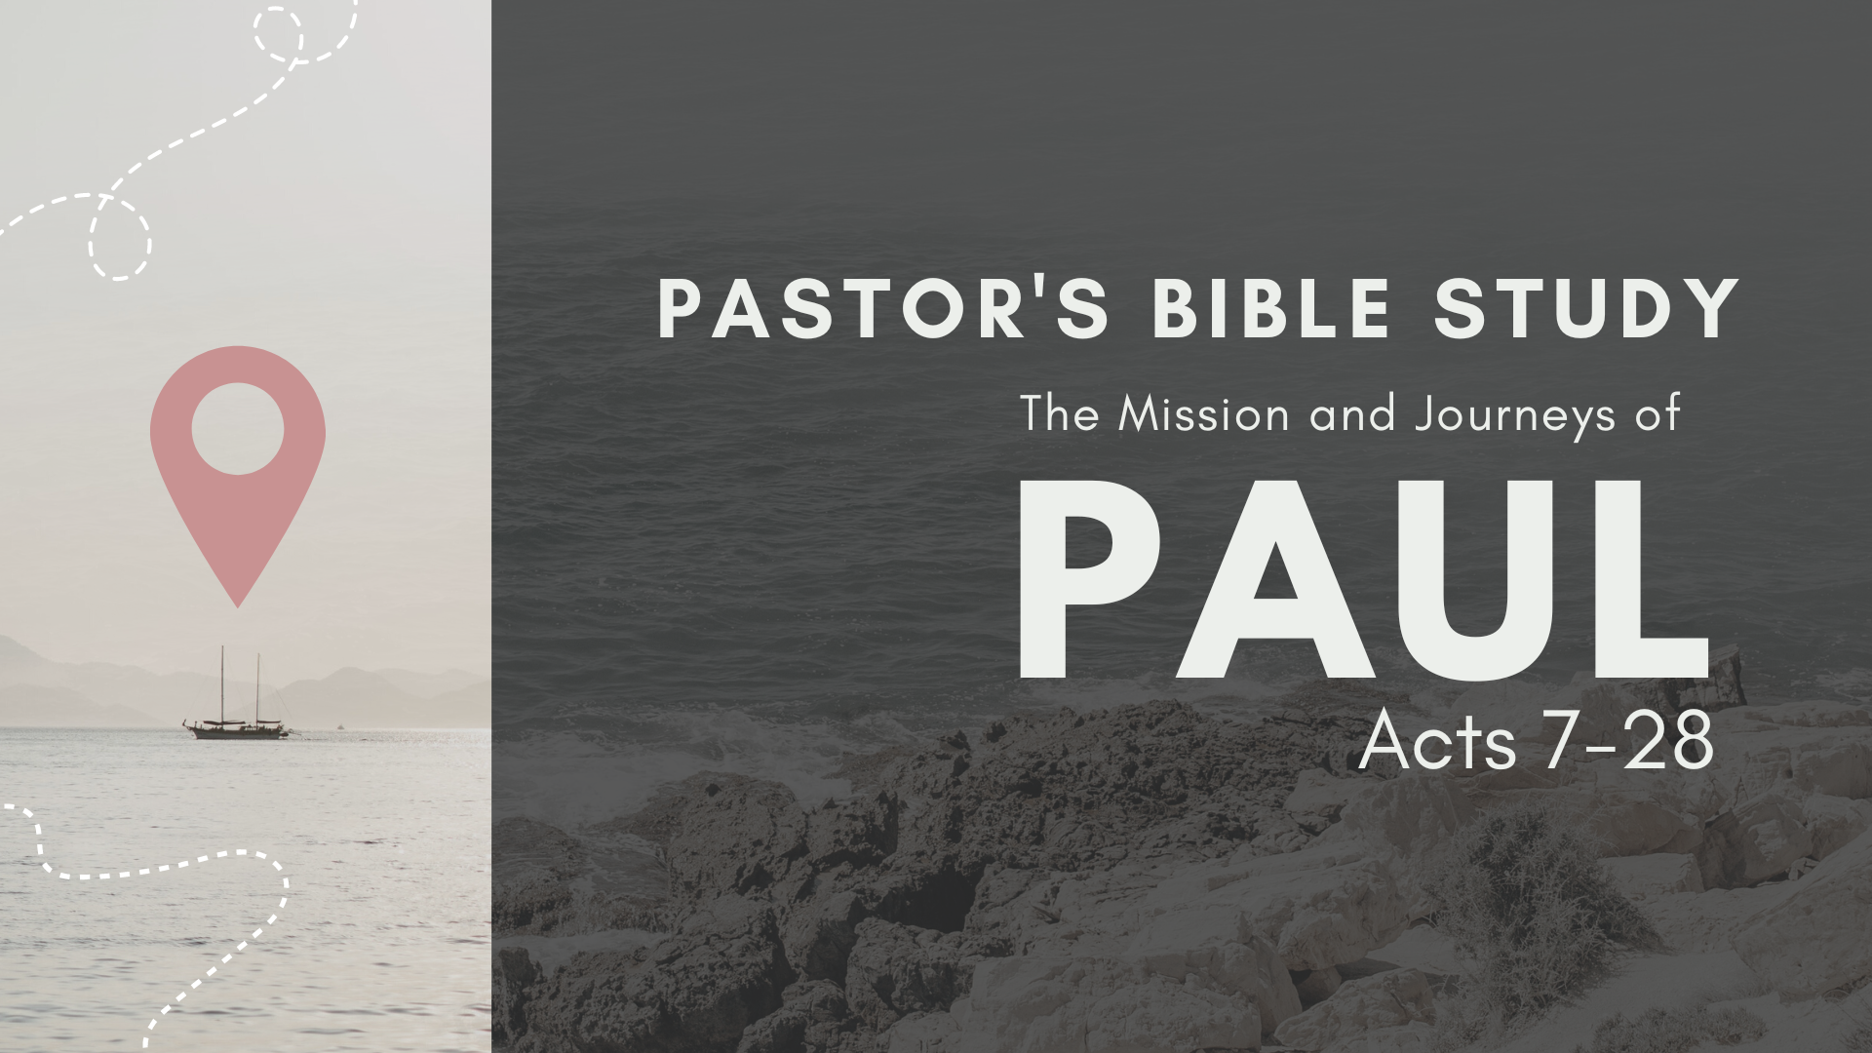

Episode 7: October 18/19
The Witness to the Ephesians
Acts 19:1-21:16

THE THIRD MISSIONARY JOURNEY

¹⁹ And it happened that while Apollos was at Corinth, Paul passed through the inland country and came to Ephesus.
(Acts 19:1)

Paul in Ephesus and the “Cosmic Battle”
- The Disciples of John (19:1–7): Paul meets twelve former disciples of John the Baptist.
  - They have never heard of the Holy Spirit (19:2b).
  - Paul brings them up to date concerning Jesus’ ministry (19:3–4).
  - When they are baptized in the name of Jesus, they receive the Holy Spirit (19:5–7).

- The Declaration of the Gospel (19:8–10)
  - Paul preaches the Good News boldly each Sabbath in the synagogue (19:8).
  - Due to open hostility, he moves to the public hall of Tyrannus and preaches daily for the final two years (19:9–10).

- Spiritual Warfare in Ephesus
  - The Miracle of the Prayer Cloths (19:11–12): God so anoints Paul that even a handkerchief of cloth that has touched Paul’s skin brings about healing when placed on the sick (reminiscent of Peter’s Shadow).
  - The Son of Sceva (19:13–17).
    - Seven brothers attempt to cast out a demon, using the name of Jesus as a magical incantation (19:13–14).
    - The demon comes out but then jumps on them, beating them severely (19:15–17).

  - New Converts (19:18–20).
    - These new believers have been brought out of the occult through Paul’s preaching (19:18).
    - They burn their books on black magic (19:19–20).
    - The apostle vows to visit Rome in the near future (19:21–22).

- The Riot in Ephesus (19:23–41): A riot breaks out in Ephesus.
  - Trouble with Demetrius (19:23–27).
    - Demetrius employs many craftsmen to make silver shrines of the Greek goddess Artemis (19:23–24).
    - He calls his associates together and lectures them concerning how Paul’s preaching is harming their business (19:25–27).
    - Demetrius’s fiery speech incites mob action against Paul and his associates (19:28–34).
    - They meet in the city amphitheater and for two hours cry out, “Great is Artemis of the Ephesians!” (19:28–31).
    - Many simply rush there without even knowing why (19:32–34).
  - The Clerk’s Intervention (19:35–41): This reasonable Greek official calms down the mob through four logical arguments.
    - All the world knows that Ephesus is the official guardian of the image of the goddess Artemis, which he says fell down to them from heaven (19:35–36).
    - The apostles have neither said nor done any punishable thing (19:37).
    - Demetrius should pursue any and all grievances through the court system (19:38–39).
    - Unless the mob disperses, the Roman officials may well intervene (19:40–41).

Paul Returns to Greece (20:1–3): The Jews plot against his life (20:3b).

PAUL RETURNS TO ASIA
- Paul in Troas (20:7–12).
  - He is accompanied by seven associates, including Timothy (20:4–6).
  - Paul preaches until midnight (20:7).
  - A young man in attendance named Eutychus accidentally falls to his death from an upper window (20:8–9).
  - Paul raises him from the dead (20:10–12).

- Paul in Miletus (20:17–38): The apostle shares his heart with a group of select men.
  - The apostle is hurrying to Jerusalem for the celebration of Pentecost (20:13–16).
  - Paul sends for the Ephesian elders to join him at Miletus (20:17).
  - Paul summarizes the gospel ministry in a threefold manner (20:18–35).
    - He reviews the past (20:18–21, 26–27, 31, 33–35).
      - For three years he fearlessly, faithfully, and tearfully preached Christ among them (20:18–21, 31).
      - Paul has always been faithful in declaring God’s Word, so no one’s damnation can be blamed on him (20:26–27).
      - Paul reminds them of his unselfish ministry (20:33–35).
      - Paul fully supports himself, taking money from no one (20:33–35a).
      - He remembers—and challenges them to remember—Jesus’ words: “It is more blessed to give than to receive!” (20:35b).
    - He overviews the present (20:22–25, 28, 32).
      - Paul explains that this will be their final meeting, for he will face difficult times ahead (20:22–25).
      - “Feed and shepherd God’s flock” (20:28).
      - “I entrust to you God and the word of his grace” (20:32).
    - He previews the future (20:29–30): Paul warns them to watch out for false teachers in the church.
      - They will be like vicious wolves, not sparing the flock (20:29).
      - They will come from the leadership of the church itself (20:30).
      - Paul’s Prayer (20:36–38): When Paul finishes speaking, he kneels and prays for them. After a tearful farewell, he departs for Jerusalem.

- Paul in Tyre (21:4–6): The Holy Spirit warns Paul through these believers that trouble awaits him in Jerusalem (21:4b–6).

- Paul in Caesarea (21:8–15).
  - Paul visits with Philip the evangelist, one of the seven deacons (21:8).
  - Philip has four unmarried daughters who have the gift of prophecy (21:9).
  - God speaks though Agabus, warning Paul of his arrest and imprisonment in Jerusalem (21:10–11).
  - Paul’s traveling companions and the believers at Caesarea beg him not to go to Jerusalem (21:12).
  - Realizing Paul is determined to visit Jerusalem, the believers declare: “The will of the Lord be done!” (21:13–15).

- Epilogue: Ephesians-- The Sovereignty of God and the Supremacy of Christ.

