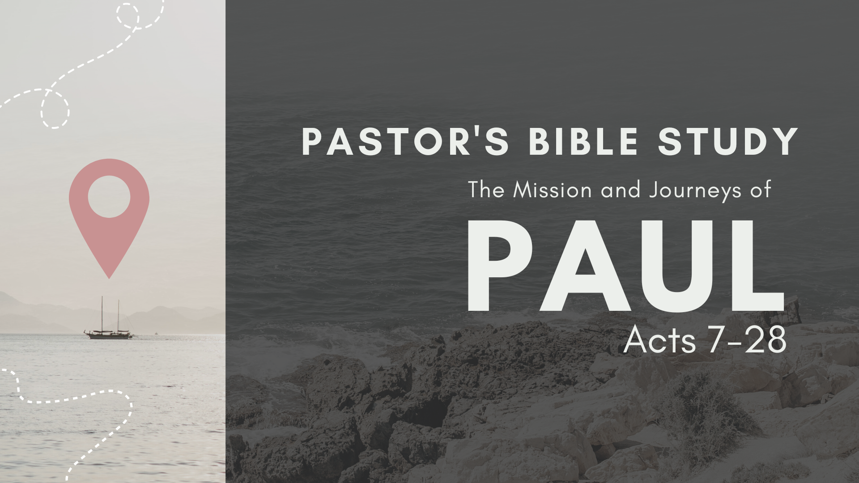

Episode 6: October 11/12
The Witness in Corinth
Acts 18:1–28

- Welcome to Corinth!
  - The City of Corinth is located on the Isthmus—or land bridge between Northern Greece and the Peloponnese (the southern part of Greece)
  - 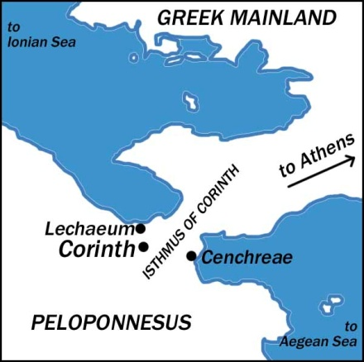
  - Corinth was a boom town. New City. Re-established only a century earlier. 250,000 people.
  - Cosmopolitan city, (Religious Diversity).

- Paul in Corinth (18:1–17).
  - The apostle’s friends in this city (18:1–3): Paul meets Aquila and Priscilla, who are tentmakers like he is.
  - The apostle’s faithfulness in this city (18:4–5): He continually preaches the gospel to Jews and Gentiles.

- Ministry and Letters from Corinth.
  - 1 Thessalonians, a.d. 49–51, early in Paul’s 18-month stay in Corinth (Acts 18:1–18).
  - 2 Thessalonians was probably penned from Corinth in a.d. 49–51, shortly after 1 Thessalonians.
- Trouble in Corinth

- ²² For Jews demand signs and Greeks seek wisdom, ²³ but we preach Christ crucified, a stumbling block to Jews and folly to Gentiles, ²⁴ but to those who are called, both Jews and Greeks, Christ the power of God and the wisdom of God. ²⁵ For the foolishness of God is wiser than men, and the weakness of God is stronger than men. (I Corinthians 1:22-25).
  - The apostle’s foes in this city (18:6, 12–17).
    - The unbelieving Jews abuse him (18:6).
    - Paul is arrested (18:12).
    - Paul brought before the Roman governor Gallio and charge Paul with blasphemy, but Gallio refuses to try the case (18:13–17).

- The Fruit of Paul’s Ministry (18:7–8).
  - Many are saved, including Crispus, the leader of the Jewish synagogue. Begins preaching in a private home, next door to the Synagogue (18:7).
  - Many Corinthians (Jews and Gentiles) are baptized. (18:8).
  - God himself reassures Paul in a vision: “Don’t be afraid! Keep preaching, for I have many people in this city!” (18:9–11).

- The Conclusion of the Second Missionary Journey.
  - Paul in Cenchrea (18:18): Here he shaves his head and takes a vow.
  - Paul in Ephesus (18:19–21): The apostle’s stay here is short, for he plans to observe a special feast soon to be celebrated in Jerusalem.
  - Paul in Antioch of Syria (18:22): No doubt he gives a report here at his home church.
  - Paul in Galatia (18:23): He begins his third missionary journey.

- Introducing Apollos (18:24–28).
  - Apollos in Ephesus (18:24–26).
    - Apollos is an effective Bible preacher from Alexandria in Egypt (18:24).
    - He knows only what John the Baptist said about Jesus. His account is incomplete (18:25).
    - After hearing Apollos’s preaching, Aquila and Priscilla fill him in with “the rest of the story.” (18:26).
  - Apollos in Greece (18:27–28): Here he is greatly used by God in strengthening the churches.

- Epilogue: To the Corinthians
  - I Corinthians
    - Paul wrote 1 Corinthians from the city of Ephesus in the Roman province of Asia (16:8, 19) sometime before the final day of Pentecost (16:8; cf. Lev. 23:11, 15), and therefore in the spring. It is unclear whether this was the spring of a.d. 53, 54, or 55. He wrote, in any case, near the end of his three-year ministry in Ephesus (1 Cor. 16:5–9; cf. Acts 19:21–22).
    - In First Corinthians, Paul was dealing with the question, “How do you believe and live like a follower of Jesus Christ when everyone in the world around you says you are crazy to believe? Paul’s Answer: The Cross and Resurrection of Jesus Christ (The reason demanded by the Greeks and the sign demanded by the Jews; I Cor 15).
  - II Corinthians
    - Paul wrote 2 Corinthians from Macedonia around a.d. 55/56, a year or so after writing 1 Corinthians and a year before he wrote his letter to the Romans from Corinth (Acts 20:2–3).
    - The central theme of 2 Corinthians is the relationship between suffering and the power of the Spirit in Paul’s apostolic life, ministry, and message. II Corinthians deals with that question, plus the question of “How do you deal with tension within the covenant community?”

