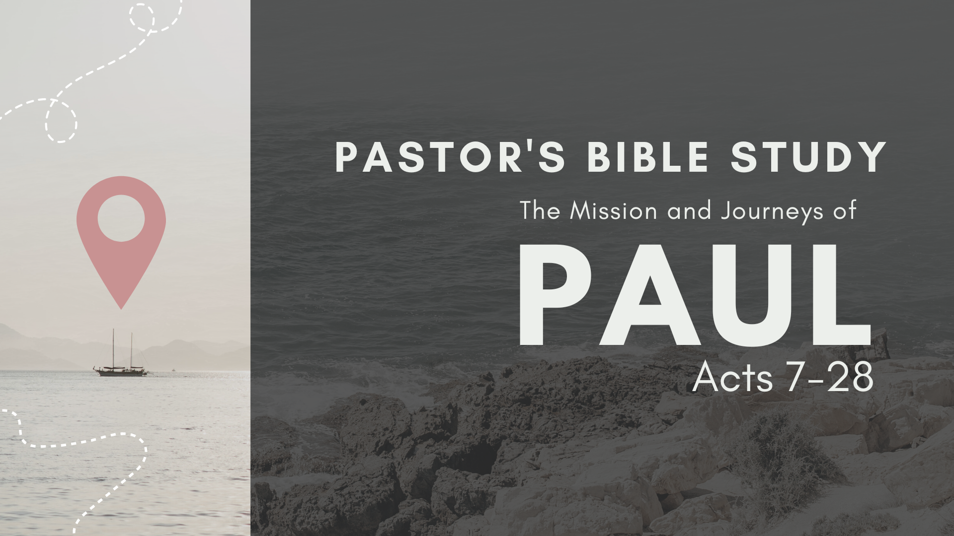

Episode 5: October 4/5
The Witness in Greece II: Thessalonica, Berea, Athens
Acts 17:1-34

Paul and Silas continue on their missionary journey.
- Paul and Silas in Thessalonica (17:1–9).
  - For three Sabbaths in a row, Paul preaches the crucifixion and resurrection of Christ in the Jewish synagogues (17:1–3).
  - Some Jews and many Gentile men and women are saved (17:4).
  - Mob and the missionaries (17:5–9).
    - A mob rushes into Jason’s house, where Paul and Silas are staying, in search of the missionaries (17:5).
    - Unable to find Paul and Silas, the mob drags Jason before the city council (17:6a).
    - The accusations (17:6b–9).
      - Paul and Silas are charged with troublemaking, and Jason is charged with allowing them to stay in his home (17:6b–7a).
      - Paul and Silas are charged with treason (17:7b–9): “They profess allegiance to another king, Jesus.”

- Paul and Silas in Berea (17:10–15).
  - Openness to God’s Word (17:10–12).
    - They listen eagerly to the teaching and research it and check the Scriptures (17:10–11).
    - Many Jews believe, as do some of the Greek men and women (17:12).
  - Opposition to God’s Word (17:13–15).
    - The demonstration against Paul (17:13): Some Jews from Thessalonica hear about Paul, come to Berea and instigate another riot.
    - Paul escapes to Athens (17:14–15).

- Paul in Athens (17:16–17).
  - Once the center of the Civilized World.
  - A city full of Idols.
  - The Athenian Audience and Attitudes (17:18–21): Four Ways to Cope: These are sophisticated Philosophical doctrines- I am in danger of oversimplifying them.
    - The Jews in the Synagogue (safety in tradition, comfort in routine): Represent cynical conservatism.
    - The Epicureans: (This life is all there is, so live it up. Don’t worry about sin or eternal consequences).
      - Represent coping through pleasure.
      - Paul acknowledges this way of thinking: 1 Corinthians 15:32 If I fought wild beasts in Ephesus for merely human reasons, what have I gained? If the dead are not raised, "Let us eat and drink, for tomorrow we die."
    - The Stoics (grin and bear it).
      - Coping through virtue.
      - “Don’t let it get to you”- either pain or pleasure. Ultra-disciplined.
      - Control emotions and Passion.
      - Marcus Aurelius (Roman Emperor):
        - “When Forced, as it seems, by thine environment to be utterly disquieted, return with all speed into thyself, staying in discord no longer than thou must.”
        - “There are many bitter pills, but we welcome them in hope of health.”
        - “If it is good for the community, it cannot be evil for the individual.”
      - Endurance without hope.
    - The Aereopagite Philosohers (try anything).
      - Philosopher: A Lover of Wisdom.
      - V. 21 (All the Athenians and the foreigners who lived there spent their time doing nothing but talking about and listening to the latest ideas.)

- Paul’s Sermon (17:22–23): The Good news of the Unknown God.
  - Paul does not use the “Pentecost” sermon style, preaching from the Jewish Scriptures. Instead he begins with the observation he has made about the city and its people.
  - The Athenians are “very religious,” as evidenced by the presence of so many idols. The entire city is filled with shrines and temples (17:16–17).
  - Paul says “I’ve got something New, (at least new to you) but it has been here all along. Better yet, I’ve got something real.”
  - The Answer is not in false idols: v.29 “we should not think that the divine being is like gold or silver or stone-- an image made by man's design and skill.”
  - Unknown God- Right under your nose: v. 22-23 “…Men of Athens! I see that in every way you are very religious…. I even found an altar with this inscription: TO AN UNKNOWN GOD.”
  - He is a God you can’t contain: v. 24 "The God who made the world and everything in it is the Lord of heaven and earth and does not live in temples built by hands.”
  - He is the one who has what you really need: v.25 “because he himself gives all men life and breath and everything else.”
  - He wants to be in a relationship with you.
    - “v.27 God did this so that men would seek him and perhaps reach out for him and find him, though he is not far from each one of us.”
    - “v.28 'For in him we live and move and have our being.' As some of your own poets have said, 'We are his offspring.'”
  - The time for ignorance is over- the time for salvation is at hand. God will someday judge the world through Jesus Christ, whom he raised from the dead (17:31).

- The reaction to this sermon (17:32–34).
    - Some mock (17:32a).
    - Some delay (17:32b): They want to hear more later.
    - Some believe (17:33–34).

