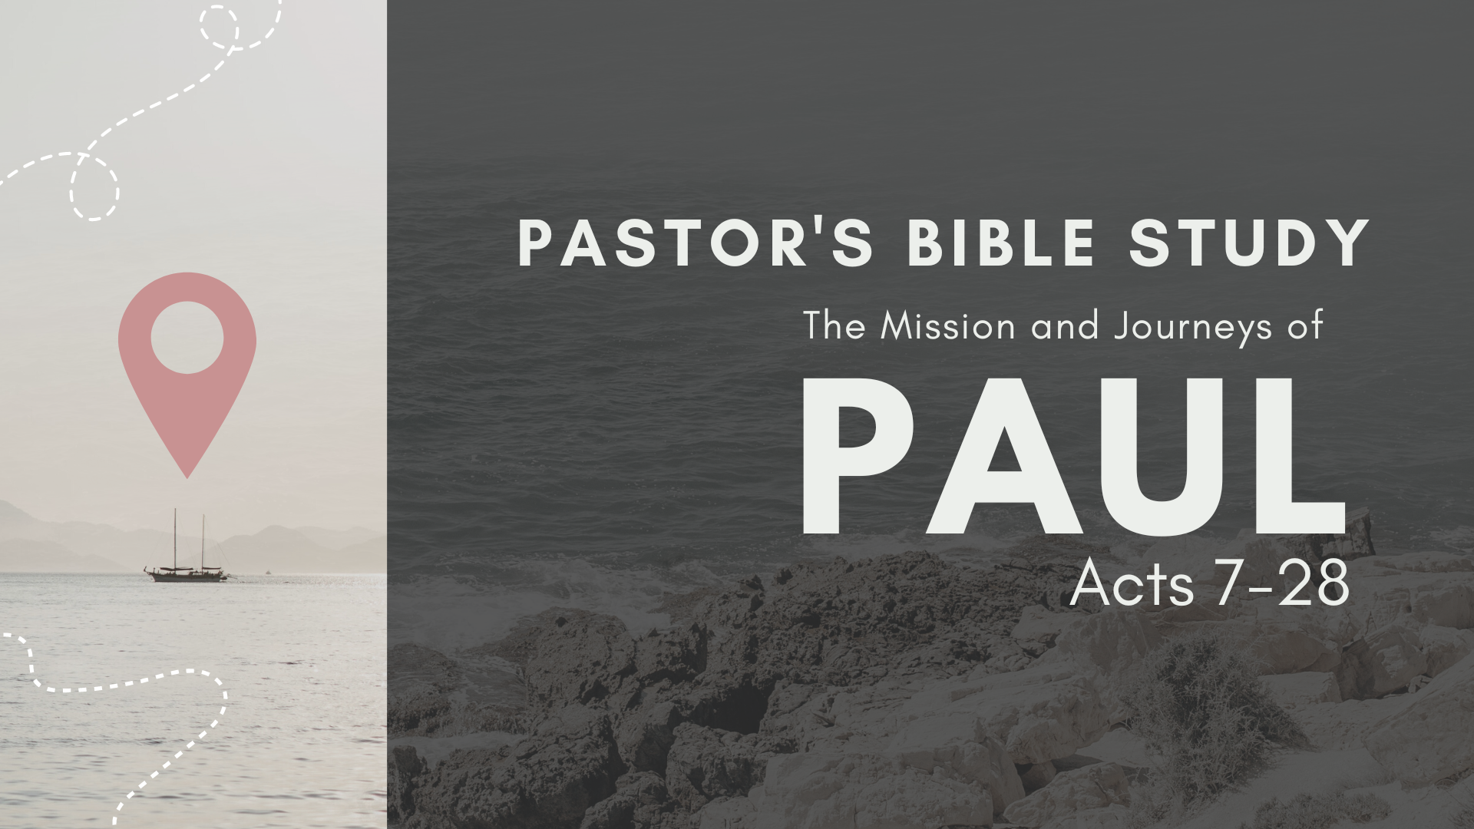

Episode 5: October 4 / 5
The Witness in Greece II: Thessalonica, Berea, Athens
Acts 17:1-34

- Where did Paul go after leaving Philippi? Acts 17:1.

- Why did he leave there? Acts 17:5–10.

- What do you think it was like for Paul to face so many riots, mobs, crowd rage, and passion? How would that have affected you if you were the focus of it?

- They said that Paul had literally “turned the world upside-down.” What do you think of that expression? How is the gospel of Jesus Christ revolutionary in human society? Acts 17:6

- What is meant by the people of Berea being more noble than others? Acts 17:11.

- Did the Jews persecute Paul here also? Acts 17:13.

- How are the Bereans an example for all believers?

- Where did Paul then go? Acts 17:15–34.

- Name some other famous historical figures associated with Athens.

- Where did Paul speak at Athens?

- Who were Stoics?

- Who were the Epicureans?

- What does “very religious” mean here? How were they “very religious”?

- Who is to be the final judge of all men?

- Who appoints the Day of Judgment? God himself.
- Did the Athenians believe in a future life?

- Why do you think Paul begins his presentation of “the unknown God” with a declaration about creation? How important is the doctrine of creation to the gospel?

- What does this teach you about reaching people in other cultures? Acts 17:24

- What do you think about Paul quoting their own pagan poets to make his point?

- How much can we use elements of truth in popular culture to reach people for Christ? What are the dangers of it? Acts 17:28

- How did the crowd react to his message? What especially did they react to? How is human pride revealed in their reaction? Acts 17:32

- Was there an opening for Paul to continue his ministry among them? What does this teach you in evangelism?

- What was the final outcome of Paul’s gospel ministry in Athens? Was it a large harvest of souls or a small one? Why do you think it went that way? Acts 17:32-34

