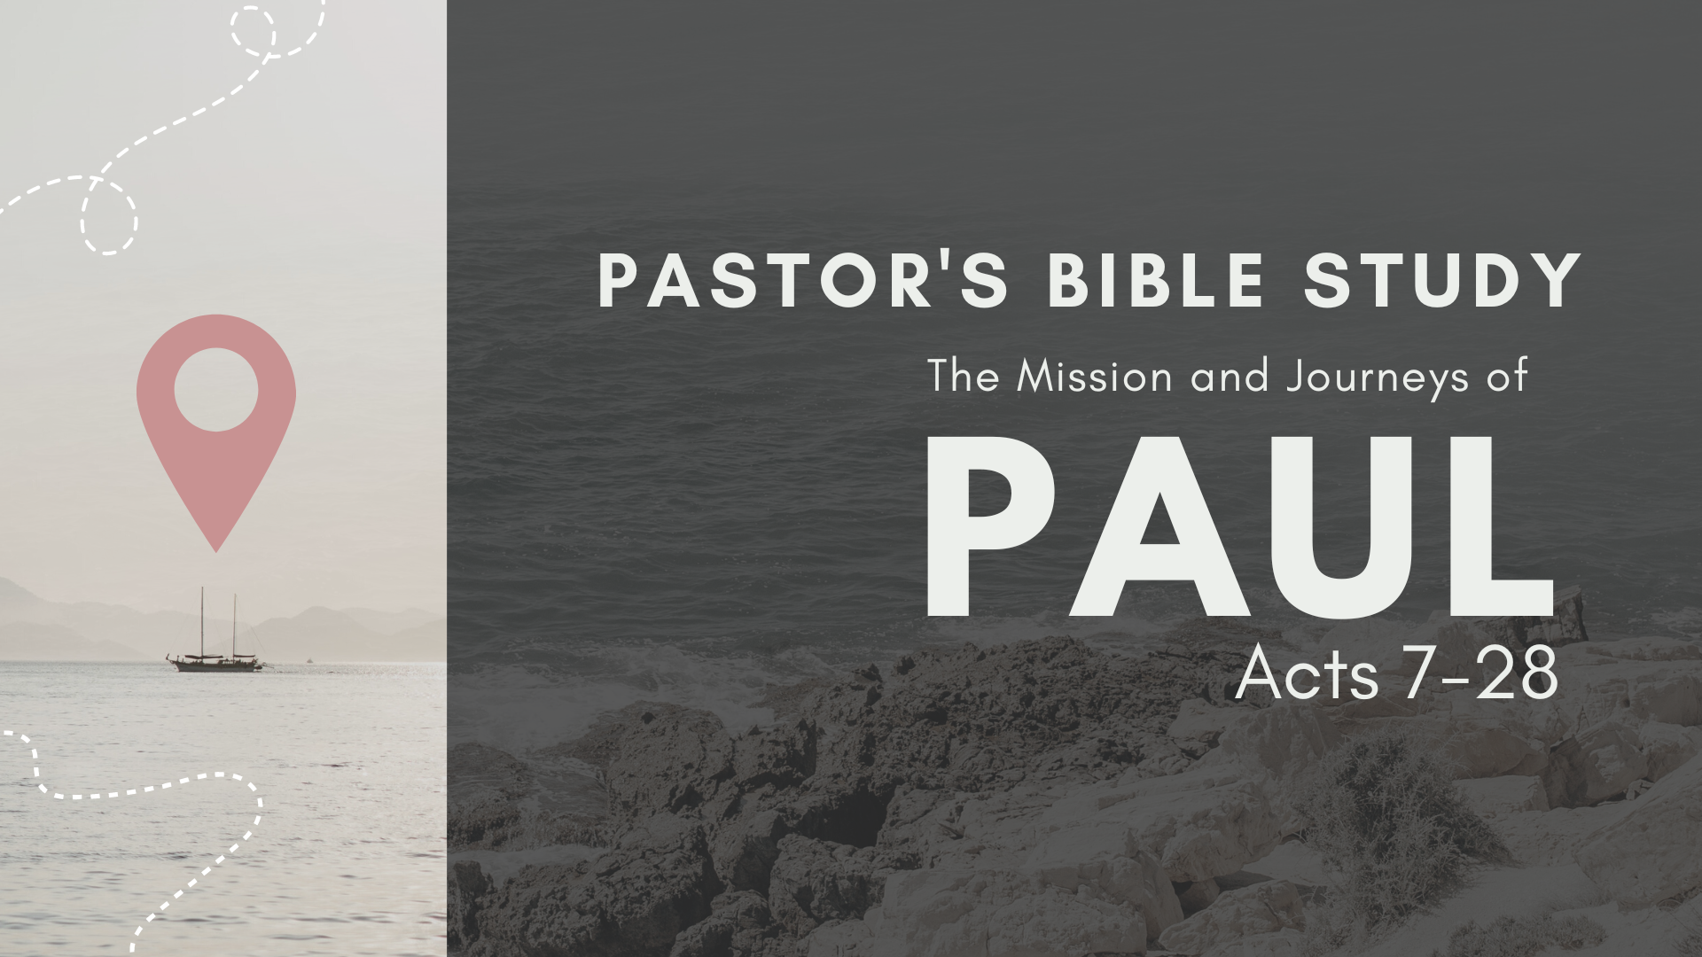

Episode 4: September 27/28
The Witness in Greece I: Macedonia and Philippi
(Acts 15:36–16:40)

- Why did Barnabas and Paul separate now? Acts 15:36–39.

- Who went with Paul? Acts 15:40.

- Where did they go first? Acts 15:41.

- Whom did Paul find in Lystra? Acts 16:1–3.

- Why did Paul circumcise Timothy when he had so earnestly opposed circumcision of new converts?

- What vision did Paul have in Troas? Acts 16:9

- What great difference was made by Paul’s heeding this call?

- Who became a Christian in Philippi? Lydia, a rich business woman. Acts 16:13–15.

- What girl did Paul often meet in the streets? Acts 16:16–18.

- What is the meaning of “divination” and “sooth-saying”?

- How does the account show that the deliverance from the evil spirit was a reality? The “masters saw that the hope of their gains was gone.” Acts 16:19.

- What was done with Paul and Silas? Acts 16:19–24.

- What happened during the night? Acts 16:25–34.

- Why was the jailer going to kill himself? See Acts 12:19.

- Why did Paul not accept the release offered him? Because they were both Roman citizens, and had been wrongly treated. Acts 16:35–40.

- What was the privilege of being a Roman citizen?

- Where did Paul go after leaving Philippi? Acts 17:1.

- Why did he leave there? Acts 17:5–10.
- What is meant by the people of Berea being more noble than others? Acts 17:11.

- Did the Jews persecute Paul here also? Acts 17:13.

- Where did Paul then go? Acts 17:15–34.

- Where did Paul speak at Athens?

- What does “very religious” mean? How were they “very religious”?

- Who is to be the final judge of all men?

- Whom does Paul quote in his sermon at the Areopagus?

- Who appoints the Day of Judgment? God himself.

- Did the Athenians believe in a future life?

- What city did Paul visit next? Acts 18:1.

- What helpers did he find there?

- Were the Jews now in favor with the Romans? Acts 18:2.

- How did Paul support himself here? Acts 18:3; 20:34.

- How was he treated here? Acts 18:6.

- What then did he do?

- How long did Paul stay in Corinth? Acts 18:11.

- Why did the Greeks beat Sosthenes rather than Paul? Acts 18:12–17.

- What is meant by “Gallio cared for none of these things”?

- What act of Paul shows that he still kept the Jewish law?

