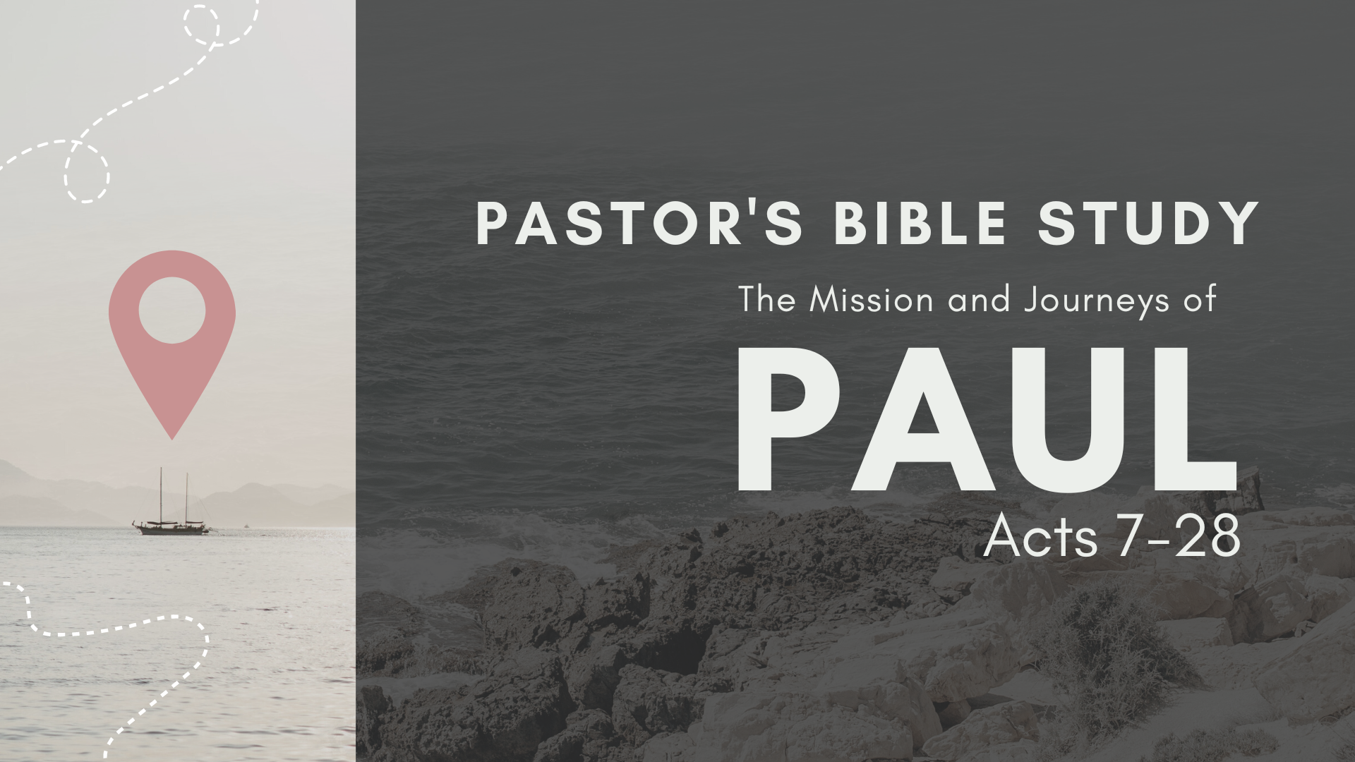

Episode 3: September 20 / 21
The Jerusalem Council
(Acts 15:1–35)

(All verse designations refer to Acts 15 unless otherwise noted)

- Why does Luke give so much space to this Council in Jerusalem? What is the significance of this council and of the issues they discussed?

- What event precipitated this whole controversy?

- How is this similar to what happened in Galatia with Peter? See Galatians 2:12

- Why did they so strenuously resist the rite of circumcision for the Gentiles?

- Who was the Simeon here spoken of?

- What do Barnabas and Paul share with the Council? How is their testimony useful in the decision?

- How does it relate to Peter’s testimony concerning Cornelius in Acts 11:15-18?

- How does it relate to the question Paul asks the Galatians who are tempted to submit to works regulations in Galatians 3:2?

- Who stood up to oppose Paul and Barnabas? What does verse 5 tell you about them?

- What points does Peter make in his presentation?

- How does Peter argue from the history of the Jews concerning the Law of Moses? How is the Law a yoke that “neither we nor our father have been able to bear”? See also Galatians 6:13. (10)

- How did Jesus handle the yoke of the Law of Moses?

- Does Peter’s speech end all discussion? (11)

- Given that Peter is considered to be the first “pope” by the Roman Catholic church, what do you find significant about Peter’s role in resolving this controversy?

- What do verses 13-21 teach you about James’s role in the early church? Compare with Galatians 1:19, 2:9, and 2:12. (13-21)
- What arguments do Barnabas, Paul, and James use to argue against requiring circumcision?

- Why does James advocate the restrictions he does in verse 20, and are these restrictions (some or all) still binding on us today?

- How does verse 21 help explain James’ reasoning? (20-21)

- Who decided to send the letter to the Gentiles? What does this teach you about early church government? (22-23)

- Why did they also decide to send messengers with Paul and Barnabas? See verse 27. (22, 27)

- What is the main idea of the letter? (24-29)

- Why do they deal with the issue that men went out without their authorization? (24)

- Why does the letter say good things about Paul and Barnabas? (25-26)

- What do you think of the phrase, “...it has seemed good to the Holy Spirit and to us...” What does this teach you? (28)

- What did the messengers do with the letter? How was it received? (30-31)

- What is the significance of the way the church went about solving this key doctrinal issue (namely, apostles and elders meeting to discuss it and render decisions for the church to obey)?

- How do you think the history of the church would have been different if the Council at Jerusalem had decided to require Gentiles to become Jews by circumcision and by obedience to the Law of Moses?

- How would it have affected evangelism and missions among the Gentiles for two thousand years?

- What do Acts 15:2 & 6 teach you about early church polity (government)? What is the significance of the way the church solved this key doctrinal issue? (2, 6)

- What kinds of issues of Christian freedom would be similar today?

- This is only the first deep doctrinal dispute recorded in church history. What does the fact that there are doctrinal disputes in the church teach you?

