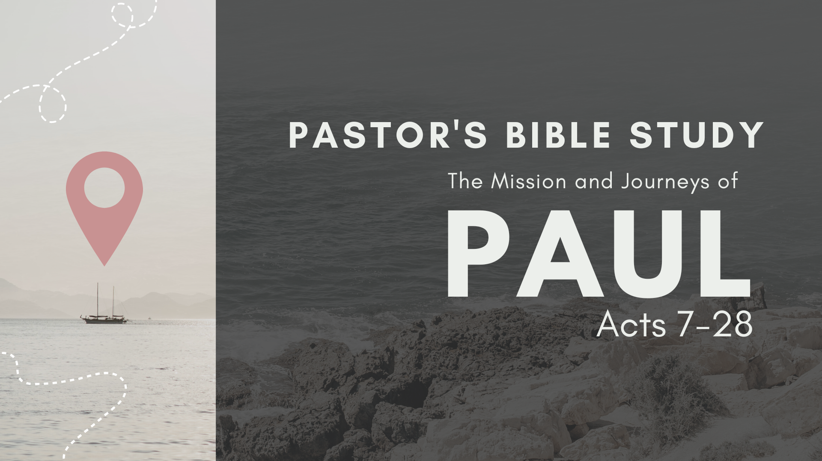

Episode 1: September 6/7
From Saul to Paul
(Acts 6:8-13:3)

Stephen gives his dramatic and compelling defense against the false charges of the Jews by showing that the Jews always resist the Holy Spirit and always persecute the saviors and deliverers God sends, and always disobey the word of God spoken through the prophets. This culminated in their rejection and murder of Christ, the Righteous One. They respond by stoning him to death, and his death brings great glory to God. He has a vision of the glorified Christ standing at the right hand of God to receive him. He dies sweetly forgiving his persecutors.

- What is Stephen’s main point and application in his defense?

- What major themes of Israel’s history are highlighted?

- What final accusation does Stephen make in verse 7:53? How does it relate to their accusation of him concerning the Law of Moses? What insight does Stephen give about the Law? See Galatians 3:19 and Hebrews 2:2 (Acts 7:53)

- How did the Jews react to Stephen’s message? How is it different than the reaction of the people who heard Peter’s message in Acts 2:37? (Acts 7:54)

- What happened in verse 55? Why does Luke tell us Stephen was full of the Holy Spirit at that moment? What did Stephen see? What is the significance of the posture and position of Jesus? (Acts 7:55)

- What did Stephen say? How did they react at that point? (Acts 7:56-58)

- What similarities do you see between Stephen’s final words and those of Christ? How does the manner of Stephen at his death show his character? (Acts 7:60)

- Why do you think Luke mentions the laying of the clothes at Saul’s feet? What is the significance of Acts 8:1 as a final word to the death of Stephen? (Acts 7:58, 8:1)

Saul, the great persecutor of the church, receives a vision of Jesus and is blinded by a heavenly light. When he regains his sight, he begins preaching that Jesus is the Son of God! Peter heals a paralyzed man and raises a woman from the dead.

- What was Saul’s hometown? (Acts 9:11)

- What was his legal status? (Acts 22:22-29)

- What was his Jewish heritage and sectarian affiliation? (Philippians 3:5-6)

- What was Paul’s mission? What does it show about his career in Judaism? (Acts 8:1-3)

- What happened to Saul? Where was he and what did he do at that time? What do you make of the fact that the encounter was begun with the flashing of a blinding light from heaven? Compare this to 2 Corinthians 4:6. (Acts 9:3-4)

- What do the circumstances of Saul’s conversion teach you about God? About conversion? About salvation? About God’s sovereignty and human will?

- What does this account teach you about Christ’s relationship to His church?

- How does Christ’s statement to Ananias in verses 9:15-16 help explain the rest of Saul’s (Paul’s) life?

- What is Paul’s mission going to be? What does it mean to carry Christ’s name before the Gentiles? Do you find it significant that the Lord also speaks of the “kings” of the Gentiles? Notice that Paul would ultimately appeal to and stand before the ultimate King of the Gentiles, the Emperor Nero. See Acts 25:11-12, Acts 27:24, and 2 Timothy 4:16-17. (Acts 9:15)

- What does verse 9:16 teach you about the Christian life? What does it teach you about Christ’s role in and view of suffering? Read 2 Corinthians 11:23-29 for a catalogue of the partial (to that point) list of his earthly sufferings in fulfillment of this statement. (Acts 9:16)

- How does the change in Paul illustrate the effects of genuine conversion?

