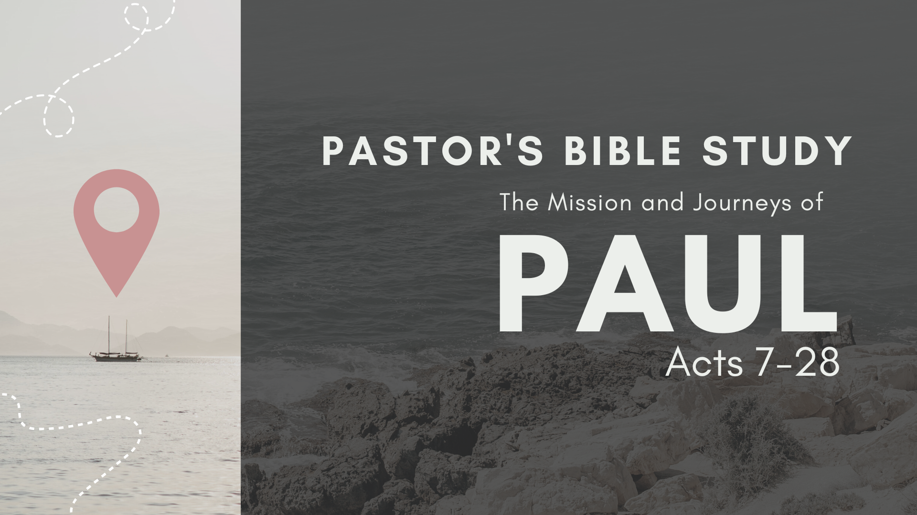

Led By Dr. Bob Fuller

Preview Edition Wednesday Evenings at 6:30 PM in Covenant Hall, beginning September 6

Thursday Mornings beginning September 7 at 9:30 a.m. in Covenant Hall.

Join us virtually via live stream through the FPC app or fpcsanantonio.org.

September 6/7 From Saul to Paul (6:8-13:3)

September 13/14 The Witness in Cyprus and Southern Galatia (13:1–14:28)

September 20/21 The Jerusalem Council (15:1–35)

September 27/28 The Witness in Greece I: Macedonia and Philippi (15:36–16:40)

October 4/5 The Witness in Greece II: Thessalonica, Berea, Athens (17:1-34)

October 11/12 The Witness in Corinth (18:1–28)

October 18/19 The Witness to the Ephesians (19:1-21:16)

October 25/26 The Arrest in Jerusalem (21:17–23:35)

November 1/2 The Witness in Caesarea (24:1–26:32)

November 8/9 The Journey to Rome (27:1–28:10)

November 15/16 When in Rome… (28:11-31)

