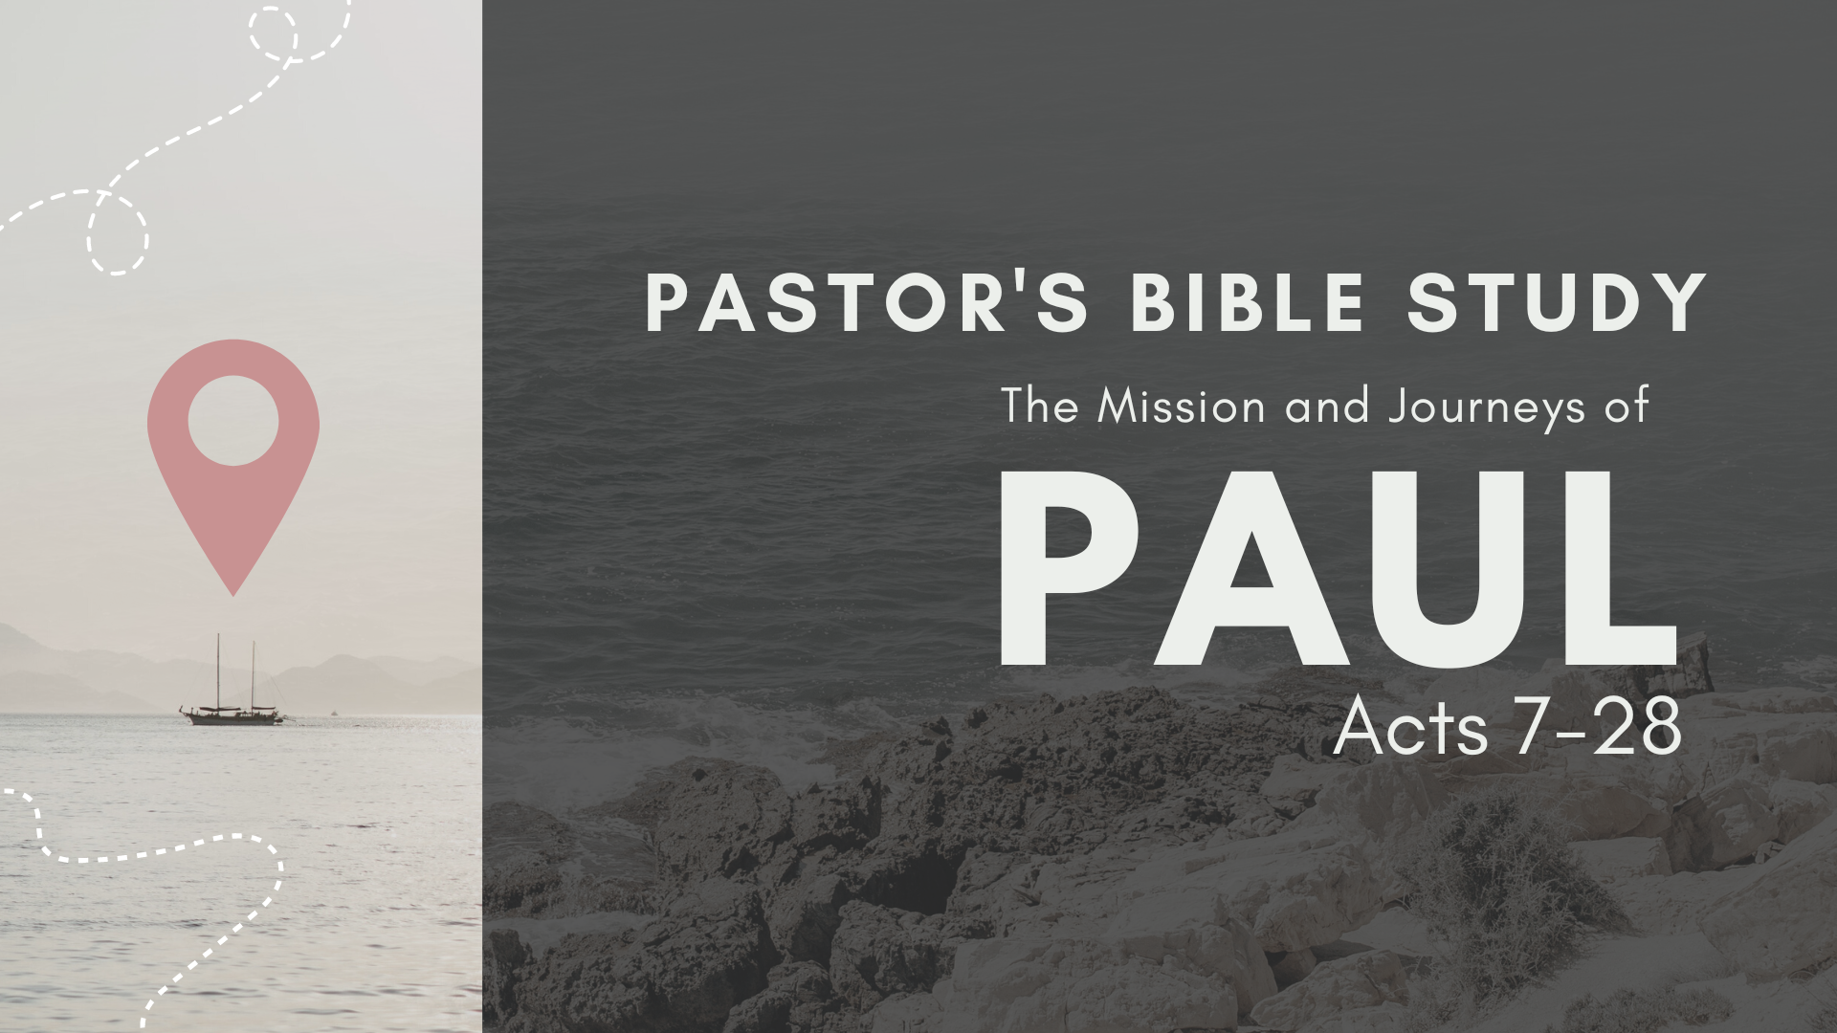

Episode 3: September 20/21
The Jerusalem Council
(Acts 15:1–35)

Preview

PETER AND CORNELIUS: ACTS 10-11:1-18
Peter receives a vision from God, telling him that the Good News is for Gentiles as well as Jews. He goes to the home of Cornelius, a Roman officer, and tells him about Christ. Cornelius and his family believe and are filled with the Holy Spirit.
Some of the Jewish Christians in Jerusalem criticize Peter for associating with Gentiles. Peter explains that the Holy Spirit has come upon the Gentiles as well as the Jews. Saul and Barnabas preach in Antioch of Syria, with huge results.
11 ‘What God has made clean, do not call common.’ …16 And I remembered the word of the Lord, how he said, ‘John baptized with water, but you will be baptized with the Holy Spirit.’ 17 If then God gave the same gift to them as he gave to us when we believed in the Lord Jesus Christ, who was I that I could stand in God’s way?” 18 When they heard these things they fell silent. And they glorified God, saying, “Then to the Gentiles also God has granted repentance that leads to life.”

PAUL AND BARNABAS’S REPORT
Acts 14:27–15:2
27 And when they arrived and gathered the church together, they declared all that God had done with them, and how he had opened a door of faith to the Gentiles. 28 And they remained no little time with the disciples.
15:1 But some men came down from Judea and were teaching the brothers, “Unless you are circumcised according to the custom of Moses, you cannot be saved.” 2 And after Paul and Barnabas had no small dissension and debate with them, Paul and Barnabas and some of the others were appointed to go up to Jerusalem to the apostles and the elders about this question.

PETER VS PAUL: THE GALATIAN CONTROVERSY

Galatians 2:11–16: 11 But when Cephas came to Antioch, I opposed him to his face, because he stood condemned. 12 For before certain men came from James, he was eating with the Gentiles; but when they came he drew back and separated himself, fearing the circumcision party. 13 And the rest of the Jews acted hypocritically along with him, so that even Barnabas was led astray by their hypocrisy. 14 But when I saw that their conduct was not in step with the truth of the gospel, I said to Cephas before them all, “If you, though a Jew, live like a Gentile and not like a Jew, how can you force the Gentiles to live like Jews?”
Justified by Faith

Galatians 2:21: 21 I do not nullify the grace of God, for if righteousness were through the law, then Christ died for no purpose.

The Jerusalem Council

A council is held in Jerusalem to determine whether Gentiles who become Christians must adhere to the old Jewish customs.
- A special council is called by the Jerusalem church. (15:1–34).
  - There is a disagreement concerning whether saved Gentile believers should be circumcised. The reason for this council meeting (15:1, 6)
  - The reports during this council meeting (15:2–5, 7–18)
    - The pro-circumcision advocates (15:5): These men were Pharisees before they became Christians.
    - The anti-circumcision advocates (15:2–4, 7–18)
  - Paul and Barnabas’s defense (15:2–4, 12): They review how God saved many Gentiles apart from circumcision during their recent missionary journey.
  - Peter’s defense (15:7–11): He speaks of Cornelius’s conversion and that of his Gentile household.
  - James’s defense (15:13–18): He reminds all present that the conversion of Gentiles was predicted by the Old Testament prophet Amos (Amos 9:11–12)
- The resolution from this council (15:19–34)
  - James announces / declares that saved Gentiles will not be forced into circumcision and will be encouraged to abstain only from a few activities. (15:19–21)
    - Eating meat sacrificed to idols (15:20a)
    - Engaging in sexual immorality (15:20b)
    - Consuming blood (15:20c)
    - Eating the meat of strangled animals (15:20d)
- Representatives such as Silas and Barsabbas are commissioned to carry letters announcing the council’s decision to the various churches. (15:22–34)
.

