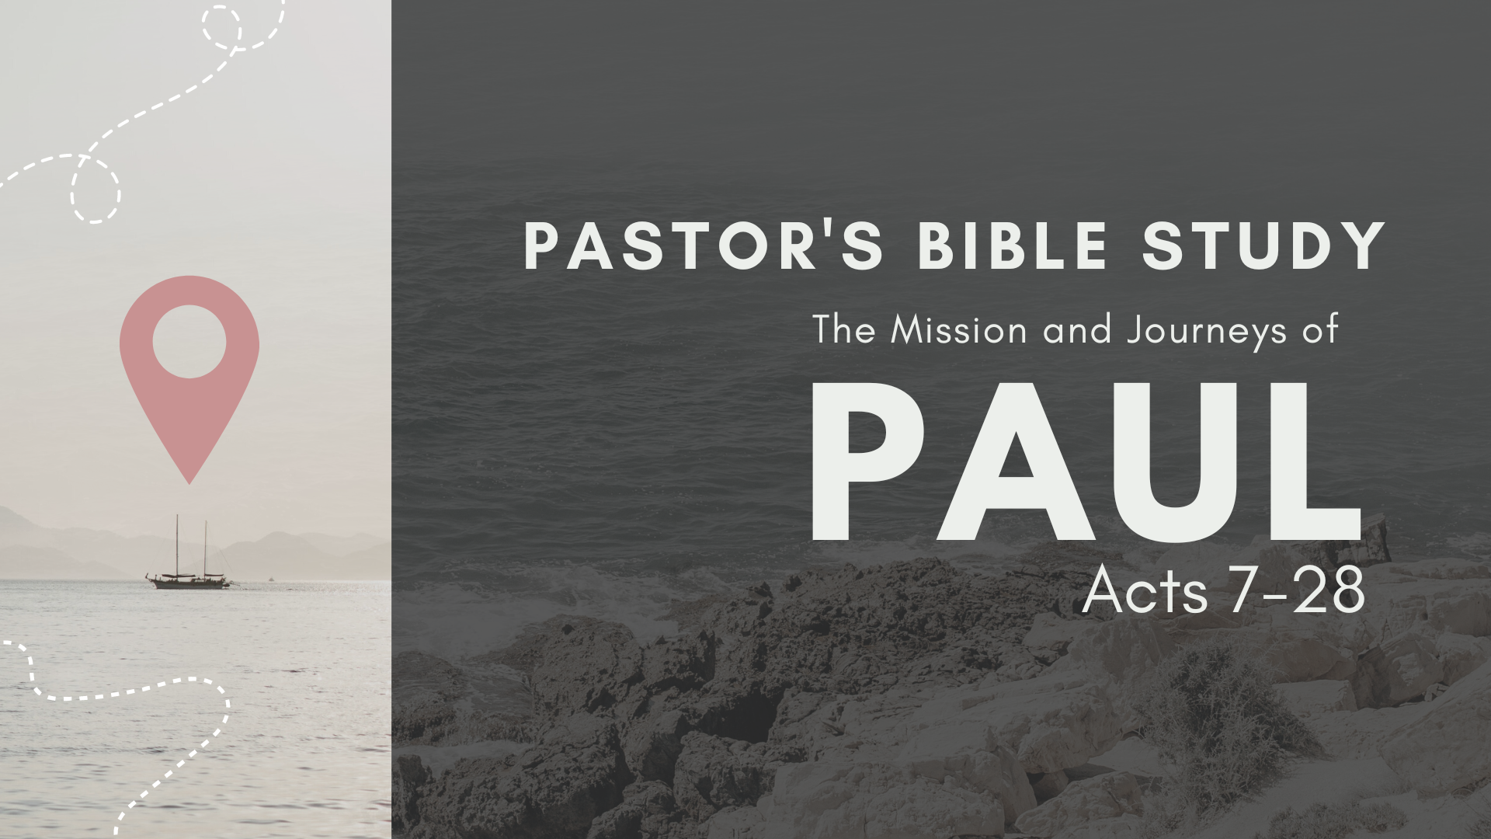

Episode 2: September 13 / 14
The Witness in Cyprus and Southern Galatia
(Acts 13:1–14:28)

“Go, for he is a chosen instrument of mine to carry my name before the Gentiles and kings and the children of Israel. ¹⁶ For I will show him how much he must suffer for the sake of my name.”
Acts 9:15-16

- Paul and Barnabas in Antioch of Syria (13:1–3)
  - The Holy Spirit tells the Antioch leaders to set these men apart for special service. (13:1–2)
  - They are commissioned by the church of God (13:3): The prophets and teachers in the assembly lay hands on the two and send them on their way.

- Paul and Barnabas in Cyprus (13:4–12)
  - John Mark joins the team.
  - Their message is well received throughout the island, especially by the governor, Sergius Paulus. (13:4–7). The governor wants to hear the
  - Opposition to God’s Word (13:8–11)
    - Elymas’s blasphemy (13:8): This false prophet and sorcerer (also called Bar-Jesus) attempts to prevent the governor from accepting Christ.
    - Elymas is blinded by the judgment of God at the hand of Paul. (13:9–11)
  - The governor becomes a believer. (13:12)

- Paul and Barnabas in Perga (13:13): John Mark abandons the team.

- Paul and Barnabas in Antioch of Pisidia (13:14–52): Here Paul delivers two sermons.
  - FIRST SERMON (13:14–43): It is a message concerning the Jewish Messiah. Men of Israel and you who fear God, listen. (13:16)
    - The overview of the Messiah (13:14–37)
      - Historical preparation for his coming (13:14–23): Paul shows from the Old Testament how God prepared the nation from which Christ would come.
        - The selection of Israel (13:14–17a)
        - The deliverance from Egypt (13:17b)
        - The wilderness experience (13:18)
        - The conquest of Canaan (13:19)
        - The rule of the judges and kings (13:20–23)
      - Homiletical preparation for his coming (13:24–25): John the Baptist served as Jesus’ forerunner.
      - Prophetical preparation for his coming (13:26–37)
        - Psalm 2:6–9 predicts God will honor the Messiah (13:26–33).
        - Isaiah 55:3 predicts God will fulfill in the Messiah the promises given to David (13:34).
        - Psalm 16:10 predicts God will not allow the body of the Messiah to see corruption (13:35–37).
    - The offer by this Messiah (13:38–41)
      - The repenting sinner is forgiven of sin (13:37–38a).
      - The repenting sinner is declared righteous (13:38b–41).
    - The obedience to the Messiah (13:42–43): Many of Paul’s audience respond favorably to his message.
  - SECOND SERMON (13:44–52)
⁴⁶ And Paul and Barnabas spoke out boldly, saying, “It was necessary that the word of God be spoken first to you. Since you thrust it aside and judge yourselves unworthy of eternal life, behold, we are turning to the Gentiles. (13:46)
    - Unbelieving Jews (13:44–46, 50–52)
      - They reject God (13:44–45, 50–52).
      - God rejects them (13:46).
    - Believing Gentiles (13:47–49)
      - The foretelling (13:47): Paul says Isaiah predicted this (Isa. 49:6).
      - The fulfilling (13:48–49): Many Gentiles accept Jesus

- Paul and Barnabas in Iconium (14:1–7)
  - The conversions (14:1): A great number of both Jews and Gentiles respond to the gospel message.
  - The confirmation (14:3): Paul and Barnabas spend considerable time here, discipling the new converts.
  - The contrast (14:4): Paul’s message divides the city in half, some receiving and others rejecting.
  - The conspiracy (14:2, 5–7): The two apostles leave after discovering a plot by their enemies to stone them.

- Paul and Barnabas in Lystra (14:8–20)
  - The cripple (14:8): There is a man in Lystra who has never walked. (MIRACLE!)
  - The command (14:9–10): Paul orders him to stand up and walk, and he does.
  - The confusion (14:11–14)
    - What the people assume (14:11–12): The amazed crowd mistakes the two disciples for gods.
      - They think Barnabas is Zeus (14:11–12a).
      - They think Paul is Hermes (14:12b).
    - What the people attempt (14:13–14): They prepare to offer sacrifices and worship the disciples.
  - SERMON TO THE GENTILES. (14:15–18): Paul quickly stops this, pointing out the identity of the true God, for whom they are witnesses. Compare this sermon to Acts 17 in Athens. Acts 17:22–31)
  - The conspiracy (14:19–20)
    - Some Jews from Antioch and Iconium turn the crowds against the apostles. (14:19a)
    - Paul is dragged out of the city, stoned, and left for dead, but he gets up and actually walks back into the city! (14:19b–20)

- Paul and Barnabas in Derbe (14:21): Again a large number respond to the gospel message.

- Paul and Barnabas back in Lystra, Iconium, and Antioch of Pisidia (14:22–25): The apostles now minister in a twofold way to the new converts in these cities.
  - They encourage everyone in the churches (14:22).
  - They select elders for the churches (14:23–25).

- Paul and Barnabas Back in Antioch of Syria (14:26–28)
  - They make a report to their home church (14:26–27). ²⁷ And when they arrived and gathered the church together, they declared all that God had done with them, and how he had opened a door of faith to the Gentiles. (14:27)
  - They remain (for a long time)(14:28).

THE END OF THE FIRST MISSIONARY JOURNEY

