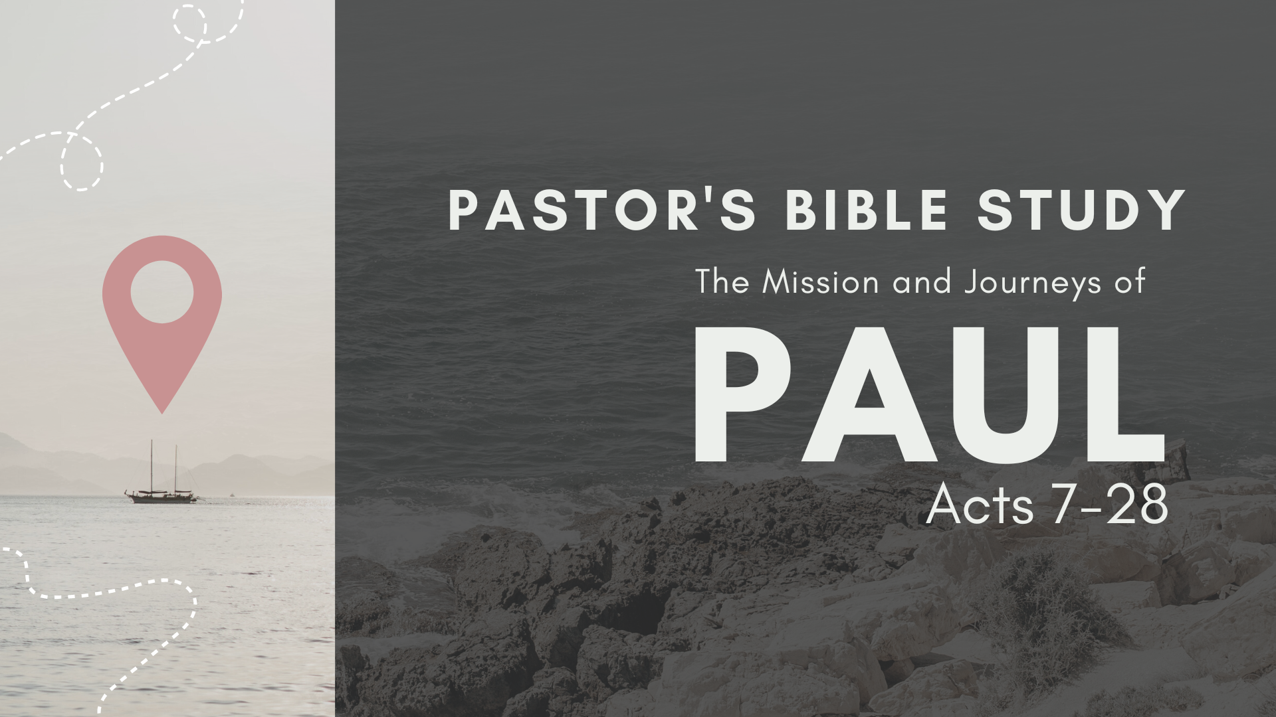

Episode 1: September 6/7
From Saul to Paul
(Acts 6:8-13:3)

THE SERVANT AND THE PROSECUTOR

The Martyrdom of Stephen
- The Slander against Stephen (Acts 6:8–15)
  - Stephen’s Miracles (6:8): He performs great wonders among the people through the power of God.
  - The Case against Stephen (6:9–14)
- Stephen’s Trial
  - Stephen’s Testimony to the Sanhedrin (7:1–53): Stephen has been falsely accused of speaking against the Temple. Now he says that the Temple is not necessary for worshiping the true God!
  - Stephen is an Educated Man. His argument shows both intelligence and training.
  - Israel was favored by God before possessing either its Tabernacle or two Temples (7:1–38).
    - As illustrated by the life of Abraham (7:1–8)
    - As illustrated by the life of Joseph (7:9–16)
    - As illustrated by the life of Moses (7:17–38)
  - But, Israel was faithless to God after possessing both its Tabernacle and two Temples (7:39–53).
    - They rebelled during the Tabernacle period (7:39–43a, 44–45).
    - They rebelled during the first Temple period (7:43b, 46–50).
    - They are rebelling during the second Temple period (7:51–53): Stephen now utterly condemns his audience with a threefold indictment:
      - They are heathens at heart and deaf to the truth (7:51).
      - They betrayed and murdered their own Messiah (7:52).
      - They are deliberately disobeying God’s laws (7:53).
  - Chaos in the Courtroom
    - Some members of the Sanhedrin mob Stephen and drag him out of the city to stone him. (7:54, 57–58a)
    - Saul of Tarsus watches the coats of the killers. (7:58b)*
    - Stephen’s vision of glory (7:55–56): Stephen sees the glory of God and Jesus standing at God’s right hand!
  - Stephen’s prayers (7:59–60)
    - Stephen prays for himself (7:59): “Lord Jesus, receive my spirit!”
    - Stephen prays for his foes (7:60a): “Don’t charge them with this sin!”
  - His death (7:60b): After he says this, he dies.

*The Man Holding the Coats: The Contrast: The Servant and the Solicitor (Lawyer) [Excerpts From The Apostle by John Pollock]

- Saul’s hometown? (Acts 9:11) a man of Tarsus named Saul
- Jewish heritage and sectarian affiliation (Philippians 3:5-6)
  - Philippians 3:5–6 (ESV): 5 circumcised on the eighth day, of the people of Israel, of the tribe of Benjamin, a Hebrew of Hebrews; as to the law, a Pharisee; 6 as to zeal, a persecutor of the church; as to righteousness under the law, blameless.
- Legal status (Acts 22:22-29)
  - … 25 But when they had stretched him out for the whips, Paul said to the centurion who was standing by, “Is it lawful for you to flog a man who is a Roman citizen and uncondemned?” … Paul said, “But I am a citizen by birth.”
- Paul’s mission? What does it show about his career in Judaism? (Acts 8:1-3)

From Persecution to Transformation Acts 9:1–31
- Saul’s vendetta against the saints of God (9:1–2)
- The Damascus Road: Saul’s vision of the Son of God (9:3–9)
- Ananias meets the great prosecutor (9:10–25)
  - God appears to a believer in Damascus named Ananias and instructs Ananias to go and minister to Saul (9:10–12).
  - Knowing Saul’s evil past, Ananias is afraid to go (9:13–14).
  - God assures Ananias that Saul is now a believer (9:15–16).
    - ¹⁵ But the Lord said to him, “Go, for he is a chosen instrument of mine to carry my name before the Gentiles and kings and the children of Israel. ¹⁶ For I will show him how much he must suffer for the sake of my name.”
  - Ananias lays hands and Saul is healed of his blindness (9:17a, 18a).
  - Saul is filled with the Spirit (9:17b, 18b–19).
- Saul begins his Ministry
  - Saul preaches Christ in all the synagogues. (9:20–22)
  - Saul’s escape from Damascus (9:23–25): Upon hearing of a plot against him, Saul leaves for Jerusalem.
- Saul’s validation (9:26–31)
  - The highly respected Barnabas reassures some fearful Jerusalem believers of Saul’s sincerity. (9:26–27)
  - Saul preaches the gospel in Jerusalem as he did in Damascus. (9:28)
  - After an attempt is made on Saul’s life, he departs for his hometown of Tarsus. (9:29–31).
  - A church begins to flourish in the city of Antioch. (11:19–30)
  - Barnabas is sent by the Jerusalem church to help the new church in Antioch. (11:19–24)
  - Barnabas brings Saul to Antioch from Tarsus to assist him (11:25–26)

