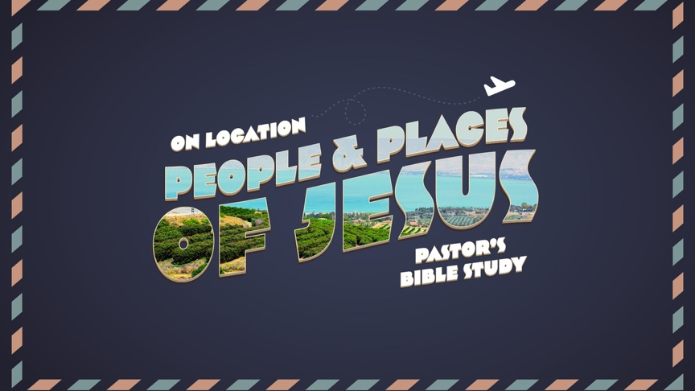

Questions for Episode 9
Last Things: Olivet and Armageddon
Matthew 24-25; Revelation 16:12-16 (Also Luke 21:5-38)
Mar 22/23
Matthew 24
- Read Matthew 24:1-2. What prophecy did Jesus give to his disciples?

- Read Matthew 24:3-14. What question did this bring up in the minds of the disciples?

- What does the "end of the age" mean according to Matthew? (Matthew 13:39-43, 49-50)

- What are some of the things that Jesus mentions that will happen before the end of the age? (Read also Mark 13:4-13)

- Read Matthew 24:15. What is Jesus referring to when He talks about the abomination that takes place in the holy place that causes desolation?

- Read Matthew 24:16-28. What instructions does Jesus give his disciples if they see the abomination in the holy place happening?

- What are 2 things that will happen after the abomination in the holy place?

- In Matthew 24:28 Jesus uses another analogy to show how you can tell that the end is near.

- Read Matthew 24:29-31. What do we learn about what will happen when the Lord returns and how He will return? (Read Luke 21:25-26)

- Matthew 24:32-34. Who are the signs in Matthew 24:4-25 reserved for?

- What are "all these things" Jesus is referring to in Matthew 24:33? What will be near?

- In Matthew 24:35 how does Jesus once more confirm that everything in God's Word will happen?

- Read Matthew 24:36-51. When will Christ return? Who knows and who doesn't know?

- How can we prepare or be prepared for Christ's return?

- Do you think it is today like it was in the days of Noah when he entered the ark? In what ways?

- Are you watching and waiting for Christ's return? In what way?

- In a capsule what have we learned about Christ's return?

Matthew 25
- Read Matthew 25:1-13. What is the kingdom of heaven like?

- Why were 5 of the virgins considered wise? Why were the other 5 considered foolish?

- Who does the bridegroom represent?

- How long would it be before the bridegroom came? What might those who are waiting for Him be tempted to do?

- What is the consequence of being unprepared for Christ's return?

- What will be the reward for being prepared to greet Christ when He does return?

- Read Matthew 25:31-46. What will the Son of Man do when He comes?

- Who do the sheep represent and where do they go? Who do the goats represent and where do they go?

- What 2 titles is Jesus called in this section?

Concept Questions: What Spiritual Concepts do these stories teach us? These are questions for reflection and discussion.
- What do these stories / passages tell us about the nature and reality of God / Jesus / Holy Spirit?

- What do they tell us about people or the world in general?

- What do they teach us about God’s involvement with real-life?

- In any of these passages, does your Study Bible share any interesting notes, references or connections to other passages of scripture?

Pondering Questions: What are you pondering after studying these chapters?
- What does this mean for Me?

- What does it mean for the people I love?

- What does it mean for the world / culture / country?

- How does this passage challenge you?

- How does this passage encourage you?

Application Questions: What is God’s message for you in today’s readings?
- Can you relate any of these passages to something happening “real-time?”

- What does God want me to know?

- What does God want me to do?

The A.W.E. question: “And What Else?”

