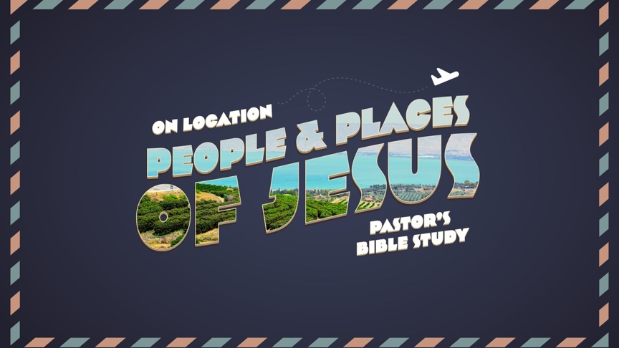

Episode 8
Through Samaria and Up to Jerusalem
Luke 9:51-19:44
Mar 8/9

PROLOGUE: THE SAMARITAN WOMAN (JOHN 4:1–42).
- THE SAVIOR AT SYCHAR (4:1–6): JESUS LEAVES JUDEA FOR GALILEE.
  - The Woman at the Well (4:7–27): A Samaritan woman comes to the well for water.
  - The Complicated Conversation (4:10–27).
    - Jesus contrasts liquid water with living water (4:10–15).
    - Jesus contrasts real worship with ritual worship (4:16–27).
    - She asks, “Why is it that you Jews insist that Jerusalem is the only place of worship, while we Samaritans claim it is here at Mount Gerizim?” (4:20).
    - The clarification (4:21–24): Jesus says that true worship involves not the where but rather the how; that is, God must be worshiped in spirit and truth!
  - The Woman Believes and Confesses Jesus is the Messiah (4:25–26).
  - The Concern of the Disciples and the Complicated Relationship (4:27).
  - The Convert becomes the Evangelist. (4:28–42).
  - What do we learn from this passage?

- SAMARIA A RELATIONSHIP WITH A COMPLICATED HISTORY
  - Samaria
    - The Central hill country of Palestine, the natural borders of which were defined by the sea on the west, the Valley of Jezreel or Plain of Esdraelon on the north (with Mt. Carmel to the west and Mt. Gilboa to the east), the Jordan River on the east, and the Valley of Aijalon on the south.
    - The area was comparatively more fertile than the southern portion of Canaan in which the tribe of Judah and its clans settled. Soil and rainfall were conducive to agriculture, the cultivation of fruit and olive trees, vegetable gardening, and wheat farming. It would appear that the use of the name ‘Samaria’ for the region dates from the time of the Assyrian conquest (post 722 b.c.), following the Assyrian practice of naming a province after its capital city, rather than to the earlier period of the Israelite monarchy (924-722 b.c.).
  - Samaritans
    - An ethnic term for the residents of the district of Samaria. In the Old Testament, the term appears only once (2 Kings 17:29) in the account of the settlement of Mesopotamian colonists in the region by the Assyrians, in the comment that these foreign people made gods of their own which they placed ‘in the shrines of the high places which the Samaritans had made.’
    - In the New Testament, however, the term is used for the members of a particular ethno-religious community based around Mt. Gerizim (John 4:1–42) but residing also in their own villages throughout the region (Matt. 10:5; Luke 9:52), who might be encountered in villages neighboring on Samaria (Luke 17:11–19) or even on the roadway between Jerusalem and Jericho (Luke 10:29–37).
    - Jews and Samaritans shared a common heritage (‘our father Jacob,’ John 4:12) but differed from one another radically in regard to the relative sanctity of Jerusalem/Zion and Mt. Gerizim (‘Our fathers worshiped on this mountain; and you say that in Jerusalem is the place where men ought to worship,’ John 4:20).
    - The Samaritans had different legal traditions regarding the cleanliness of vessels and, in general, they avoided contact with one another (John 4:7–10).
  - Relationship with the Jews
    - The negative attitude of the Jews towards the Samaritans is reflected in Jesus’ statement in Matt. 10:5, in which Samaritans are linked with Gentiles in contrast to ‘the house of Israel.’
    - Samaria occupies a “gray area” between Jerusalem/Judea and the gentile world). The itinerary of Jesus in Mark (10:1; it is followed in Matt. 19:1 but altered somewhat in Luke) seems to reflect a standard Jewish practice of avoiding Samaria in pilgrimages to Jerusalem.
    - The Jews regarded the Samaritans as a people foreign to themselves, in spite of an obviously shared heritage.The historian Josephus relates that the Samaritans were excluded from the Jerusalem Temple by formal edict, not because of nationality but due to acts of mischief they allegedly perpetrated there).
  - Religious Heritage:
    - The Samaritans were a strict, Torah-observing party. They maintain that they and not the Jews are the bearers of the true faith of ancient Israel as expounded by Moses and as practiced at Mt. Gerizim in ancient times.
    - The name by which they call themselves is Shamerim, ‘observers [of the Torah].’
    - They understand themselves to be the descendants of the Joseph tribes of ancient Israel, as Jews are descendants of the tribe of Judah.
    - Judaism as a heresy is traced to the priest Eli, who is said to have established a rival sanctuary at Shiloh.
    - Only the Pentateuch (their own distinctive version) was considered sacred scripture. The chief error of the Jews, according to the Samaritans, was in having edited the Torah to minimize the importance of Gerizim and in having erected a Temple in Jerusalem.
    - Thus, for them, the history of the Israelite faith as traced in the books of History and the prophets is not sacred but of apostate history.

- THE MISSION TO SAMARIA AND MOVEMENT TOWARD JERUSALEM
  - The first mention of the journey to Jerusalem (9:51–13:21).
    - The mission to Samaria and Rejection (9:51–56).
      - The cost of following Jesus (9:57–62).
      - The mission of the seventy-two (10:1–24).
      - The parable of the Good Samaritan (10:25–37).
      - Martha and Mary (10:38–42).
      - The Lord’s Prayer (11:1–13).
      - Jesus and Beelzebul (11:14–23).
      - The return of an unclean spirit (11:24–26).
      - Various warnings and teachings (11:27–13:9).
      - Jesus heals on the Sabbath (13:10–17).
      - The parables of the mustard seed and the leaven (13:18–21).
    - The second mention of the journey to Jerusalem (13:22–17:10).
      - The narrow door (13:22–30).
      - Lament over Jerusalem (13:31–35).
      - The healing of a man on the Sabbath (14:1–6).
      - Various teachings and parables (14:7–17:10).
    - The third mention of the journey to Jerusalem (17:11–19:27).
      - Jesus cleanses ten lepers (17:11–19).
      - The coming of the kingdom (17:20–37).
      - The parable of the persistent widow (18:1–8).
      - The parable of the Pharisee and the tax collector (18:9–14).
      - Jesus blesses the children (18:15–17).
      - The rich ruler (18:18–30).
      - Jesus foretells his death a third time (18:31–34).
      - Jesus heals a blind beggar (18:35–43).
      - Jesus and Zacchaeus (19:1–10).
      - The parable of the ten minas (19:11–27).

Outline adapted from the The ESV Study Bible (pp. 1939–1940). Wheaton, IL: Crossway Bibles.

