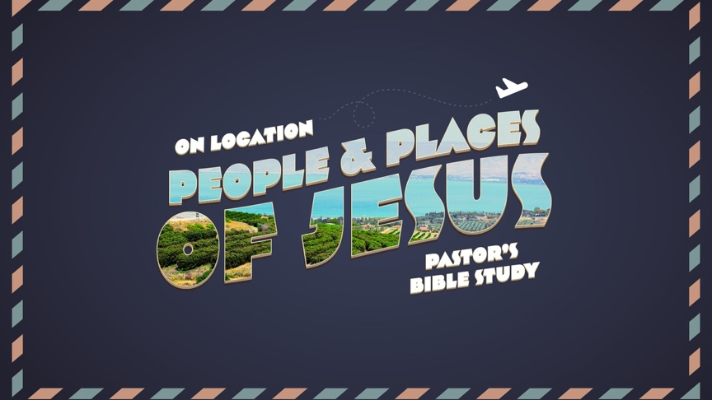

Questions for Episode 7
On the Sea of Galilee
Luke 8-9:50
Mar 1/2
Jesus Calms a Storm (Luke 8:22-25)
- What does this story illustrate about Jesus’s power and authority? (verse 24)

- What (and Who) did Jesus rebuke in this story? (verses 24-25)

Jesus Heals a Man with a Demon (Luke 8:26-29)
- Who were the “Gerasenes?” were they Jew or Gentile? How do we know?

- Where and how was the demoniac (person possessed by demons) living?

- What was the name of the demon?

- What was the people’s reaction to Jesus and his miraculous power?

- What does this story illustrate about Jesus’s power and authority?

Jesus Heals a Woman and Jairus’s Daughter (Luke 8:40-56)
- There are two stories in this passage. What is the “inner story” and what is the “outer story?”

- What was the condition of Jairus’s daughter?

- How did Jesus know that he had been touched, and why was this remarkable in the heavy crowd?

- What did Jesus declare to the woman?

- What does this story teach us about attention to people?

- What does this story illustrate about Jesus’s power and authority?

- What command did he give to the parents of the girl? Why?

Jesus Feeds the Five Thousand
- What was the Disciples’ suggestion to meet the needs of the crowd? (verse 12)

- What was Jesus’s suggestion? (verse 13)

- Peter Confesses Jesus as the Christ (Luke 9:18-20).

- What does “Christ of God” mean? (verse 20)

Concept Questions: What Spiritual Concepts do these two stories teach us? These are questions for reflection and discussion.

- What do these stories / passages tell us about the nature and reality of God / Jesus / Holy Spirit?

- What do they tell us about people or the world in general?

- What do they teach us about God’s involvement with real-life?

- In any of these passages, does your Study Bible share any interesting notes, references or connections to other passages of scripture?

Pondering Questions: What are you pondering after studying these chapters?
- What does this mean for Me?

- What does it mean for the people I love?

- What does it mean for the world / culture / country?

- How does this passage challenge you?

- How does this passage encourage you?

Application Questions: What is God’s message for you in today’s readings?
- Can you relate any of these passages to something happening in “real-time?”

- What does God want me to know?

- What does God want me to do?

The A.W.E. question: “And What Else?”

