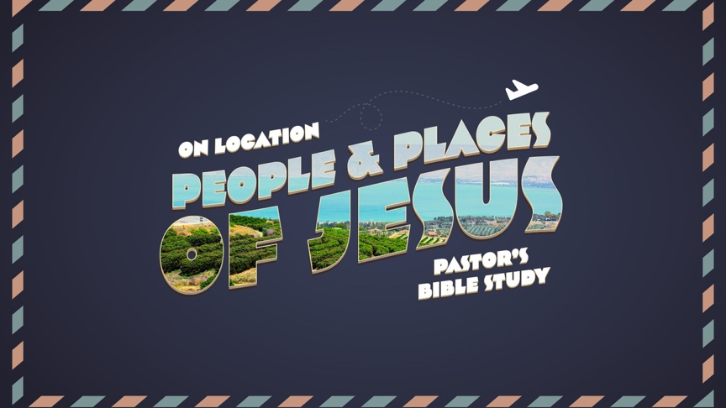

Episode 4
Jesus, John, the Jordan and the Wilderness
Luke 3:1-4:1-12; Matthew 3
Feb 8/9

- THE WILDERNESS
  - The Place.
  - The Importance of the Wilderness.

- JOHN THE BAPTIST and the ESSENES
  - The Miracle of John’s Birth.
  - John’s Mission-- The Isaiah Prologue.
    - John’s special mission was to prepare the way of the Messiah—the Christ—the Savior.
    - ⁴ As it is written in the book of the words of Isaiah the prophet, “The voice of one crying in the wilderness: ‘Prepare the way of the Lord, make his paths straight.
    - John’s mission was to prepare the people of Israel for the coming of the Messiah by calling them to repentance and forgiveness because God wants us to be ready for the coming of his Son.
  - Description of John.
    - Utter Dependence on God.
    - ⁶ Now John was clothed with camel’s hair and wore a leather belt around his waist and ate locusts and wild honey.
  - John’s Message.
    - To Convict and Call for Repentance: ⁴ John appeared, baptizing in the wilderness and proclaiming a baptism of repentance for the forgiveness of sins.
    - To Announce the Coming of The Messiah:
      - “After me comes he who is mightier than I, the strap of whose sandals I am not worthy to stoop down and untie. ⁸ I have baptized you with water, but he will baptize you with the Holy Spirit.”
      - ²⁹ The one who has the bride is the bridegroom. The friend of the bridegroom, who stands and hears him, rejoices greatly at the bridegroom’s voice. Therefore this joy of mine is now complete. ³⁰ He must increase, but I must decrease.”
  - His Community.
    - Who were the Essenes? (Was John an Essene?)
General-- Neither in the world nor of the world.
.
Law-- Wrote hidden law, accepted and gave interpretations to old law.

Interpretation-- Creative, adaptive.
God-- Messiah will destroy the evil of world.

Fate-- Accepted Fate.
Society-- Great attachment to each other.

Main locations-- Remote communes, separate quarters. The Essenes eventually dropped out of public life and became a network of close-knit communities.
Gentiles-- Mostly rejected.
Property-- Despised wealth, held goods in common.
Souls-- Bodies perishable, souls immortal, liberated upon death.
    - The Dead Sea Scrolls-- Thousands of documents and fragments make up the Dead Sea Scrolls. They contain parts of all OT books except Esther, as well as parts of some apocryphal and pseudepigraphal writings. “Sectarian documents” are related to the organization, worship, and thought of the group that collected and wrote them.

- THE BAPTISM OF JESUS
  - 13 Then Jesus came from Galilee to the Jordan to John, to be baptized by him. 14 John would have prevented him, saying, “I need to be baptized by you, and do you come to me?” 15 But Jesus answered him, “Let it be so now, for thus it is fitting for us to fulfill all righteousness.” Then [John] consented.
  - Cleansing.
  - Claiming and CONFIRMATION.
    - ²¹ Now when all the people were baptized, and when Jesus [God the Son]also had been baptized and was praying, the heavens were opened, ²² and the Holy Spirit [God the Holy Spirit] descended on him in bodily form, like a dove; and a voice [the voice of God the Father] came from heaven…, (Luke 3:21-22)
    - The Holy TRINITY together: Jesus… [God the Son]; Dove…Holy Spirit [God the Holy Spirit]; a voice from heaven…[the voice of God the Father].
    - “You are my beloved Son; with you I am well pleased.” (Luke 3:22)

- THE TEMPTATIONS AND THEIR PURPOSE
  - The Wilderness.
  - Who drove Jesus in to the Wilderness? It was God the Holy Spirit.
  - The Purpose of the Temptations.
  - The Tests.
    - Need.
    - Wealth and Power.
    - Fame.
  - Jesus’ Response: Jesus excelled because he not only resisted Satan, but found in the testing an opportunity to Obey and proclaim the Good news of God!
  - The Purpose (What God allows, He redeems).
    - To prove he was the worthy sacrifice—the lamb without blemish.
    - To Prove His Credibility: ¹⁷ … He had to be made like His brothers in every respect, so that He might become a merciful and faithful high priest in the service of God, …¹⁸ because He Himself has suffered when tempted, He is able to help those who are being tempted.”
    - To Prove God’s Faithfulness: “the Angels were ministering to him.”
  - Satan’s gambit was to Isolate Him from God so… You are all alone.
    - Satan wants to prove Jesus Unworthy.
    - Satan wanted to Disprove His credibility to us. (“He doesn’t know you. He doesn’t know how hard it is down here!”)
    - Satan wanted to Make Him believe He had to depend on Himself.

The Holy Bible: English Standard Version. (2016). (Jn 3:29–30). Wheaton, IL: Crossway Bibles.
The Holy Bible: English Standard Version. 2001 (Heb 2:17-18). Wheaton: Standard Bible Society.

