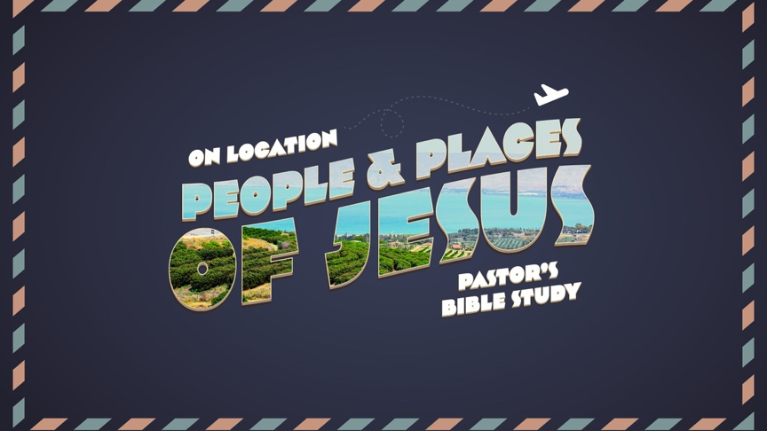

Led by Rev. Dr. Bob Fuller

If the stories of the Bible are true, then the events described involved real people, in real places at real times in history. Following on our Fall study of the People and Places of the Bible, this winter we will focus on the People and Places of Jesus. We will unlock the depth of the gospels and the life of Jesus by learning more about the historical, cultural and geographic context of the people and places Jesus knew.

Beginning January 11 Wednesday Evenings (Preview) 6:30 PM Covenant Hall
January 12 Thursday Mornings (Large Groups) 9:30 AM Covenant Hall

Date | Topic | Passages
Jan 11/12 | Introduction: From Old to New | Read Ahead: Read the Entire Gospel of Luke
Jan 18/ 19 | The Romans and Herod’s World | Luke 1:1-4; Matthew 2
Jan 25/26 | Advent to Adolescence | Luke 1:5- Luke 2; Matthew 1
Feb 1/2 | ECO Meeting in California: No Class
Feb 8/9 | Jesus, John, the Jordan and the Wilderness | Luke 3:1-4:1-12; Matthew 3
Feb 15/16 | Nazareth: You can’t go home again. | Luke 4-5; Luke 24:50-53; Acts 1, Mark 16, Matthew 28:16-20, John 21
Feb 22  Feb 23 | No Class – Ash Wednesday  The Ministry in Galilee | Luke 6-7
Mar 1/2 | On the Sea of Galilee | Luke 8-9:50
Mar 8/9 | Through Samaria and Up to Jerusalem | Luke 9:51-19:44
Mar 15/16 | No Class: Spring Break
Mar 22/23 | Last Things: Olivet and Armageddon | Matthew 24-25; Revelation 16:12-16. (Also Luke 21:5-38)
Mar 29/ 30 | The Holy Week | Luke 19:28-24:49 (Matthew 21-27; Mark 11-15; John 12-20)

