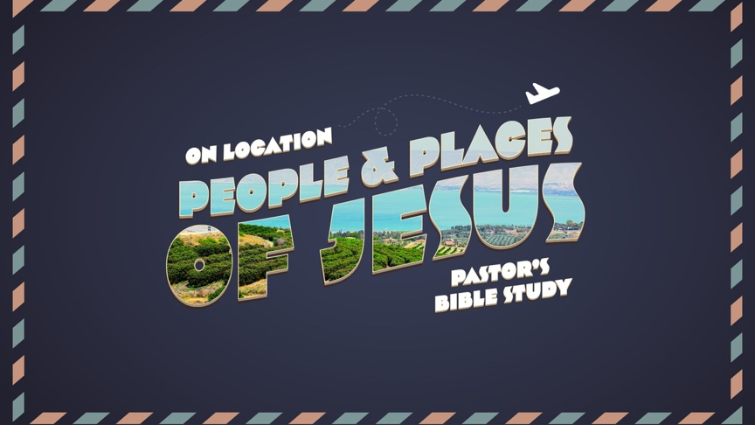

Episode 3
Advent to Adolescence Luke - 1:5- Luke 2; Matthew 1
Jan 25/26

⁴ But when the fullness of time had come, God sent forth his Son, born of woman, born under the law, ⁵ to redeem those who were under the law, so that we might receive adoption as sons.
Galatians 4:4–5

WHAT MAKES THESE STORIES REAL TO YOU?

NAZARETH: The Annunciation of Jesus (1:26–38)
- The Context: Nazareth, a small village on a ridge overlooking the Jezreel Valley, is never mentioned in the Old Testament. The name comes from the Hebrew word for branch or shoot (netzer). Nazareth became important historically because it was the “hometown” of Jesus.”

- The Messenger and The Message (Luke 1:26–37): She receives a heavenly visit.
  - The angel Gabriel appears to this virgin girl in Nazareth; Mary is engaged to Joseph the carpenter. (Luke 1:26–28):
  - Gabriel’s assurance (Luke 1:29–30): He comforts Mary, saying she has found favor with God.
  - Gabriel’s announcement (Luke 1:31–33): Mary will give birth to Jesus, the Messiah, whose Kingdom and reign over Israel will never end!

- The Promise of a King and a Kingdom
  - DIVINELY DIFFERENT: He will be great and will be called the Son of the Most High,.. (Luke 1:32)
  - DESIGNED: And the Lord God will give to him the throne of his father David, …( Luke 1:32)
  - DURABLE: And he will reign over the house of Jacob forever, and of his kingdom there will be no end.” (Luke 1:33)

- The PROOF
  - Being a virgin, Mary is perplexed, wondering how this can be accomplished. (Luke 1:34)
  - Gabriel tells her that the Holy Spirit will father the baby! (1:35)
  - Mary now learns that her aged relative Elizabeth is already six months into her pregnancy! (Luke 1:36–37)

- Mary’s DECISION: And Mary said, “Behold, I am the servant of the Lord; let it be to me according to your word.” (Luke 1:38)

BETHLEHEM (2:1–21)
- “Bethlehem (“house of bread”) was originally a small village just to the east of the main road through the hill country of Judah.
  - Genesis 35:16–20; 48:7—The tomb of Rachel, wife of Jacob and mother of Joseph and Benjamin, is just outside Bethlehem. Rachel died while giving birth to Benjamin.
  - Period of the Judges Book of Ruth—The story of Ruth and Boaz took place here during the barley and wheat harvest.
  - “United Kingdom 1 Samuel 16:1–13; 17:12—David was born in Bethlehem and anointed here by Samuel as king of Israel. David was called from tending his father’s flocks to shepherd the nation of Israel.
  - 1 Samuel 17:15, 34–37—Although David was a shepherd in Bethlehem, he traveled to the Valley of Elah where he killed Goliath (1 Sam. 17:12–58).
  - 2 Samuel 23:13–17—While fleeing from King Saul, David longed for water from the well at Bethlehem.
  - Micah 5:2—Micah prophesied that the Messiah would be born in the village of Bethlehem.
  - Luke 2:8–20—The shepherds visited the infant Jesus in Bethlehem.

- Paul: …Born of Woman
  - The two Most understated events in the universe.
  - Mary Gave Birth: ⁷ And she gave birth to her firstborn son and wrapped him in swaddling cloths and laid him in a manger, because there was no place for them in the inn. (Luke 2:7)
  - And He was Crucified: ³³ And when they came to the place that is called The Skull, there they crucified him, and the criminals, one on his right and one on his left. (Luke 23:33)

- Bethlehem 2022

- Luke’s Details:
  - In those days a decree went out from Caesar Augustus that all the world should be registered. ² This was the first registration when Quirinius was governor of Syria. ³ And all went to be registered, each to his own town. ⁴ And Joseph also went up from Galilee, from the town of Nazareth, to Judea, to the city of David, which is called Bethlehem, because he was of the house and lineage of David, ⁵ to be registered with Mary, his betrothed, who was with child. (Luke 2:1–5).
  - ⁷ And she gave birth to her firstborn son and wrapped him in swaddling cloths and laid him in a manger, because there was no place for them in the inn. (verse 7)

- The Angels’ Message
  - “A SAVIOR IS BORN” ¹¹ For unto you is born this day in the city of David a Savior, who is Christ the Lord. ¹² And this will be a sign for you: you will find a baby wrapped in swaddling cloths and lying in a manger.” (Verse 11-12)
  - “GLORY TO GOD IN THE HIGHEST.” “Glory to God in the highest, and on earth peace among those with whom he is pleased!” (Verse 14)
  - “PEACE ON EARTH”
  - ¹⁹ But Mary treasured up all these things, pondering them in her heart. (verse 19)
  - ^{The Shepherds} (2:15–21): The shepherds kneel before the babe in the manger. When they leave, they tell everyone what has happened.

JERUSALEM (2:22–38, 41–50)
- Paul: …Born Under the Law
  - Circumcision: On the eighth day, the babe is circumcised and named Jesus, in accordance with what the angel said before the baby was even conceived. (2:21)
  - Presentation: ²² And when the time came for their purification according to the Law of Moses, they brought him up to Jerusalem to present him to the Lord ²³ (as it is written in the Law of the Lord, “Every male who first opens the womb shall be called holy to the Lord”) ²⁴ and to offer a sacrifice according to what is said in the Law of the Lord, “a pair of turtledoves, or two young pigeons.”(2:22-24)
  - Leviticus 12:1-8

- Jesus’ first recorded Temple visit (2:22–38)
  - New Parents—New Responsibilities: Mary and Joseph bring him up to Jerusalem (to the Temple) to dedicate him to the Lord (2:22).
  - Simeon (2:25–35)
    - This devout man has been promised by the Holy Spirit that he would live to see the Messiah. (2:25–26): Verse 26: … it had been revealed to him by the Holy Spirit that he would not see death before he had seen the Lord’s Christ.
    - The Holy Spirit tells him that Mary’s baby is the Messiah! (2:27–32) Verse 29: “Lord, now you are letting your servant depart in peace, according to your word; ³⁰ for my eyes have seen your salvation.
    - His revelation (2:33–35)
      - Concerning the Messiah (2:33–34): He will cause the rising and falling of many in Israel.
      - Concerning the mother (2:35): He says a sword will someday pierce the soul of Mary!
    - Anna (2:36–38): This aged and godly widow joins Simeon in praising God for Israel’s Messiah.
  - Jesus’ second recorded Temple visit (2:41–50)
    - Deuteronomy 16:16-17 ¹⁶ “Three times a year all your males shall appear before the Lord your God at the place that he will choose: at the Feast of Unleavened Bread, at the Feast of Weeks, and at the Feast of Booths. They shall not appear before the Lord empty-handed. ¹⁷ Every man shall give as he is able, according to the blessing of the Lord your God that he has given you.
    - Missing Child! (2:41–47)
      - Jesus attends the Passover festival in Jerusalem with his parents at age 12. (2:41–42)
      - He is accidentally left behind by his parents. (2:43–45)
      - After looking for him everywhere, they finally locate him in the Temple, discussing theology with the Jewish teachers. (2:46–47)
    - Rebuke and Reminder (2:48–49)
      - Mary’s rebuke (2:48): “Why have you done this to us?”
      - Jesus’ reminder (2:49): “You should have known that I would be in my Father’s house.”
    - The Misunderstood Son (2:50): They cannot comprehend what he is saying!

GROWING UP IN GALILEE: Nazareth (2:39–40, 51–52) and Sepphoris
- Hebrews 2
¹⁴ Since therefore the children share in flesh and blood, he himself likewise partook of the same things, that through death he might destroy the one who has the power of death, that is, the devil, ¹⁵ and deliver all those who through fear of death were subject to lifelong slavery. (Hebrews 2:14-15)

- Sepphoris: Possible birthplace and childhood home of Mary and her parents.
  - Roman Influence
  - Synagogue
  - Marketplace
  - Theatre (Hypocrites)

- He lived the life we live. ³⁹ And when they had performed everything according to the Law of the Lord, they returned into Galilee, to their own town of Nazareth.
  - While growing up in Nazareth, Jesus grows in the following areas: 2:52
  - ⁵² And Jesus increased in wisdom and in stature and in favor with God and man.
    - In height (physical maturity) (2:39–40a, 52a)
    - In wisdom (mental maturity) (2:40b)
    - In favor with God (spiritual maturity) (2:52b)
    - In favor with man (social maturity) (2:52c)
  - INCARNATION: If Jesus is Immanuel: “God with us,” the birth is only the beginning.
  - Real Boy, Real Life.

