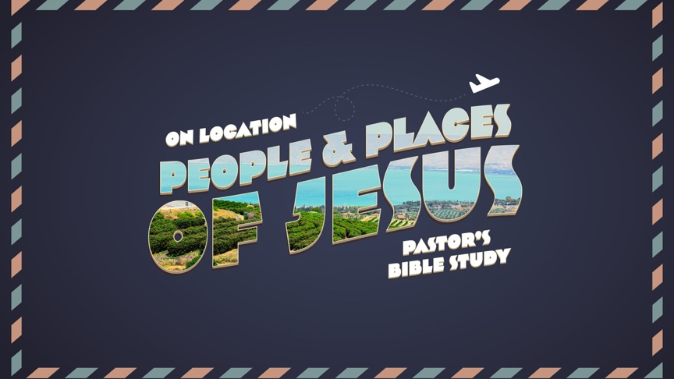

Questions for Episodes 1 and 2
Jan 11/12, Jan 18/19

Questions for Episode 1 (Review)
1. How many years went by between the Old and New Testaments?
a) 200 years.
b) 400 years.

2. Which military power first ruled Palestine during this period?
a) Babylonians.
b) Egyptians.
c) Persians.

3. The main legacy of Alexander the Great here was that Greek influence continued for several centuries.
a) True.
b) False.

4. The Maccabean revolt was primarily a reaction to Egyptian oppression.
a) True.
b) False.

5. Which language became the primary instrument for the spread of the gospel?
a) Hebrew.
b) Greek.
c) Aramaic.

6. Studying what happened during these 400 ‘silent’ years does not really help us understand the New Testament better.
a) True.
b) False.

Questions for Episode 2
- Are there factions within contemporary Christianity?

- If so, what is the effect of the divisions within Christianity?

- Have you ever been part of a church other than First Presbyterian Church of San Antonio?

- How was that Christian community different from FPCSA?

- Who delivered to Luke the things he writes about in this book? (Luke 1:2)

- Why did Luke feel he was qualified to write this book? (Luke 1:3)

- To whom was the book of Luke addressed? (Luke 1:3)

- Why did Luke write to Theophilus? (Luke 1:3)

- Who was the first emperor of Rome, and emperor when Jesus was born? (Luke 2:1)

- Who was the Ruler of Judea when Jesus was born? In whose “days” was Jesus born? (Matthew 2:1)

- Who were the Pharisees?

- Who were the Scribes?

- Who were the Essenes?

- Who were the Sadducees?

- Give the city and province in which Jesus was born. (Matthew 2:1)

- When Jesus was born, who was led from the east of Jerusalem by a star? (Matthew 2:1-2)

- State the reason the wise men of the east gave for following the star to Jerusalem when Jesus was born. (Matthew 2:2)

- State the inquiry the wise men made as they entered Jerusalem when Jesus was born. (Matthew 2:2)

- Who became concerned or “troubled” along with all Jerusalem when the wise men came seeking Jesus? (Matthew 2:3)

- Name two groups of people Herod gathered together and demanded of them where the Christ should be born. (Matthew 2:4)

- What Old Testament prophet did the priests and scribes quote to Herod when he inquired of them where Christ should be born and they answered Bethlehem of Judea? (Matthew 2:5-6)

- The chief priest and scribes quoted to Herod “and thou Bethlehem, in the land of Judea, art not the least among the princes of Judea–” what shall come and for what purpose? (Matthew 2:6)
- After Herod gathered the chief priests and scribes together, whom did he call privately and ask what time the star appeared? (Matthew 2:7)

- Where did Herod send the wise men to search for the Christ child and what were they to do when they found him? (Matthew 2:8)

- How did Herod feel when the wise men failed to return after finding the Christ child in Bethlehem? (Matthew 2:16)

- True or False? Only male children were ordered slain by Herod in all the coasts of Bethlehem. (Matthew 2:16)

- Give the age of the children ordered slain by Herod when he sought the death of Jesus. (Matthew 2:16)

- Name the person who made the following prophecy “In Rama was there a voice heard, lamentation, and weeping, and great mourning, Rachel weeping for her children, and would not be comforted because they are not. (Matthew 2:17-18)

