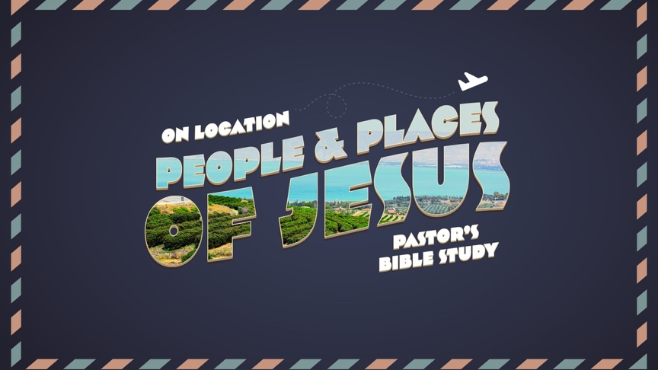

Episode 1: Introduction: From Old to New
Read Ahead: Read the Entire Gospel of Luke
Jan 11/12

- True and Real—A few Words and Pictures from the Pilgrimage to Israel

- From Old to New: Between the Testaments
  - Why is Hannukah the most important Jewish Holiday we don’t understand as Christians?
  - The Hellenistic Period (331–164 B.C.) [See appendix attached]
    - Alexander the Great of Macedonia (ruled 334–323).
1 After Alexander son of Philip, the Macedonian, who came from the land of Kittim, had defeated King Darius of the Persians and the Medes, he succeeded him as king. (He had previously become king of Greece.) ² He fought many battles, conquered strongholds, and put to death the kings of the earth. ³ He advanced to the ends of the earth, and plundered many nations. When the earth became quiet before him, he was exalted, and his heart was lifted up. ⁴ He gathered a very strong army and ruled over countries, nations, and princes, and they became tributary to him.
⁵ After this he fell sick and perceived that he was dying. ⁶ So he summoned his most honored officers, who had been brought up with him from youth, and divided his kingdom among them while he was still alive. ⁷ And after Alexander had reigned twelve years, he died.
⁸ Then his officers began to rule, each in his own place. ⁹ They all put on crowns after his death, and so did their descendants after them for many years; and they caused many evils on the earth. (I Maccabees 1:1-9)
    - Egyptian Ptolemaic Empire (320 to 198 B.C.)
    - Syrian/Seleucid Empire (198 to 164 B.C.).
  - The Hasmonean (Maccabean) Period (164–63 B.C.)
³⁶ Then Judas and his brothers said, “See, our enemies are crushed; let us go up to cleanse the sanctuary and dedicate it.” ³⁷ So all the army assembled and went up to Mount Zion. ³⁸ There they saw the sanctuary desolate, the altar profaned, and the gates burned. In the courts they saw bushes sprung up as in a thicket, or as on one of the mountains. They saw also the chambers of the priests in ruins. ³⁹ Then they tore their clothes and mourned with great lamentation; they sprinkled themselves with ashes ⁴⁰ and fell face down on the ground. And when the signal was given with the trumpets, they cried out to Heaven. …⁵⁰ Then they offered incense on the altar and lit the lamps on the lampstand, and these gave light in the temple. (I Maccabees 4:36-40, 50)
  - Why is Hannukah important?
[About Judas Maccabeus:]
³ He extended the glory of his people.
Like a giant he put on his breastplate;
he bound on his armor of war and waged battles,
protecting the camp by his sword.
⁴ He was like a lion in his deeds,
like a lion’s cub roaring for prey.
⁵ He searched out and pursued those who broke the law;
he burned those who troubled his people.
⁶ Lawbreakers shrank back for fear of him;
all the evildoers were confounded;
and deliverance prospered by his hand.
⁷ He embittered many kings,
but he made Jacob glad by his deeds,
and his memory is blessed forever.
⁸ He went through the cities of Judah;
he destroyed the ungodly out of the land;
thus he turned away wrath from Israel.
⁹ He was renowned to the ends of the earth;
he gathered in those who were perishing.
I Maccabees 3:1–9
- Enter the Romans (63-B.C—4th Century A.D.)
8 Now Judas heard of the fame of the Romans, that they were very strong and were well-disposed toward all who made an alliance with them, that they pledged friendship to those who came to them, ² and that they were very strong. …¹²They have subdued kings far and near, and as many as have heard of their fame have feared them. ¹³ Those whom they wish to help and to make kings, they make kings, and those whom they wish they depose; and they have been greatly exalted. ¹⁴ Yet for all this not one of them has put on a crown or worn purple as a mark of pride, ¹⁵ but they have built for themselves a senate chamber, and every day three hundred twenty senators constantly deliberate concerning the people, to govern them well. ¹⁶ They trust one man each year to rule over them and to control all their land; they all heed the one man, and there is no envy or jealousy among them.
¹⁷ So Judas chose Eupolemus son of John son of Accos, and Jason son of Eleazar, and sent them to Rome to establish friendship and alliance, ¹⁸ and to free themselves from the yoke; for they saw that the kingdom of the Greeks was enslaving Israel completely. ¹⁹ They went to Rome, a very long journey; and they entered the senate chamber and spoke as follows: ²⁰ “Judas, who is also called Maccabeus, and his brothers and the people of the Jews have sent us to you to establish alliance and peace with you, so that we may be enrolled as your allies and friends.” (I Maccabees 8:1-20)

- I and II Maccabees
  - The name Maccabee, probably meaning “hammer,” is actually applied in the Books of Maccabees to only one man, Judas, third son of the priest Mattathias and first leader of the revolt against the Seleucid kings who persecuted the Jews(1 Mc 2:4, 66; 2 Mc 8:5, 16; 10:1, 16).
  - The two Books of Maccabees contain independent accounts of events (in part identical) that accompanied the attempted suppression of Judaism in Palestine in the second century B.C.
  - First Maccabees was written about 100 B.C., in Hebrew, but the original has not come down to us. Instead, we have an early, pre-Christian, Greek translation full of Hebrew idioms. The author, probably a Palestinian Jew, is unknown. The first and second Books of Maccabees, though regarded by Jews and Protestants as apocryphal, i.e., not inspired Scripture, because not contained in the Jewish list of books drawn up at the end of the first century A.D., have always been accepted by the Catholic Church as inspired and are called “deuterocanonical” to indicate that they are canonical even though disputed by some. (summary by the Roman Catholic Diocese of DesMoines)

- Overview of the Course (see the Syllabus)

Appendix: Summary from the ESV Study Bible
Second Temple Judaism emerged in the fifth century b.c. during the Persian Empire, which was the dominant power at the end of OT history. The Hebrews, both living in their own land and scattered elsewhere, seem to have had a fairly ordinary existence, apart from events such as rebuilding the temple and the walls of Jerusalem. The book of Esther, however, demonstrates how quickly serious crises could develop for the Jews.

The Hellenistic Period (331–164 b.c.)
In the 330s b.c. the Persians were supplanted by the Greeks under Alexander the Great (ruled 334–323). In addition to military conquest and political control, Alexander was intent to spread Greek (Hellenistic) culture, including use of the Greek language.
The Jews simply shifted allegiance to Alexander and, at first, were generally left alone. Following Alexander’s death and the ensuing struggles, his empire was divided among four of his generals.
From 320 to 198 b.c., the Jews were controlled by the Egyptian Ptolemaic Empire. A sizable Jewish community also grew in Egypt, and a large Jewish colony in Alexandria was influential well past the time of Christ (cf. Apollos, Acts 18:24). A Greek translation of the Pentateuch was made in Egypt c. 250 b.c., and of the rest of the OT by about 130 b.c. (together commonly called the Septuagint). Most of Palestine’s countryside, outside Jerusalem, adopted Greek culture (Hellenism).
In about 198 b.c., the Seleucid (Syrian) Empire to the north of Palestine gained control over the Jews. The Seleucids attempted to spread Hellenism throughout their empire. The Jews were forbidden, on pain of death, to practice their traditional way of life, including their religion. The Jerusalem temple was turned into a pagan shrine, and persecution became prevalent.

Major Periods within Second Temple Judaism
Second Temple Judaism developed as political authority changed hands from the Persians to the Greeks, to the Jewish Hasmoneans, and finally to the Romans.

539–331 b.c. | 331–164 b.c. | 164–63 b.c. | 63 b.c.–a.d. 70
The Persian Period | The Hellenistic Period  Ptolemaic  (Egyptian) Period (320–198)  Seleucid (Syrian) Period (198–164) | The Hasmonean (Maccabean) Period | The Roman Period

Mattathias, an aged priest, along with his five sons, led a revolt. After Mattathias’s death, leadership fell to one of his sons, Judas (called “Maccabaeus”). Judas and his successors eventually won independence. In 164 b.c. the temple was cleansed, and the daily burnt offering and other religious ceremonies resumed. The event is still commemorated by Jews each December as Hanukkah, the “Feast of Lights.”

The Hasmonean (Maccabean) Period (164–63 b.c.)
During the Maccabean period (164–63 b.c.) all rulers were from the same family of Jewish priests (also called the “Hasmonean” family after the Hebrew name of Simon, an early Maccabean leader). Nine rulers followed Judas Maccabaeus to the throne, including two of his brothers. From the second generation onward, the Maccabean rulers became progressively dictatorial, corrupt, immoral, and even pagan. Internal strife led Jewish leaders to ask the Roman general Pompey to come and restore order. Pompey did so, but he also brought Roman rule, which began in 63 b.c. and lasted into the fourth century a.d.

Maccabees quotations from The Holy Bible: New Revised Standard Version. (1989). Nashville: Thomas Nelson Publishers.
Crossway Bibles. (2008). The ESV Study Bible (p. 1783). Wheaton, IL: Crossway Bibles.

