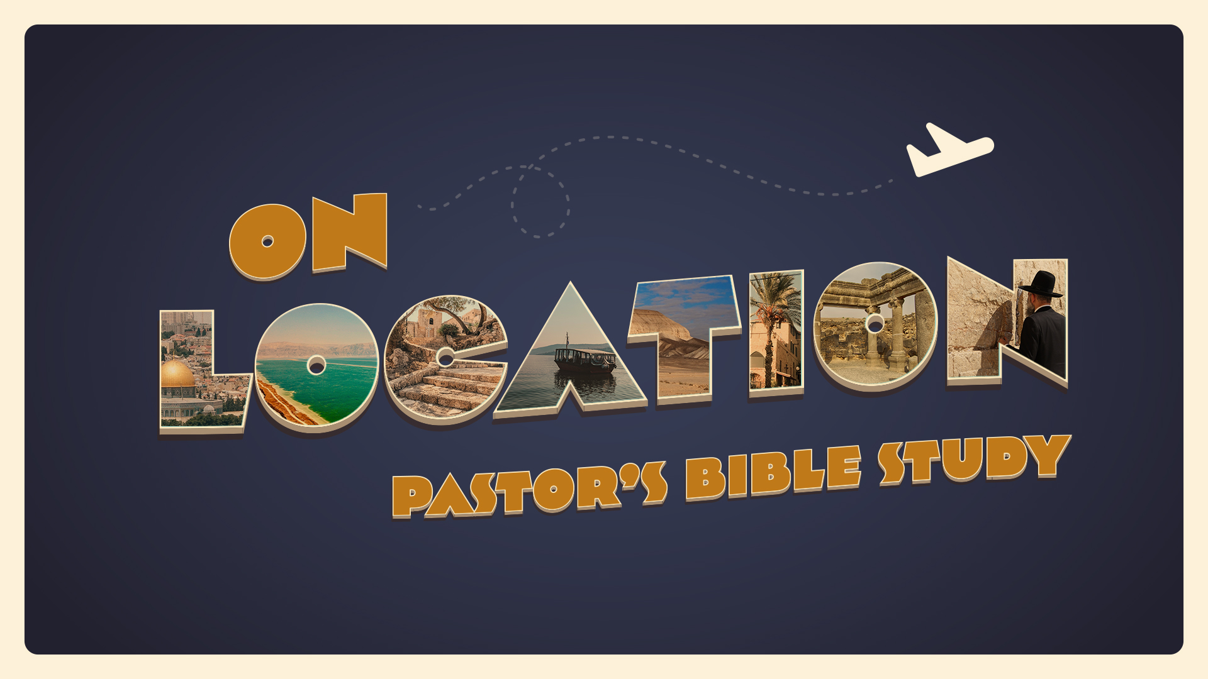

EPISODE 9: Exile and Diaspora: Babylon and Persia (and Egypt again!)
Jeremiah 43-44; Daniel 1-5; Esther 1-3; Acts 2:5-11
10/26-10/27

Jeremiah Chapters 43-44
- How did Johanan and the other leaders rationalize their disobedience, according to these first three verses of this book? (Jeremiah 43:1-3)

- Who were the people who entered Egypt, some of them against their will in verses four through seven? (Jeremiah 43:4-7)

- When he was at Tahpanhes with the others, what symbolic action did God tell Jeremiah to take, and what was the meaning in these verses? (Jeremiah 43:8-13)

- What sin did God, through Jeremiah, remind the people that He had punished Judah and Jerusalem for in these verses? (Jeremiah 44:1-6)
- Why was Jeremiah amazed that the remnant had not learned a lesson from all that had happened before in these verses of this book? (Jeremiah 44:7-10)

- What did God say He would do to all those determined to go to Egypt for protection, according to these verses? (Jeremiah 44:11-14)

- What superstitious belief did the people cite as they defied Jeremiah openly in verses fifteen through nineteen of this book? (Jeremiah 44:15-19)

- How did Jeremiah proceed to correct their thinking about the real cause of their misfortune in these verses? (Jeremiah 44:20-23)

- What vow did God answer the people with that vowed to continue worshiping the “Queen of Heaven” in these verses? (Jeremiah 44:24-28)

- What did God promise to do to the pharaoh of Egypt, whom the Israelites considered an ally against Babylon in verses twenty-nine and thirty? (Jeremiah 44:29-30)

Daniel Chapter 1
- Who was the King of Babylon during the third year of the reign of Jehoiakim? (Daniel 1:1)

- Who gave the King of Judah into the hand of Nebuchadnezzar the King of Babylon? (Daniel 1:2)

- What kind of young children was he looking for in this verse four of the book of Daniel? (Daniel 1:4)

- Who were the three young children that the King Nebuchadnezzar took from Judah? (Daniel 1:6) What new names were given to the three young children from Judah by the prince of the eunuchs? (Daniel 1:7)

- Why did Daniel purpose in his heart not to eat any portion of the King’s food or drink the wine? (Daniel 1:8)

- What test did Daniel ask the prince of the eunuchs to let them perform for ten days? (Daniel 1:12)

- What did God give the four young children in this verse seventeen of the book of Daniel? (Daniel 1:17)
- How much better did King Nebuchadnezzar find that they had more wisdom than all of the magicians and the astrologers in his realm? (Daniel 1:20)

Daniel Chapter 5
- Who was the king at the great feast when a thousand lords were drinking wine from the golden and silver vessels? (Daniel 5:1)

- How did King Belshazzar defile the vessels of the house of God? (Daniel 5:3-4)

- Was King Belshazzar scared when the fingers of a man’s hand wrote on the wall? (Daniel 5:6)

- What did the King promise to the wise men of Babylon that whosoever could read this writing and show him its interpretation? (Daniel 5:7)

- When all the King’s wise men came could they read the writing and interpret it for him? (Daniel 5:8)

- Who spoke to the King and said for him not to be troubled that there was a man in his kingdom that could interpret the writing? (Daniel 5:10)
- Who was the one that King Belshazzar called to show him the interpretation of the writing on the wall? (Daniel 5:12-13)

- What did the King promise Daniel if he could read the writing and tell him the interpretation of it? (Daniel 5:16)

- What did Daniel say to King Belshazzar about the gifts and rewards that he offered to him? (Daniel 5:17)

- What was the interpretation of the writing on the wall in these verses of the book of Daniel? (Daniel 5:26-28)

- When the King made a proclamation concerning Daniel that he should be the third ruler in his kingdom, what happened to the King? (Daniel 5:30)

Esther Chapter 1
30. What is the background of this story in these verses of this book? (Esther 1:1-3)

Acts Chapter 2
31. How many different diaspora nationalities were represented who listened to the apostles on the day of Pentecost? (Acts 2:9-11)
32. Can you name the nationalities represented who listened to the apostles speak on the day of Pentecost? (Acts 2:9-11)

33. What effect did the apostles’ speaking in a language all nations could understand have on the people who heard them? (Acts 2:12-13)

