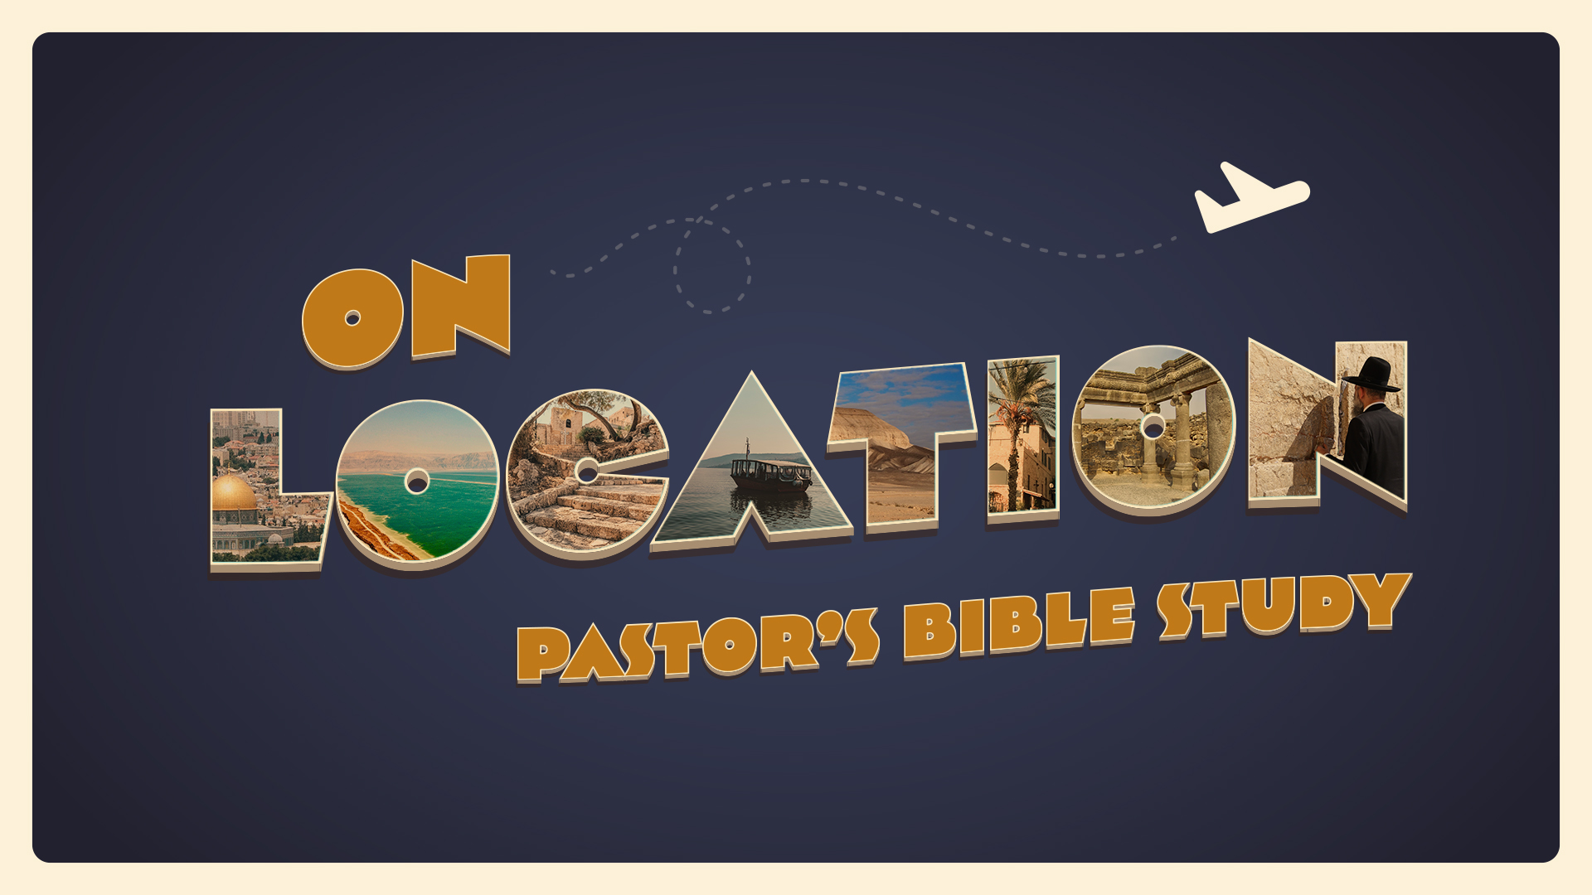

EPISODE 8: Israel — Solomon and Kings
1 Kings 9-11,18
10/19-10/20

First Kings Chapter 9

- When did the Lord appear to Solomon a second time in verse one? (I Kings 9:1-2)

- What positive response did God make to the prayers Solomon had offered at the dedication of the temple? (I Kings 9:3)

- What “if” did God reiterate to Solomon concerning his relationship to God? (I Kings 9:4-5)

- What did God promise to do if Solomon or his descendants failed to obey His commands? (I Kings 9:6-9)

- How did Hiram feel about the “gift” Solomon gave him in thanks for the raw materials for the temple? (I Kings 9:11-13)

- Who provided the slave labor in Solomon’s kingdom? (I Kings 9:20-21)

First Kings Chapter 10

- Why did the queen of Sheba come to visit Solomon in verse one of this book? (I Kings 10:1)

- What gifts did the queen of Sheba bring to Solomon in verse two? (I Kings 10:2)

- Why did people continually come seeking an audience with Solomon? (I Kings 10:24-25)

First Kings Chapter 11

- What was one of Solomon’s primary downfalls and areas of disobedience against God? (I Kings 11:1-2)

- How many wives did Solomon marry in verse three? (I Kings 11:3)

- What happened to Solomon’s devotion to God as he got older in verse four? (I Kings 11:4)

- What gods did Solomon allow to be worshiped in Israel because of his foreign wives? (I Kings 11:5-8)

- What reason did God have to be especially angry with Solomon? (I Kings 11:9-10)

- What word did God speak in judgment of Solomon? (I Kings 11:11)

- Why did God choose not to utterly destroy Solomon and remove the whole kingdom from him? (I Kings 11:12-13)

- What was the history of the first enemy God raised up against Solomon? (I Kings 11:14-22)

- To which of David’s battles did Rezon’s enmity hearken back? (I Kings 11:23-25)

First Kings Chapter 18

- Whom did Elijah hold accountable for Israel’s troubles? (I Kings 18:18)

- What groups did Elijah want to assemble in these verses of this book? (I Kings 18:19-20)

- How did the people respond when Elijah confronted them with their double-mindedness? (I Kings 18:21)

- How did the people respond to the confrontation Elijah proposed between Baal and God? (I Kings 18:22-24)

- How did Elijah taunt the prophets of Baal when their god did not ignite the sacrifice? (I Kings 18:27-29)

- What preparations did Elijah make in the sight of the people before he prayed to God? (I Kings 18:30-35)

- How did Elijah address God in prayer in these verses of this book? (I Kings 18:36-37)

- What happened to the altar of the Lord when Elijah prayed? (I Kings 18:38)

- How did the people react when they saw fire burn up Elijah’s offering? (I Kings 18:39)

- What vengeance did Elijah exact against the prophets of Baal? (I Kings 18:40)

