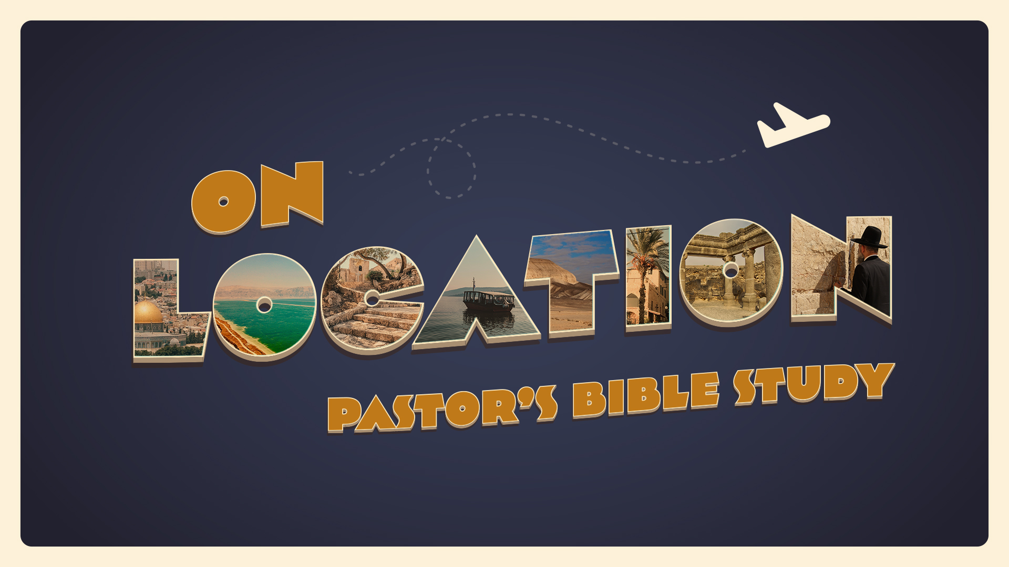

EPISODE 7: The New Kingdom—Saul and David
I Samuel 11, 14, 17; 2 Samuel 2:1-11; 2 Samuel 5-6;
10/12-10/13

- When Nahash, the Ammonite came to battle against the Israelites at Jabesh-gilead, what did the men of Jabesh want to make and what did they agree to do? (I Samuel 11:1)

- On what condition does Nahash agree to make a covenant with the people of Jabesh-gilead? (I Samuel 11:2)

- According to Samuel’s words to Saul, who remembered Amalek and what he did to Israel as Israel came out of Egypt? (I Samuel 15:1-2)

- As Samuel brought the words of the Lord to Saul to go against Amalek, list those things Saul is to “utterly destroy.” There are eight. (I Samuel 15:3)

- Give the name of the place Saul mustered his army to go against Amalek. (I Samuel 15:4)

- How many footmen were gathered at Telaim to go against Amalek by Saul? (I Samuel 15:4)

- How many men of Judah were numbered by Saul at Telaim to destroy the Amalekites? (I Samuel 15:4)

- As Saul waited in a valley against the city of Amalek, to whom did he send word to leave the city before it was destroyed because they had shown kindness to the children of Israel as they left Egypt? (I Samuel 15:5-6)

- How far did Saul smite the Amalekites? (I Samuel 15:7)

- In spite of the Lord’s command to “utterly destroy” all the Amalekites, whom did Saul save alive? (I Samuel 15:8)

- From what Philistine city did Goliath come? (I Samuel 17)

- What were the external challenges David faced? What were the internal leadership challenges he faced?

- How old was David when he was anointed king over all of Israel? (II Samuel 5:4)

- How long did David reign as king over all of Israel? (II Samuel 5:4)
- How long did David reign as king in Jerusalem over all Israel and Judah? (II Samuel 5:5)

- When news of Saul’s and Jonathan’s deaths reached Jonathan’s son and his nurse in their haste to flee, the five year old son fell and became lame. Name him. (II Samuel 4:4)

- Who came to David in Hebron saying “Behold we thy bone and thy flesh”? (II Samuel 5:1)

- To whom were all the tribes of Israel speaking when they said in part, “it was you who led out and brought in Israel?” (II Samuel 5:2)

- Who had said to David, when the tribes of Israel came to him at Hebron, ‘You shall be shepherd of my people Israel, and you shall be prince over Israel?’” (II Samuel 5:2)

- Can you name the place David was anointed King over all of Israel? (II Samuel 5:3)

- Can you give two other names for the city of Jerusalem? (II Samuel 5:6-7)

- Who were the group of people occupying Jerusalem that said to King David and his men “You will not come in here, but the blind and the lame will ward you off?” (II Samuel 5:6)

- Can you name the King of Tyre who sent cedar trees, carpenters, and masons, and built David a house in Jerusalem? (II Samuel 5:11)

- Who encamped in the valley of Rephaim not far from Jerusalem, thus forming a menace to David? (II Samuel 5:17-18)

- Can you give the name David gave the place in the valley of Rephaim because the Lord gave him the victory over the Philistines? (II Samuel 5:1-20)

- What did the Philistines leave behind at Baal-perazim? (II Samuel 5:21)

- What was the signal from the Lord to David and his men to start the battle with the Philistines the second time in the valley of Rephaim? (II Samuel 5:22-23)

- The slaughter of the Philistines in the valley of Rephaim extended from Geba to where? (II Samuel 5:25)

