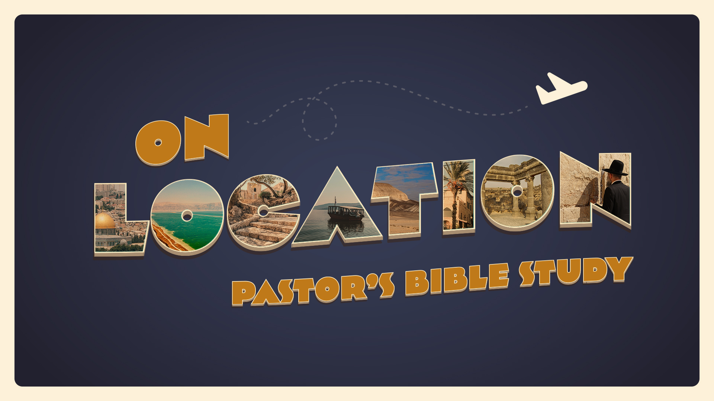

EPISODE 4
9/21-22 |  | Egypt (Joseph and Moses) |  | Genesis 46-50; Exodus 1-12
Genesis 15:13-14
¹³ Then the Lord said to Abram, “Know for certain that your offspring will be sojourners in a land that is not theirs and will be servants there, and they will be afflicted for four hundred years. ¹⁴ But I will bring judgment on the nation that they serve, and afterward they shall come out with great possessions.

What was the new name God gave to Jacob? (Genesis 32:28)

OPTIONAL-- Review the Story of Joseph in Egypt (Genesis 37-45)
- How did Joseph get to Egypt? (Genesis 37:23-28)

- What happened to him in the House of Potiphar? (Genesis Chapter 39)

- What were the dreams that Joseph interpreted for the Pharaoh’s? (Genesis 41:1-7))

- What did Joseph suggest that Pharaoh do? (Genesis 41:33-36)

- To what place of prominence did Pharaoh put Joseph? (Genesis 41:40-44)

- Whom did Joseph marry? (Genesis 41:45)

- Whom did Jacob send to Egypt to buy grain? (Genesis 42:1-2)

- What did Joseph reveal to the sons of Israel? (Genesis 45:1-4)

- What reason did Joseph give for why he had been sold into Egypt? (Genesis 45:7-8)

- When Pharaoh heard that Joseph’s brothers had come, what did he tell Joseph to do? (Genesis 45:16-20)

Genesis 46-50
- What did Israel do when he and his family arrived at Beer-Sheba? (Genesis 46:1)

- What did Israel take with him on his journey to Egypt? (Genesis 46:1)

- What did God say to Israel in verse three? (Genesis 46:3-4)

- After Jacob blessed Pharaoh, what did Pharaoh ask Jacob? (Genesis 47:8-10)

- Where did Joseph swear he would bury his father? (Genesis 47:30-31)

- Who adopted Manasseh and Ephraim as his own sons? (Genesis 48:5-6)

- When Israel asked Joseph who the boys were that were with him, what was Joseph’s answer? (Genesis 48:8-9)

- What three things did Israel do to Ephraim and Manasseh? (Genesis 48:9-10)

- Who did Israel praise for being able to see Ephraim and Manasseh? (Genesis 48:11)

- How did Jacob bless Ephraim and Manasseh? (Genesis 48:17-20)

- After Israel told Joseph he was going to die, what did he say God would do for Joseph? (Genesis 48:21)

Exodus 1-12
- The sons of Jacob entered Egypt with Jacob and whom? (Exodus 1:1)

- How many of Jacob’s descendants entered Egypt? (Exodus 1:5)

- What happened to Joseph and his brothers? (Exodus 1:6)

- What happened to the Israelites? (Exodus 1:7)

- With what was the land of Egypt filled? (Exodus 1:7)

- Who came to power in Egypt? (Exodus 1:8)

- What did he not know? (Exodus 1:8)

- What did the new king fear, according to this verse? (Exodus 1:10)

- Why were slave masters put over the Israelites? (Exodus 1:11)

- What did they build? (Exodus 1:11)

- What were Pithom and Rameses? (Exodus 1:11)

- How did the oppression affect the Israelites? (Exodus 1:12)

- How did Moses come to be saved and become Egyptian royalty? (Exodus 2:1-10)

- What does the name “Moses” mean? (Exodus 2:10)

- What name did God reveal to Moses from the burning bush?

- Under what name will God be remembered? (Exodus 3:15)

- With whom did Moses have a contest in Exodus Chapter 4?

- What was the purpose of this contest?

- What did Moses and Aaron ask Pharaoh to do? (Exodus 5:1)

- Who did Pharaoh not know and what would he not do? (Exodus 5:2)

- Why did they say the trip to the desert to worship was necessary? (Exodus 5:3)

- What were the first nine (9) plagues the Lord inflicted upon Egypt? (Exodus 7-10)

- What was the final plague? Exodus Chapter 12

- How long were the Israelites in Egypt? (Exodus 12:40)

