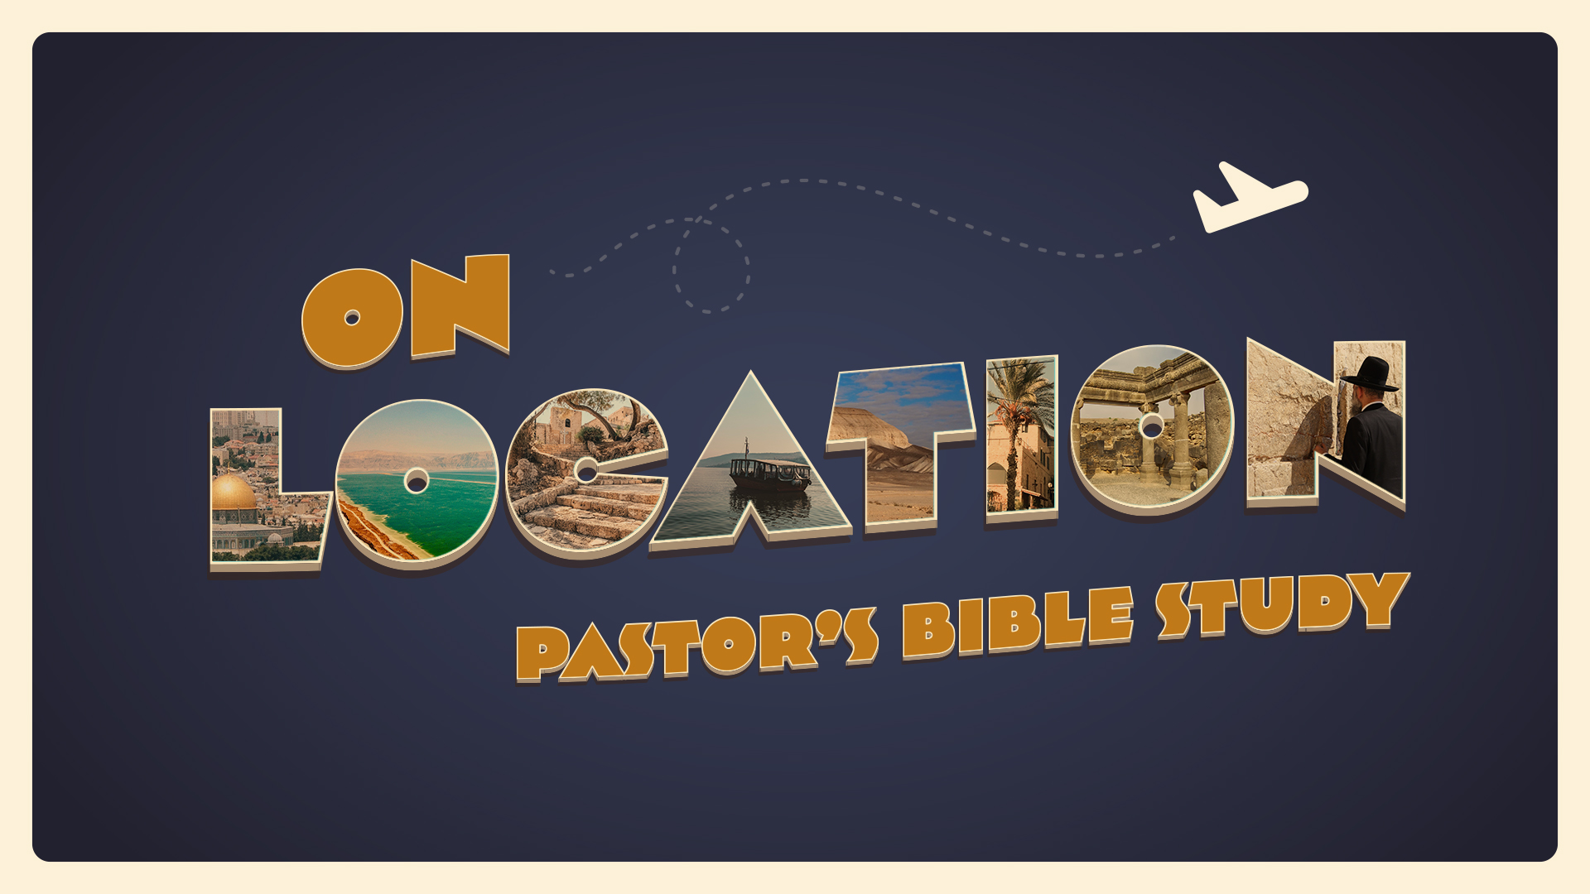

EPISODE 3

9/14-9/15 | Canaan: The promised land and the patriarchs | Genesis 14; Genesis 19; Genesis 25; 31:17-21; Genesis 36
- Have you ever moved, or been the “newcomer” in a community? How did you adjust?

- Have you ever had difficult neighbors?

- Have you ever had neighbors of a different religion, nationality or culture?

- Have you ever discovered that you have a cousin / sibling you did not know you have?

Genesis Chapter 14
- Where were the people at war when Lot was captured? (Genesis 14:1-11)

- Who was Melchizedek? (Genesis 14:18)

- What was Melchizedek’s blessing? (Genesis 14:19-20)

- In what New Testament book does Melchizedek play a prominent role (think of Spring 2022)?

- How does Abram’s meeting with the King of Sodom differ from his meeting with the King of Salem? (Genesis 14:1-20)

Genesis Chapter 19
- What two nations came from the descendants of Lot? (Genesis 19:37-38)

Genesis Chapter 25
- What was Abraham’s second wife’s name? (Genesis 25:1-4)

- Do any of the names of her sons sound familiar?

- Who inherited all of Abraham’s possessions? (Genesis 25:5-6)

- How many sons were born to Ishmael? (Genesis 25:12-16)

Genesis Chapter 31
- Did Jacob consult Leah and Rachel about leaving their father’s place? (Genesis 31:1)

- What did Rachel do while Jacob was loading to leave Laban’s house? (Genesis 31:20-22)

- How long did it take Laban to catch up with Jacob? (Genesis 31:23)

- What did God tell Laban in a dream? (Genesis 31:24)

- What was Laban’s regret about Jacob leaving in secret? (Genesis 31:26-29)

- What was Jacob’s answer to Laban about the theft of his idols? (Genesis 31:31-32)

- Why didn’t Laban find his images? (Genesis 31:33-35)

Genesis Chapter 36
- What were the names of Esau’s wives? (Genesis 36:2)

- Name Esau’s sons. (Genesis 36:4-5)

- Why did Esau leave Canaan? (Genesis 36:6-7)

- Can you name the generations of Esau in Mount Seir? (Genesis 36:10-30)

