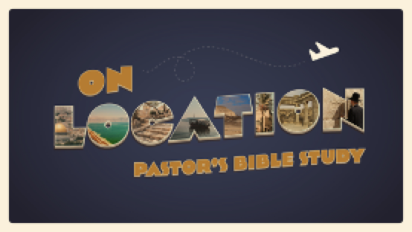

Episode 4: Egypt (Joseph and Moses)
9/21-22
Genesis 46-50; Exodus 1-12

¹² As the sun was going down, a deep sleep fell on Abram. And behold, dreadful and great darkness fell upon him. ¹³ Then the Lord said to Abram, “Know for certain that your offspring will be sojourners in a land that is not theirs and will be servants there, and they will be afflicted for four hundred years.”- Genesis 15:12-13

- THE GLORY OF THE NILE - THE CIVILIZATION OF ANCIENT EGYPT

- OLD BEFORE HISTORY (Reckoning Time in Egypt). Timeline by Dr. Mike Fanning
  - The Proto-Dynastic Period (3100-2600 B.C.)
  - The Old Kingdom Period (Dynasties I-VI, 2600-2100 B.C.) was a time of great strength and stability in Egypt, symbolized most noticeable in the fact that the great pyramids were constructed during this time as tombs for the pharaohs.
  - The First Intermediate Period (2100-2000 B.C.) was a period of great insecurity and change. This change in Egypt was primarily caused by the invasion and destruction of tribal groups called the Amorites.
  - The Middle Kingdom Period (Dynasties XI-XIV, 2000-1700 B.C.) witnessed the rise once again of great kings, strong rule, and stable government. It was the period when contact with ancient Palestine increased. In addition, this period roughly coincides with the wanderings of the Patriarchs described in the Old Testament.
  - The Second Intermediate Period (1700-1570 B.C.) was a time of insecurity and change once again, instigated by an outside force. The Hyksos, or "foreign rulers", dominated the scene for about 150 years, and many scholars believe that the historical situation in Egypt at that time fits well into the story of Joseph and his rise to power in Egypt. Perhaps Joseph was "second in command" to one of the Hyksos rulers during this period!
  - The New Kingdom Period (Dynasties XVIII-XX,1570-1100 B.C.) was ushered into existence with the defeat of the Hyksos by Ahmos, the founder of the 18th dynasty. Many scholars believe that the Exodus took place during the reign of the 19th Dynasty pharaoh, Ramses the Great, and recent archaeological evidence strengthens this possibility. In any event, the 18th to 20th dynasties in Egypt represent the greatest period of Egyptian power and prestige in her history.
  - The Late Period (1000-650 B.C.) was a period of decline, ultimately culminating in defeat of the Egyptians by the Persians.

- ORIENTATION TO CULTURE IN GENERAL
  - The Nile
  - Agriculture
  - Industry
  - Everyday Life in Old Egypt

- GOVERNMENT
  - The Pharaoh
    - Pero / Pharaoh = “Great House.”
    - The Supreme ruler. An active leader of the State.
  - Vizier and Bureaucracy
    - ³⁹ Then Pharaoh said to Joseph, “Since God has shown you all this, there is none so discerning and wise as you are. ⁴⁰ You shall be over my house, and all my people shall order themselves as you command. Only as regards the throne will I be greater than you.” ⁴¹ And Pharaoh said to Joseph, “See, I have set you over all the land of Egypt.” ⁴² Then Pharaoh took his signet ring from his hand and put it on Joseph’s hand, and clothed him in garments of fine linen and put a gold chain about his neck. (Ge 41:39–42).
  - Civil Order

- EGYPTIAN RELIGION
  - The Egyptian Pantheon (An example of the “Basic” gods of Egypt)
    - Re (Ra)- Sun
    - Osiris — Death, The Nile (Death and Rebirth)
    - Horus — Sun Also
    - Hathor — Mother, Goddess
    - Seth — Evil, Storms
    - Ptah — Artists and Craftsmen
    - Thoth — Wisdom and Knowledge
    - Bast — Cat (Guardian of the Dead)
    - Anubis — Jackal (Guardian of the Dead)
  - Egyptian Religion (Magic and Death)
- IKHNATON: THE HERETIC PHARAOH
  - Reformer
  - Monotheist (Aton — Re)
  - “O sole god, whose powers no other possesseth. Thou didst create the earth according to thy heart”—Ikhnaton

- EGYPT AND THE BIBLE: From Eisodus to Exodus
  - Joseph Into Egypt— Clues to History: In addition to being a powerful story in its own right, the story of Joseph is an important “back story” for the Exodus. It explains how the people of Israel (the descendants of Abraham, Isaac and Jacob / Israel came to be in Egypt in the first place).
  - The Hyksos (1600-1500’s B.C.)
  - The New Kingdom and Slavery
  - The Egyptian 18th dynasty overthrew the Hyksos rulers around 1500 B.C.
  - ⁸ Now there arose a new king over Egypt, who did not know Joseph. ⁹ And he said to his people, “Behold, the people of Israel are too many and too mighty for us. ¹⁰ Come, let us deal shrewdly with them, lest they multiply, and, if war breaks out, they join our enemies and fight against us and escape from the land.”(Exodus 1:8-10)
  - The Exodus: The False God meets the Real God (² But Pharaoh said, “Who is the Lord, that I should obey his voice and let Israel go? I do not know the Lord, and moreover, I will not let Israel go.” Ex 5:2)
  - The Plagues (See Handout)

- EGYPT AND THE STORY OF GOD’S PEOPLE

