Episode 5: Biblical Covenants vs. Hittite Treaty Format
9/28-29

3 Moses came and told the people all the words of the LORD and all the rules. And all the people answered with one voice and said, “All the words that the LORD has spoken we will do.” 4 And Moses wrote down all the words of the LORD. He rose early in the morning and built an altar at the foot of the mountain, and twelve pillars, according to the twelve tribes of Israel. 5 And he sent young men of the people of Israel, who offered burnt offerings and sacrificed peace offerings of oxen to the LORD. 6 And Moses took half of the blood and put it in basins, and half of the blood he threw against the altar. 7 Then he took the Book of the Covenant and read it in the hearing of the people. And they said, “All that the LORD has spoken we will do, and we will be obedient.” 8 And Moses took the blood and threw it on the people and said, “Behold the blood of the covenant that the LORD has made with you in accordance with all these words.”— Exodus 24:3-8

- The Covenantal Structure of the Bible

In the Reformed tradition covenant is generally seen as the central unifying concept of Scripture. Others do not go quite so far, but virtually all Reformed theologians agree that a grasp of covenant is vital to an understanding of Scripture and God’s interactions with mankind, Israel, and the church.

Considering the story of the Bible from a wide angle perspective, the central, organizing theme in the Bible of the kingdom of God can be seen as traceable by the series of covenants by which the Lord administers his kingdom.

Nature of OT covenants:
A covenant as a solemn promise made binding by an oath, which may be either a verbal formula or a symbolic action. Such an action or formula is recognized by both parties as the formal act which binds the actor to fulfill his promise.

Formalization of covenants:
Various conventions (a sacrifice, a ritual meal, or the sharing of salt) may be utilized in the cutting of various kinds of covenant. Covenants were often solemnized by sacrificial rituals, which served to portray the fate of an unfaithful taker of a covenant oath.

There was a phrase we hear from time to time in Israelite literature — “to cut a covenant, ‘karath berith.” This could refer to the cutting of its stipulations in stone, or the cutting of its sign in the flesh, but it meant that the covenant was inaugurated and valid. Although such sacrifices were often used to express the cutting of a covenant, an oath is at least sometimes sufficient without a ritual.

Self-malediction and covenant:
Self-malediction is equivalent to saying, “May I die if I fail to fulfill my oath.” The covenant-cutting ritual of Genesis 15:9–12 is viewed by many as implying such an oath by God.

- Ancient Near East Covenants

As a brief review of key ideas regarding Ancient Near East (ANE) covenant we will highlight similarities between Deuteronomy and Hittite suzerainty covenants. In such covenants, one party (a god, an individual, or a group) obligates himself to perform certain actions for another party. Many but not all acknowledge that such covenants can be formally unilateral or bilateral (having one or two actively covenanting parties, respectively), and virtually all agree that they may contain regulations and conditional penalties.

Our focus here is on second-millennium suzerainty covenants because these were well established in the patriarchal era. The standard terminology “suzerain” for the superior party and “vassal” for the inferior party, whether it is an individual or a group of persons.

Does comparing the biblical covenants with the ANE suzerain-vassal treaty form imply that the Bible borrowed from pagan ideas?

In response to this objection, we ought to appeal to the Reformed doctrine of God's providential control of history, particularly the political history of the ancient near eastern peoples. God sovereignly arranged the situation so that the peoples around Israel would be using this format for their political treaties at that time, in order to provide the necessary conceptual framework for Israel to understand her vassal relationship with Yahweh, the Great King.

Obviously, the pagan conception is mixed with erroneous theology. But God took the basic format, cleansed it of the pagan errors, and used it to teach Israel about her relationship with God. In other words, God’s covenant with Israel “providentially coincided" with the political treaties of the ancient near east, thus making the treaty form available, “needing only to be taken up and inspired by the breath of God.”

Here it should be noted that the Old Testament covenant form is a distinctive one that occurs in the Old Testament alone. However, it bears some resemblance both to the form of ancient Near Eastern 'law codes' and that of ancient Near Eastern treaties.

In addition to the concept of providence, there is also the important theological consideration that fallen man retains the image of God by common grace. The very institution of human kingship in the ancient world was a pale reflection of the glory of God the King.

The unquestioned authority of ancient near eastern kings, the ability of their law-word to define reality by decree, their absolute power over all their subjects, etc. – these were all mixed with sin, abuse of authority, tyranny, and so on, but they nevertheless reflected something true about God's own authority. That reflection was distorted by sin, but it was not a totally false reflection, since God restrains man's sin by common grace and preserves some sparks of truth and some conception of deity.

Thus, it is not surprising that these pagan kings would employ a covenantal treaty form as the means of exercising their authority. The treaty was not negotiated with the vassal but sovereignly imposed. The sanctions were enforced by the gods in whose name the treaty was sworn. The obedience of the vassal was expected unconditionally. The treaty form highlights the sovereignty of the king over his subjects, thus reflecting the vestiges of some awareness of the covenantal sovereignty of God over his creatures.

Study of the covenant traditions in the Old Testament was given a new impetus by the study of Hittite vassal treaties. Circa 1906, a motherlode of tablets was discovered which showed that the Hittite treaties were strikingly similar to the Deuteronomic covenant format. That is to say, the Sinai covenant seems to have been similar in form to the ancient Near Eastern vassal treaties of the fourteenth and thirteenth centuries BC. And thus, the covenantal structure represented in the Bible was influenced by ancient international diplomacy treaties (esp. early Hittite treaties as opposed to late Assyrian/neo-Assyrian treaties), and we should use this as the basis for understanding our doctrine of covenant.

In the Old Testament this pattern is clearest in the structure of the book of Deuteronomy. The Hittite treaty format especially lends light for understanding Deuteronomy and serves as a lynchpin to understand covenant throughout the Bible. The pattern of these treaties is:

1. Preamble, introducing the sovereign.
2. Historical prologue outlining previous relations of the parties.
3. Stipulations: (a) basic, (b) detailed.
4. Document clause, providing for the deposition of a copy of the covenant in the
vassal’s sanctuary, and its periodic reading.
5. Witnesses, a long list of gods invoked to witness the covenant.
6. Curses and blessings.

What I wish to call attention to specifically is how parallels have been proposed between biblical covenants and two types of ancient Near Eastern texts: Suzerain-Vassal Treaties and Royal Land Grants.

- In a word, Suzerain-Vassal Treaties were formally ratified international arrangements between greater kings and lesser kings in the ancient Near East.

- Royal Land Grants were legal declarations in which kings granted properties, usually to priests and other high-ranking officials, as rewards for faithful service.

It is widely held among scholars that the covenant with Moses should be closely associated with Suzerain-Vassal Treaties and that the covenants with Abraham and David should be closely associated with Royal Land Grants. These associations provide important frames of reference out of which they describe the dynamics of these biblical covenants.

- Suzerain-Vassal Treaties

Let us look at the similarities between the Mosaic covenant and Suzerain-Vassal Treaties. Broadly speaking, these treaties were bi-lateral, at least implicitly obligating both Suzerains and vassals to observe their respective duties. They stipulated that loyalty from the vassal would result in further benevolences and that disloyalty would result in a variety of punishments, usually from the gods.

Correspondingly, the Mosaic covenant has been characterized as a bi-lateral, conditional or obligatory covenant. It stipulated that after Sinai Israel's loyalty would result in divine blessings and that Israel's disloyalty would result in divine curses. There can be little doubt that these outlooks are fundamentally correct.

B. Royal Land Grants

In the second place, Royal Land Grants of the ancient Near East have been viewed as unconditional or promissory declarations. In line with this analysis, a number of reformed theologians have argued that the divine covenants with Abraham and David reflected these qualities as well.

In this view, in covenant with Abraham, God himself fully guaranteed future fulfillment of the blessings promised in this covenant. Similarly, the blessings of the Davidic covenant were also secured by an unconditional covenant that reflected Royal Land Grants. In this sense, the Mosaic covenant was an interlude, a covenant of obligation situated between the unconditional covenants of promise in Abraham and David.

- The Hittites

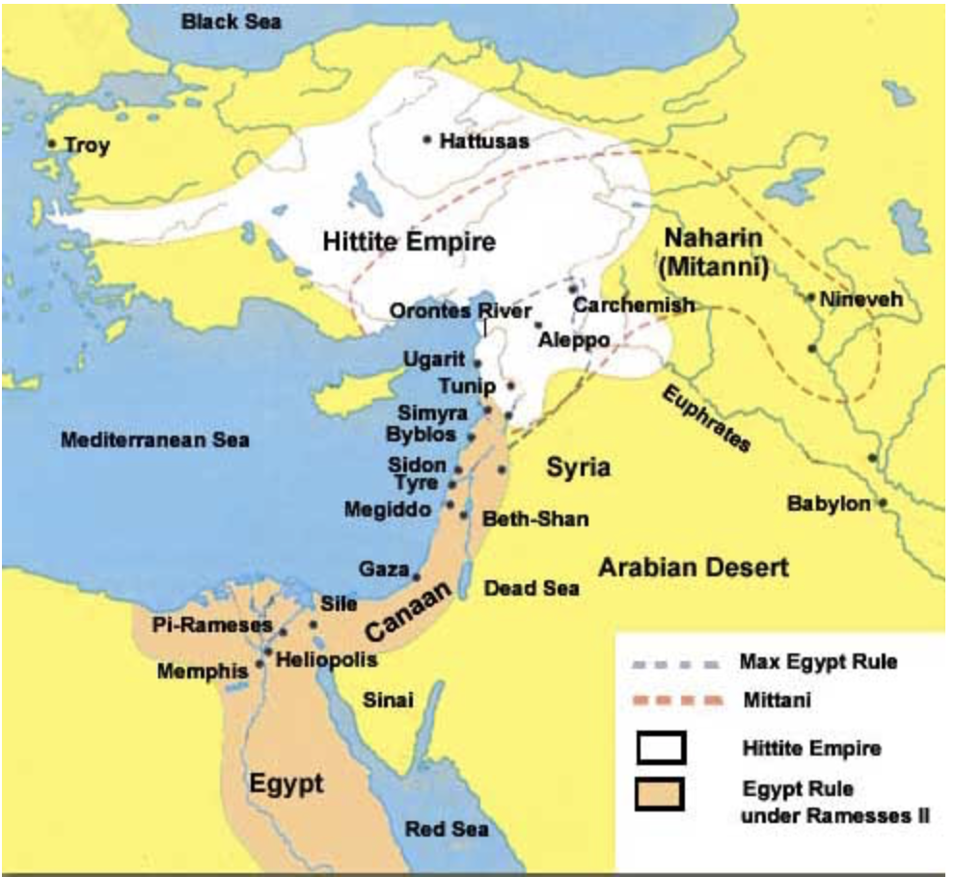

What race were the Hittites in the Bible?

The Hittites were an ancient group of Indo-Europeans who moved into Asia Minor and formed an empire at Hattusa in Anatolia (modern Turkey) around 1600 BCE.

The Hittites are mentioned more than 50 times in the Bible. They were descended from Heth, the son of Canaan (and great-grandson of Noah, Genesis 10:15). They ruled the area of Syria and eastern Turkey and battled with Egypt and Babylon for territory.

Genesis 15:18-20 tells us that the land of the Hittites was part of the promised land for the Israelites, as does Joshua 1:1-4, which includes their territory as a great part of the Promised Land for Israel.

Abraham was well acquainted with the Hittites, and he bought the burial cave for Sarah from them in Genesis 23:1-20. Esau took wives from among the Hittites (Genesis 26:34-35; 27:46).

According to Judges 1:18-26, when the Israelites captured Bethel, they allowed one man to escape, and he went to the "land of the Hittites" where he founded the settlement of Luz.

Furthermore, Uriah the Hittite was one of David’s mighty men (2 Samuel 11:3). Uriah joined Israel’s army and became one of David’s elite soldiers. He was very faithful in his duties, to God, the king, his army commander and to Israel at large. In 2 Samuel 11, we read the story of how King David committed adultery with Uriah’s wife Bathsheba and later had him killed in battle as a cover-up when Bathsheba became pregnant.

In King Solomon's era the Hittites are depicted in the Old Testament along with Syria as among his powerful neighbors. The Hittites are mentioned throughout the kingdom years and even after the Jews’ return from captivity (Ezra 9:1).

It is assumed that the Hittites were eventually absorbed into the surrounding cultures and lost their distinctive identity.

2. What did the Hittites invent?

Credit is given to the Hittites who, by most accounts, were the first to make iron into weapons and armor, ushering in the Iron Age, which was a period dominated by the use of iron.

3. Did the Hittites worship Baal?

The religion of the Hittites was a pluralistic worship of nature. They believed in various gods over the elements of earth, sky, weather, etc., and these gods were often listed as witnesses on treaties and oaths. As in most other pagan societies, this nature worship led to despicable practices which brought the wrath of the true God on them. When God delivered Canaan to the Israelites, one of the given reasons for destroying the inhabitants was to eliminate the pagan practices which would ensnare God’s people (Exodus 23:28-33). God didn’t want His people following the idolatry of the Hittites.

The deity opposed by the biblical prophets as "Baal" was usually a version of Baal-Hadad, the major deity of the Hittites, Syrians, and Assyrians. Baal-worship extended from the Canaanites to the Phoenicians.

- Examples of Covenants in the Bible

Abrahamic Covenant

The covenant in Genesis 15 may be described as follows:

- Parties: the suzerain is God; the vassal group is Abraham and his heirs
- Laterality: unilateral with God as the only active party
- Covenant obligations of God: (1) the land promises, (2) the seed promises,
and (3) the blessing promises
- Covenant obligations of Abraham: none

The symbolic significance of the "smoking firepot with a blazing torch" that passed through the midst of the carnage in Genesis 15:17 also receives no explanation in the text. Once again, modern readers are often confused as to its significance, but apparently Moses felt no explanation was needed because of the immediate association it brought to the minds of the Israelites who received his account. It reminded them of the appearance of God in the form of the "pillar of fire and cloud" leading them toward the promised land (Exodus 13:21-22; 14:19, 24; 33:9-10; Numbers 14:14). Most early competent readers would have made this association and realized that it was God who walked among the carnage, taking the threat of curse upon himself.

On the one side, God made promises in the covenant with Abraham that will certainly be fulfilled. God swore to fulfill them and he cannot fail to bring them about without violating his oath. What were these promises? In Genesis 15:16 and 18 God promised that Abraham's descendants would come out of slavery and possess the land of Canaan. This promise could not be broken. It was unconditional. As the rest of the OT indicates, Abraham's descendants did in fact receive this promise. They successfully inherited the land and established a great nation there.

God swore to keep this promise because it was a necessary step in his larger kingdom purposes. God chose the family of Abraham to be the instrument through which his original purposes for humanity would be fulfilled. As God commanded Adam and Eve to be fruitful, to fill the earth, to subdue it and to rule (Genesis 1:28), Abraham was promised that his progeny would possess the land of Canaan as the beginning point of successful worldwide dominion (Romans 4:13). The Abrahamic covenant established an unfailing direction for God's imperial plan. In this sense, the Abrahamic covenant was unconditional.

On the other side, however, participation in and reception of Abraham's promised blessings was quite conditional. Despite the fact that God promised Abraham's descendants the land, this promise did not guarantee this promise for particular individuals, families or groups.

In sum, there were senses in which the covenant with Abraham was both unconditional and conditional. Abraham was promised by divine oath that in one way or another his descendants would come out of Egypt and possess the land of Canaan. But at the same time, for particular individuals, families and groups to enjoy this promise, they had to fulfill covenant obligations.

Mosaic Covenant

3 Moses came and told the people all the words of the LORD and all the rules. And all the people answered with one voice and said, “All the words that the LORD has spoken we will do.” 4 And Moses wrote down all the words of the LORD. He rose early in the morning and built an altar at the foot of the mountain, and twelve pillars, according to the twelve tribes of Israel. 5 And he sent young men of the people of Israel, who offered burnt offerings and sacrificed peace offerings of oxen to the LORD. 6 And Moses took half of the blood and put it in basins, and half of the blood he threw against the altar. 7 Then he took the Book of the Covenant and read it in the hearing of the people. And they said, “All that the LORD has spoken we will do, and we will be obedient.” 8 And Moses took the blood and threw it on the people and said, “Behold the blood of the covenant that the LORD has made with you in accordance with all these words.”— Exodus 24:3-8

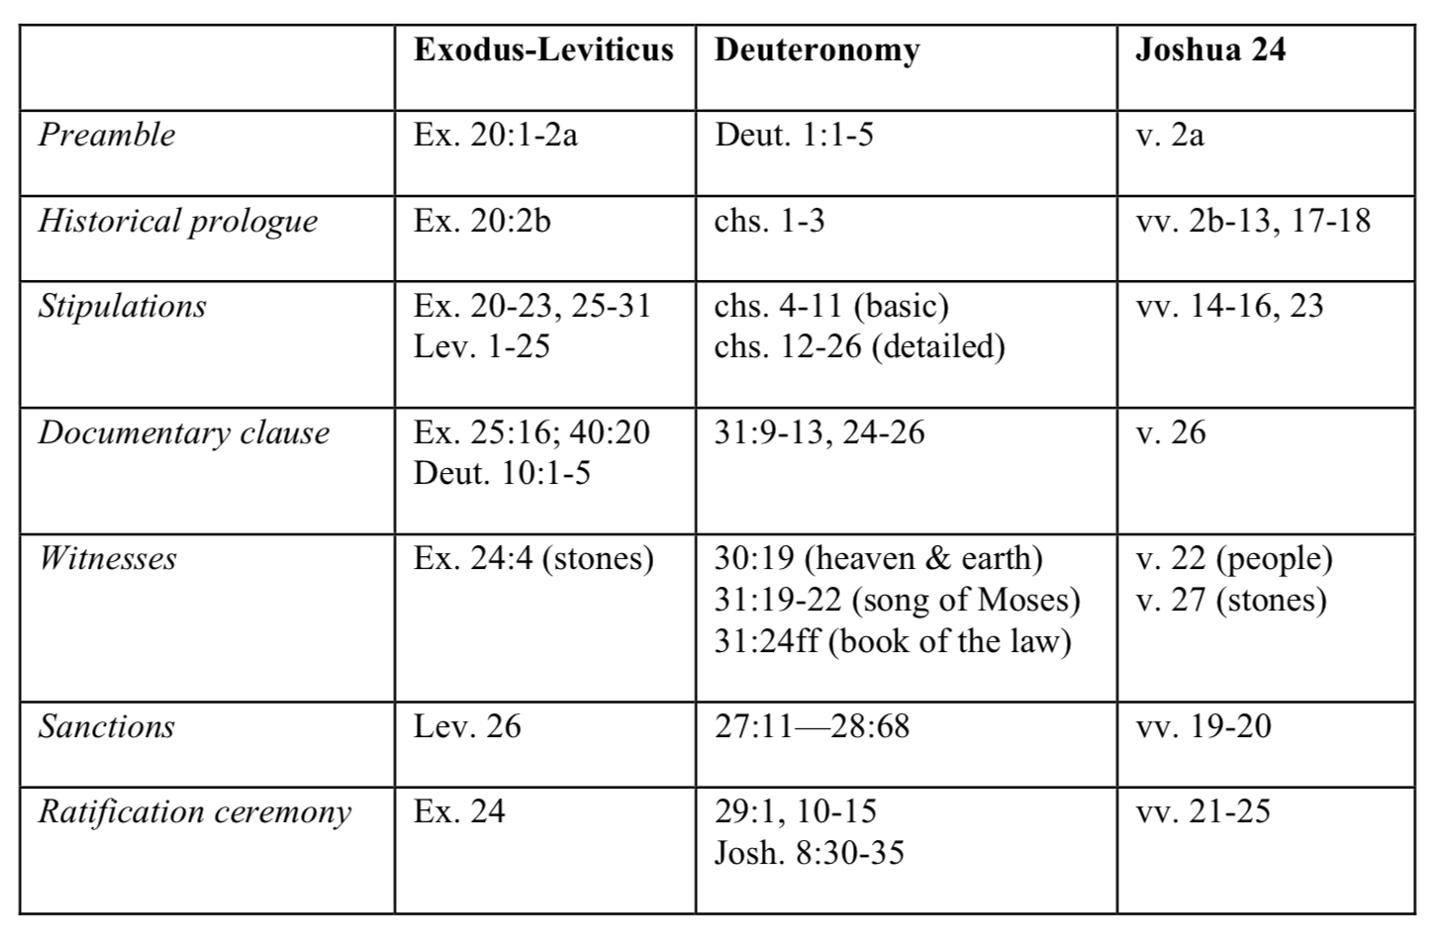

Davidic Covenant

In many respects what we have seen about the covenant with Abraham also characterized God's covenant with David. There are four main texts that are normally in view when discussing the Davidic covenant: 2 Sam 7:1-29, 1 Chronicles 17:1-27, Psalm 89 and Psalm 132. Of these four passages only the last two actually use the term "covenant." Yet, there is warrant for focusing on all of these passages as so many interpreters have done through the centuries.

The eventual success of the Davidic dynasty was a thoroughly unconditional dimension of the covenant with David reaching back to the covenant with Abraham. Although the Scriptures indicate that this promise was fulfilled by Christ in ways that were not expected by Old Testament believers, it was unconditionally secured by divine oath to David and simply could not fail.

In the second place, it is also clear that the covenant with David entailed conditions. With the exception of 1 Chronicles 17:1-27, the main biblical passages dealing with David's covenant emphasize that he and his royal descendants faced the possibility of severe curses from God if they failed to be faithful to Yahweh. David himself declared his faithfulness to God as the grounds of his assurance of full participation in his family's future (2 Samuel 23:5). 2 Samuel 7:14 indicates that Solomon would be severely punished for his sins and Psalms 89 and 132 extend this conditionality to every son of David.

In effect, as with the Abrahamic covenant, the certainty of eventual outcomes for the kingdom of God rested on the unconditional dimension of David's covenant. Yet, this certain hope did not imply that every royal figure in David's family would enjoy the blessing of God. On the contrary, only those who were faithful to covenant could expect to participate in the blessings promised to David's house.

To characterize David's covenant as entirely unconditional is to mischaracterize it. It was unconditional in its dynastic guarantees, but conditional in its requirements for David and his sons.

To reinforce what we have seen at this point, we should mention that the language of conditionality is the same in all three covenants God made with Israel. As we have already seen, in Genesis 17:9 God told Abraham and his descendants to "keep my covenant" by observing circumcision. This expression also appears in the Mosaic covenant when God says to Israel in Exodus 19:5 "and you must keep my covenant.” In the same way, in Psalm 132:11 the Davidic line is also required to "keep my covenant." This shared language makes it clear that the fundamental dynamics of all three covenants are the same. God will keep the promises he made in each covenant, but participation in those blessings for individuals, families and groups among God's people is conditional upon their keeping covenant.

The old covenant certainly had elements of grace and promise as well. However, and this is the crucial point, because the stipulations and promises and sanctions are in various regards different between the various old covenants and the new one, it is clear enough the new covenant is not simply a renewal of any of the old covenants. Paul does inform us that the new covenant involves the fulfillment of the promises made to Abraham through Christ, but this is a different matter. God has chosen to carry over certain promises into the new covenant and have them fulfilled by and through Christ.

Genesis 17 — Reaffirmation of the Abrahamic Covenant

The covenant in Genesis 17 is considered not as a re-doing of the covenant in Genesis 15, as if that covenant was nullified, but as a reaffirmation of the covenant in Genesis be 15. In Genesis 17:13-14, we see an unmistakable allusion to being cut off if the covenant is broken.

There was often as well a covenant sign, and the sign itself usually was the sign of the oath curse, a reminder of what would happen if the covenant was not kept. For example, circumcision was a sign of the warning-- 'if you do not keep the covenant I will cut you and your descendants off'. What more graphic reminder of having yourself and your descendants cut off than the circumcision of the organ of generation, from which descendants come?

Why is this symbol of circumcision included into the covenant community?

It’s a covenant sign signifying and dramatizing what will happen if you break the covenant with God — not just of being cut off yourself but your descendants too (male organ is involved).

The sign of circumcision in the NT points to Christ who is circumcised for us, a cutting off that Christ underwent for that of his people. For apart from Christ there is death and there is also the promise of the Cross entails that the redemptive judgment undergone by Christ has been fulfilled, cf. Col 2:11.

In the NT we hear language about Christ's death being both like a circumcision, a cutting off, and like a baptism, a symbol of drowning by water ordeal (also a curse sanction), and further more Christian baptism is associated not primarily with repentance, but rather as Romans 6 makes clear with death and burial--- of the old person. The reason for this is clear enough-- the covenant sign symbolizes the curse sanction.

When a new covenant is inaugurated, a suzerain may choose to carry over some of the promises and stipulations and sanctions into the new covenant, as well as adding to them new promises, stipulations, and sanctions. One of the reasons Christians get confused about the relationship of the old and new covenant is that they both have some of the same rules and regulations and features. This is hardly surprising since God, who makes these covenants, has not changed in character.

But it needs to be stressed, that only those commandments given as a part of the new covenant are binding on Christians. Thus for instance, Christians are not obligated to keep the sabbath, food laws, and a host of other stipulations we find in Leviticus. On the other hand, Christians are obligated to love their enemies, turn the other cheek, and leave retaliation or vengeance entirely in the hands of God. This is a striking difference between the old and new covenants. The reason why Christians keep the commandment — ‘No adultery’ is because Jesus stipulated it was part of his law for his disciples. Not because it is part of the ten commandments. In fact Jesus basically reaffirmed most of the ten commandments, but not the sabbath commandment.

Thus, in the death of Christ God enacted the the curse sanctions of the Mosaic covenant on Jesus. And here is the crucial point---once the curse sanction has been enacted, the covenant is over and done with. It is abolished and finished. It is fulfilled and done away with. It becomes obsolete. This is made perfectly clear in the NT at various junctures.

What is especially amazing about the death of Jesus from the perspective of covenantal theology is three things:

- His sacrifice for sins is 'once for all', not only once for all time, but a ransom once for all persons (see e.g. 1 Tim. 2.6). Previous sacrifices only had a temporal and temporary benefit, and did not cover sins committed with a 'high hand' for which there was no forgiveness under OT Law. This is not true of the new covenant cut by Christ.

- Christ's death exhausted God's righteous anger against sin committed under the old covenant, and indeed his general wrath against sin even of non-covenantal peoples. In other words, the curse sanction was exhausted on him, and so the OT covenant ended on the cross, in Christ's sacrifice.

- Equally amazing is the fact that the inaugurating sacrifice for the new covenant was this same death of Christ. It served a dual purpose of ending the old covenant and beginning the new one, in the same act. It thus is the ultimate place where we see the convergence on God's justice and mercy, his holiness and his grace, in a single act.

- A Dummies’ Guide to Biblical Covenants

What is a covenant?

A legal instrument established by an oath and defined by specific commitments. Any proposed definition of covenant must be broad enough to incorporate all the various types of (divine) covenants in Scripture. Divinely sanctioned commitment best covers the data.

What is the Hebrew word for "covenant"?

The primary Hebrew word for "covenant" is berith. It is a binding legal arrangement. This is suggested by the numerous statements about keeping and remembering the covenant, or being false to it and transgressing it.

What is a synonym for “covenant"?

"Oath" or "curse". The use of this synonym demonstrates that covenants are binding, oath-bound commitments. E.g.: Moses said to Israel assembled on the plains of Moab: You stand here "to enter into the covenant of Yahweh your God and into his oath which Yahweh your God is making with you this day" (Deut 29:12).

How does taking an oath or curse function in a covenant?

It is the ritual performed when ratifying a covenant. The typical covenant ratification ritual involved slaying and cutting up animals to symbolize the curse that would befall the breaker of the oath. As a result, "to cut a covenant" became the usual phrase for making a covenant (Genesis 15:18; Psalm 50:5). The ritual of animal dismemberment, the language of cutting a covenant, and the association with an oath-curse, are features found in political ANE treaties.

What are the two types of covenants?

Covenants of works, and covenants of grace. The divine sanctioning of a covenant of grace occurs when God himself takes the oath and thus commits himself to do something for man. In a covenant of works, divine sanctioning is present because God serves as the divine witness of the human oath in which man commits himself to God.

What is the litmus test for distinguishing the two types of covenants?

The identity of the party who takes the ratification oath: (1) If the covenant is ratified by a human oath, the arrangement is informed by the works principle. When humans take the oath, they are committing themselves to perform the obligations imposed by his Lord. E.g., Israel's oath in Exodus 24:3, 7. (2) If the covenant is ratified by divine oath alone, it is a covenant of grace (either saving grace or common grace). In some covenants there is both a human and a divine oath. In these cases the divine oath is God's commitment to enforce the sanctions appropriately, rewarding obedience with the promised blessing and recompensing disobedience with the threatened curse. (E.g., Deut. 29:12). These would fit under (1) above, as covenants of works. For a covenant to be a covenant of grace, it must be ratified by divine oath alone.

