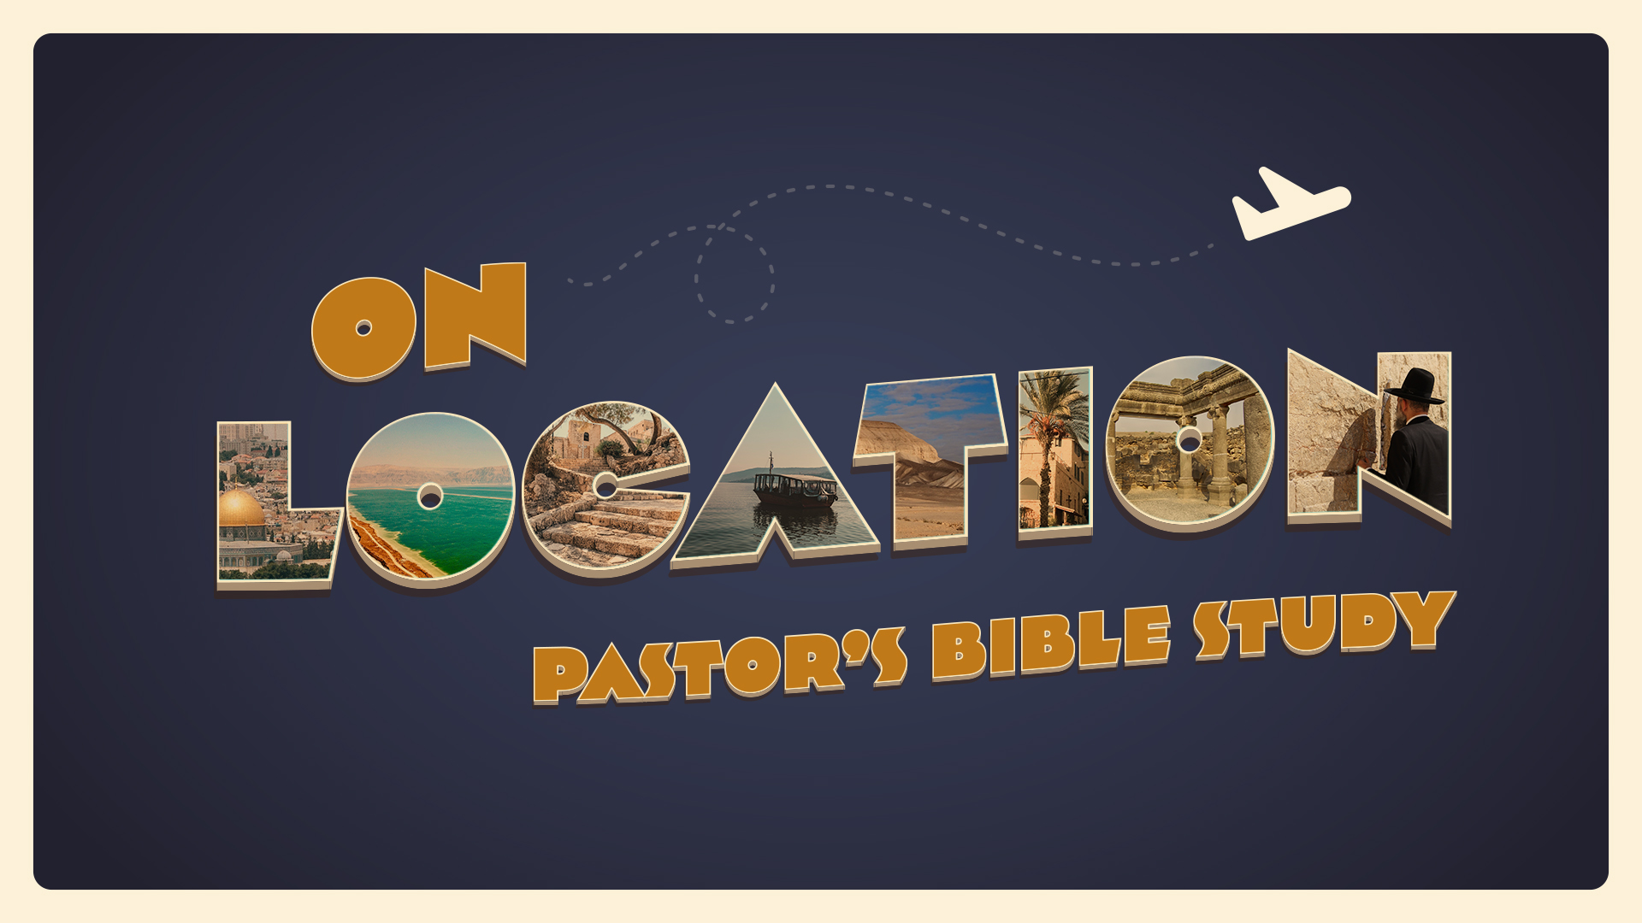

EPISODE 3: Canaan: The Promised Land and the Patriarchs
9/14-9/15

Genesis 14; Genesis 19; Genesis 25; 31:17-21; Genesis 36

⁴ So Abram went, as the Lord had told him, and Lot went with him. Abram was seventy-five years old when he departed from Haran. ⁵ And Abram took Sarai his wife, and Lot his brother’s son, and all their possessions that they had gathered, and the people that they had acquired in Haran, and they set out to go to the land of Canaan. When they came to the land of Canaan, ⁶ Abram passed through the land to the place at Shechem, to the oak of Moreh. At that time the Canaanites were in the land.
-Genesis 12:4–6
- THE LAND OF CANAAN
  - Canaan in the World (c. 2091 B.C.)
    - The “Land of Purple.”
    - The Alphabet and Bible.
    - A crossroads of trade and a land between empires.
  - This was the land of the Children of Ham. -- ⁶ The sons of Ham: Cush, Egypt, Put, and Canaan. (Ge 10:6).
  - But it was also “The Promised Land.” “To your offspring I give this land, from the river of Egypt to the great river, the river Euphrates, 19 the land of the Kenites, the Kenizzites, the Kadmonites, 20 the Hittites, the Perizzites, the Rephaim, 21 the Amorites, the Canaanites, the Girgashites and the Jebusites.” (Genesis 15:18–21)

- LIFE IN CANAAN
  - THE SOURCE by James Michener
  - Makor—a fictional village of Galilee
  - Life in a Village
  - The account of Sinuhe
    - An Egyptian fugitive in North Palestine.
    - Werner Keller: “the Egyptian had written a factual account of Canaan at about the time that Abraham migrated there.”

- THE GODS OF CANAAN
  - The Old God—El. The general term for “deity” in Semitic languages as well as the name of the chief deity of the West Semites. Although a venerable deity, he was not active in the myths, which primarily concerned his daughters and sons.
    - He was usually portrayed as an old man with a long beard and, often, two wings. He was the equivalent of the Hurrian god Kumarbi and the Greek god Cronus.
    - But— In the Old Testament, “El” is commonly used as a synonym for Yahweh and less commonly as the general term for “deity.”
  - The Young Gods
    - Baal
      - A deity worshipped in many ancient Middle Eastern communities, especially among the Canaanites, who considered him a fertility deity, a storm (rain, thunder and lightning) deity, and one of the most important gods in the pantheon.
      - Baal was also worshipped by various communities as a local god.
    - Melak
      - Melek, Moloch, also spelled Molech, a Canaanite deity associated in biblical sources with the practice of child sacrifice.
      - A newer, imported god from the Hittites.
      - Moloch / Melek was at times illegitimately given a place in Israel’s worship as a result of the syncretistic policies of certain apostate kings. Ahaz (2 Kings 16:3) and Manasseh (2 Kings 21:6).
    - Astarte (Astarte/ Ishtar)
      - Canaanite and Mesopotamian goddess of fertility, sex, motherhood. Consort of the supreme god.
      - The word “Asherah” in the Old Testament was used not only in reference to the goddess herself but also to a wooden cult object associated with her worship.
  - Little gods (Household and Everyday gods)
    - Jacob's wife Rachel stole the “images” of her father Laban (Genesis 31:17–24).
    - Laban moved heaven and earth to get these “images” back. The Nuzi tablets tell us why. The person who was in possession of these “household gods” (idols) had the rights to the inheritance.

- ABRAHAM’S WAR
- Genesis 14.
- The Bible’s account is absolutely consistent with Canaan of this period.

- ABRAHAM AND HIS DESCENDANTS
  - The Line of Isaac and Jacob (Israel).
  - The Line of Ishmael (Genesis 25:12–18).
  - The Children of Keturah (Genesis 25:1–6).
  - The Children of Esau (Ge 36:1–5). Genesis 35:8 “So Esau settled in the hill country of Seir. (Esau is Edom.)”
- THE COUSINS: THE CHILDREN OF LOT. Moabites and Ammonites
  - The destruction of Sodom and Gomorrah: Genesis 19:24–26.
  - Genesis 19:37–38 (ESV): ³⁷ The firstborn bore a son and called his name Moab. He is the father of the Moabites to this day. ³⁸ The younger also bore a son and called his name Ben-ammi. He is the father of the Ammonites to this day.

- THE GOSPEL IN CANAAN—THE PRIEST OF THE “GOD MOST HIGH”
  - ¹⁸And Melchizedek king of Salem brought out bread and wine. (He was priest of God Most High.) ¹⁹And he blessed him and said, “Blessed be Abram by God Most High, Possessor of heaven and earth; ²⁰and blessed be God Most High, who has delivered your enemies into your hand!”(Genesis 14:18-20).
  - Melchizedek is only mentioned in two other books of the Bible: Psalms (110:4) and Hebrews (5:6, 6:20, 7:1).
  - Calvin says that in Melchizedek, “the kingdom and priesthood of Christ was shadowed forth.”
  - The bottom line is this: The LORD was preparing the way.

