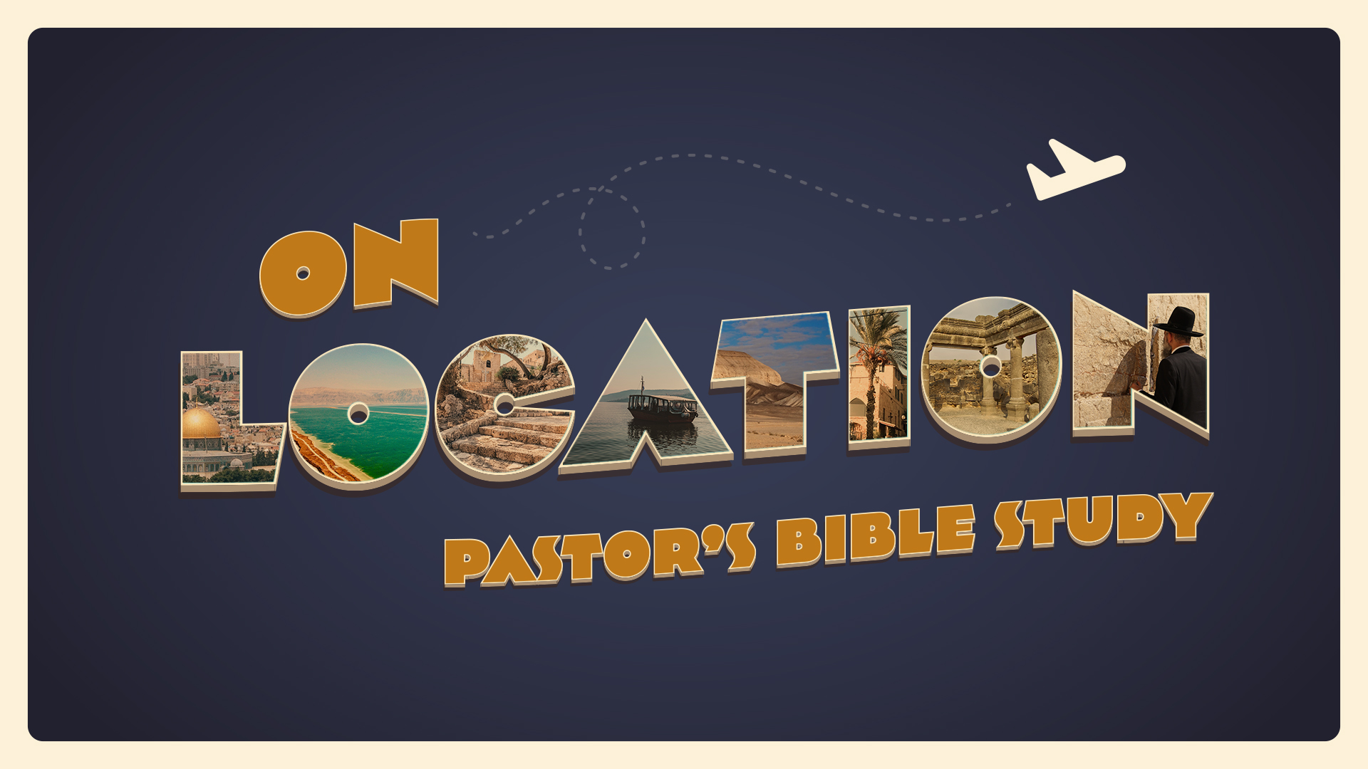

EPISODE 2: Mesopotamia (The World of Abraham)
9/7-9/8
Genesis 10-11 (12)

- ABRAHAM AND HIS FAMILY (2166-1991 BC/ 2000-1825 BC)
  - The Abraham Problem. Who was Abraham? Where did He come from? Who were his people?
    - ³¹ Terah took Abram his son and Lot the son of Haran, his grandson, and Sarai his daughter-in-law, his son Abram’s wife, and they went forth together from Ur of the Chaldeans to go into the land of Canaan, but when they came to Haran, they settled there. (Ge 11:31–32).
  - The Line of Shem
    - 21 To Shem also, the father of all the children of Eber (Hebrew?) (Ge 10:21–31). Wheaton, IL: Crossway Bibles.
    - 10 These are the generations of Shem. When Shem was 100 years old, he fathered Arpachshad two years after the flood. …(Ge 11:10–26). Wheaton, IL: Crossway Bibles.
    - The line of Shem is the Messianic line.
    - Terah’s was a family of Semites (Shemites), long settled at Ur, now “the land of his kindred.”

- ABRAHAM AND HIS NEIGHBORS: SUMERIANS AND AKKADIANS
  - Sumerian Civilization (Identified c. 3500 BC) — The origins of almost everything.
    - “Sumerian civilization may be summed up in this contrast between crude pottery and consummate jewelry; it was a synthesis of rough beginnings and occasional but brilliant mastery.—William Durant, The Story of Civilization
    - Writing.
      - Oldest inscriptions are on stone, and date apparently as far back as 3600 B.C.54 Towards 3200 B.C. the clay tablet appears.
      - Cuneiform.
  - Sargon I and The Akkadians (Sumerians?).c. 2334–2279 BC
    - Sargon I (the Great), was the first ruler of the Akkadian Empire, known for his conquests of the Sumerian city-states in the 24th to 23rd centuries BC.
    - First “emperor” of the world’s first “empire.”
    - “Origin Story” Similar to Moses.
    - He called himself “King of Universal Dominion.”
  - Ur of the Chaldees (3500 BC-700 BC)
    - Sumerian city that played an active role in the 3d millennium and in the beginning of the 2d millennium BC. After Babylon, it is without a doubt the best known Mesopotamian site in the Bible because it is mentioned in connection with Abraham.
    - Its modern name is “Tell Muqqayyar.”
    - The best known monument is the ziggurat which was constructed by Ur-nammu, the founder of the Third Dynasty. It is a temple perhaps dedicated to the god Nanna.
    - Royal tombs.

- The Children of Ham: Nimrod, the Amorites, and Babylon
  - The sons of Ham (Ge 10:6–12).
  - Nimrod (Proto-Babylonian):
    - Cush fathered Nimrod (v. 10:8). Cush fathered Nimrod; he was the first on earth to be a mighty man. 9 He was a mighty hunter before the Lord. Therefore it is said, “Like Nimrod a mighty hunter before the Lord.”
    - According to Gen 10:10 Nimrod's kingdom included the cities of Babel, Erech, Akkad, and perhaps Calneh, in Shinar.
    - He is linked to the great cities of Babel (i.e., Babylon; see note on 11:9) and Nineveh in Assyria, whose inhabitants at a later stage would descend in destructive power on the kingdoms of Israel and Judah.
    - In Jewish and Christian tradition, Nimrod is considered the leader of those who built the Tower of Babel in the land of Shinar,^{[6]} although the Bible never actually states this (Genesis 11:1–9).
  - The Amorites
    - ⁶ The sons of Ham: Cush, Egypt, Put, and Canaan. (Genesis 10:6)… ¹⁵ Canaan fathered Sidon his firstborn and Heth, ¹⁶ and the Jebusites, the Amorites, the Girgashites,… (Genesis 10:15-6).
    - AMORITES. The term amurru first occurs in Old Akkadian sources as the general designation of “the West.” The Amorites were a nomadic population of the Syro-Arabian steppe-land who infiltrated into Syria, gradually became sedentary, and then civilized enough to form states and empires (Anchor Bible Dictionary).
    - There is increasing evidence suggesting that venerable cultural and religious traits all over the ancient near-east have Amorite origins.
      - Connections with the story of Abraham. The basic structure of the narrative fits entirely the nature of the historical process of Amorite migrations attested in the Bronze Age sources.
      - Much of the theological vocabulary of the Hebrew Bible has Amorite origins.
        - “salvation”(yšʿ), “righteous”(ṣdq), faithful,” (ḥsd), “and “remember” (zkr).
        - Amorite Texts from the City of Nuzi (c. 1800 BC) show a striking influence on the legal practices of the Biblical patriarchs.
        - (Gen. 15:2, Gen. 16:2, Gen. 30:3, Gen. 31:3 ff).
    - In summary, from the MB Age on, there was no region of the Levant that had not been influenced by the Amorite language and culture in various ways and various degrees.

  - HAMMURABI (c. 1810 – c. 1750 BC)
    - Hammurabi was the sixth Amorite king of the Old Babylonian Empire, reigning from c. 1792 BC to c. 1750 BC.
    - Hammurabi is best known for having issued the Code of Hammurabi, which he claimed to have received from Shamash, the Babylonian god of justice. The Code of Hammurabi and the Law of Moses in the Torah contain numerous similarities.
    - Hammurabi was honored above all other kings of the second millennium BC and he received the unique honor of being declared to be a god within his own lifetime.

- The God of Abraham and the gods of his neighbors: Now the Lord said to Abram, “Go from your country and your kindred and your father’s house to the land that I will show you. (Ge 12:1).
  - Was Terah, Abram’s father, a believer or a pagan? Josh. 24:2:“From ancient times your fathers lived beyond the River, namely, Terah, the father of Abraham and the father of Nahor, and they served other gods.”
  - The gods of Abraham’s Neighbors
      - Anu— head of the pantheon
      - Enlil— storm
      - Ea-Enki— fresh water and subterranean water
      - Sin (Nanna)— moon
      - Utu— Sun
      - Ishtar—Fertility
      - Ninurta— War
      - Tiamat— Salt Water (Evil)
      - Marduk— Another Storm God— Became Chief God
  - Abraham was different
    - The God Abraham worshipped is usually referred to by the name YHWH (ESV LORD); twice Abraham “called on the name of the LORD” (Gen 12:8; 13:4), and his servant Eliezer spoke of the Lord, the God of Abraham (Gen 24:12, 27, 42, 48).
    - The simple term “God” (ʾĕlōhı̂m) occurs in several passages, notably Gen 17:3ff; 19:29; 20 often; 21:2ff; 22. Additional divine names found in the Abraham narrative are: God Almighty (ʾel šadday, Gen 17:1), Eternal God (yhwh ʾēl ʿôlām Gen 21:33), God Most High (ʾēl ʿelyôn Gen 14:18–22), Sovereign Lord (ʾădōnāy yhwh, Gen 15:2, 8), and Lord God of heaven and earth (yhwh ʾĕlōhê haššā-mayim wĕhāʾāreṣ Gen 24:3, 7).

- THE ABRAHAM CHALLENGE
  - Who was Abraham?
    - ⁵ “And you shall make response before the Lord your God, ‘A wandering Aramean was my father…. (Deuteronomy 6:5)
    - The God of glory appeared to our father Abraham when he was in Mesopotamia, before he lived in Haran… (Acts 7:2)
    - ³¹ Terah took Abram his son and Lot the son of Haran, his grandson, and Sarai his daughter-in-law, his son Abram’s wife, and they went forth together from Ur of the Chaldeans to go into the land of Canaan, but when they came to Haran, they settled there. (Genesis 11:31)
    - City dweller or nomad? My Conclusion: _________________________.

  - What have you ever had to leave behind to follow God?
    - Place?
    - Family?
    - Gods?
    - Culture?
  - Abraham took his culture and context with him. What are the artifacts of his old culture and context we see in the story?
  - “In addition to their family members and chattel, they took their Sumerian outlook. However much of a discontinuity with the past this journey would come to represent, Avram, Sarai, and Lot, their families and slaves were people of Sumer and could no more escape the mind-set of their culture than we can escape ours” – Thomas Cahill

