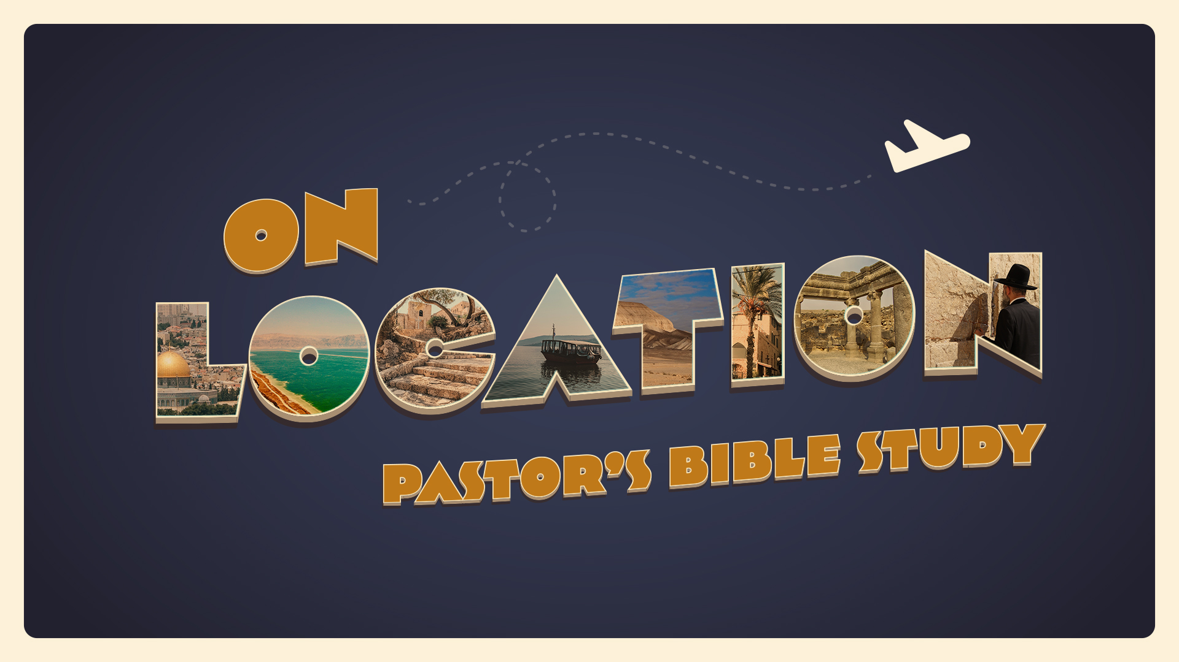

EPISODE 1

August 31/ September 1 | Introduction | Psalm 67; Deuteronomy 4:1-40; Joshua 1:1-4; 24:1-15; Romans 1:20-23; (For Domestic and Everyday life, see Judges 17-18; Proverbs 31, Ruth; Leviticus); John 13 (washing the disciple’s feet).

- What is the most exotic (meaning different) place to which you have ever travelled; or, describe an exotic (meaning different) place to which you would like to travel.

- Describe the Culture (language, food, clothing, customs, architecture) that made an impression on you while you were there.

- If you could travel back in time, is there a particular time you would like to visit (or observe first hand)?

- Ur, Babylon, Nineveh, Memphis, Susa, Athens and Rome were all great cultural centers in their time. What are the great cultural centers of our era?

- What cultural challenges does the church face in the United States today?

- What opportunities exist for today that have not existed for the spread of the Gospel in the past?

EPISODE 2

9/7-9/8 Mesopotamia (The World of Abraham) Genesis 10-11 (12)

- Who were the Sons of Noah?

- Who was Nimrod (10:8-9)?

- What one thing characterized the whole earth? (1)

- Why did the people want to build a tower? (4)

- What was the name of the city where God confused the languages? (9)

- This chapter traces the genealogy of Abram back to what person? (10)

- Why is the genealogy of Shem mentioned immediately after the Towel of Babel?

- Where was Abraham from, and in which ancient civilization did he live?

- What was the name of Abram's nephew? (27)

- What was the name of Abram's first wife? (29)

- From what place did Abram and Terah depart as they went to the land of Canaan? (31)

- What does the mention of all these different nations tell you about God’s concern and perhaps even the purpose of why we are going to be reading so much about Israel?

