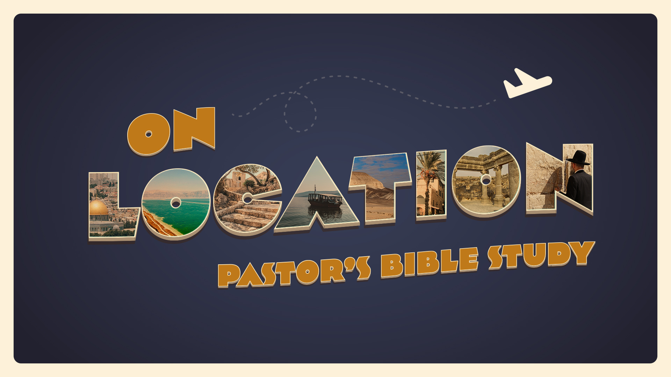

OUTLINE

²³ “When my angel goes before you and brings you to the Amorites and the Hittites and the Perizzites and the Canaanites, the Hivites and the Jebusites, and I blot them out, ²⁴ you shall not bow down to their gods nor serve them, nor do as they do, but you shall utterly overthrow them and break their pillars in pieces.
Exodus 23:23–24

- INTRODUCTION
  - The Source, by James Michener—The People of the Place
  - Real History—Real People
  - If the stories of the Bible are true, then the events described happened to real people, in real places, at real times in history. This fall join us as we unlock the beauty of the Bible and our understanding of God’s Word by learning more about the historical, cultural and geographic context of God’s covenant history.
  - Connecting History and Heart. They had a culture—we have a culture.
  - Context and Responsible Bible Study. Dr. D.A. Carson: “A text without a context is a pretext for a proof text."

- THE BIRTH OF HUMAN CULTURE: Out of Eden -- Genesis 3:16–19 (ESV):
  - ¹⁹ By the sweat of your face you shall eat bread, till you return to the ground,
for out of it you were taken; for you are dust, and to dust you shall return.”
  - Agriculture, Art and Industry:
    - Genesis 4:2 (ESV): Now Abel was a keeper of sheep, and Cain a worker of the ground.
    - Genesis 4:17–22 (ESV):
      - … 20 Adah bore Jabal; he was the father of those who dwell in tents and have livestock.
      - 21 His brother’s name was Jubal; he was the father of all those who play the lyre and pipe.
      - 22 Zillah also bore Tubal-cain; he was the forger of all instruments of bronze and iron.

- NOAH
  - Genesis 9:18–27: ¹⁸ The sons of Noah who went forth from the ark were Shem, Ham, and Japheth. (Ham was the father of Canaan.) 19 These three were the sons of Noah, and from these the people of the whole earth were dispersed.
  - …Genesis 10:32: ³² These are the clans of the sons of Noah, according to their genealogies, in their nations, and from these the nations spread abroad on the earth after the flood.

- BABEL: Genesis 11:1–9 (The Tower of Babel).

- THE PEOPLE OF GOD
  - 12 Now the Lord said to Abram, “Go from your country and your kindred and your father’s house to the land that I will show you. ² And I will make of you a great nation, and I will bless you and make your name great, so that you will be a blessing.(Genesis 12:1-2)
  - The Gift of the Jews—A whole new worldview.

- THE PASSAGES FOR TODAY
  - Psalm 67 (Yahweh is not a Tribal God, but the hope of the world).
  - Deuteronomy 4:1-40 (The Danger of Idolatry and Syncretism).
  - Joshua 1:1-4; 24:1-15; (Choose this day whom you will serve).
  - Romans 1:20-23 (No Excuse for Idolatry).
  - (For Domestic and Everyday life, see):
    - Judges 17-18;
    - Proverbs 31;
    - Ruth;
    - Leviticus;
    - John 13 (washing the disciple’s feet).

- THE SYLLABUS and the People we will Meet
  - Mesopotamia (The world of Abraham).
  - Canaan: The Promised Land and the Patriarchs.
  - Egypt (Joseph and Moses).
  - The wilderness (Moses).
  - The land of the Canaanites and Philistines (Joshua and Judges).
  - Judah— Saul and David.
  - Israel—- Solomon and Kings.
  - Assyria, Babylon and Persia.
  - Galilee and the Greeks.

- WHY DOES THIS MATTER?
  - They lived in a culture-- We live in a culture.
  - How did the people of God engage the culture around them and how did it engage them?
  - Those Cultures are still here.
  - Challenges and Opportunities.
  - The Gospel before the Gospel.
  - Connecting History and Heart.

The Holy Bible: English Standard Version. (2016). (Ge 12:1–2). Wheaton, IL: Crossway Bibles.

