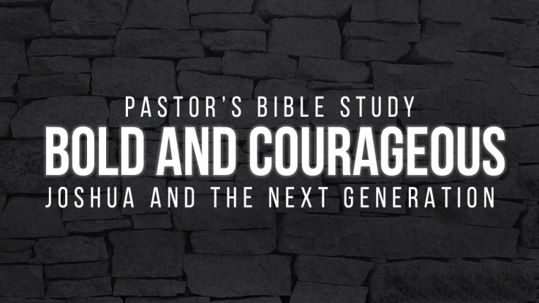
Episode 7: Jericho

- In Chapter 5:13-15, who is this character Joshua is talking to? What clues in the text can help us discover his identity?

- What can we learn about Joshua from his response?

- What battle plan was given to Joshua?

- How often did the Israelites march around Jericho the first six days? (6:11-14)

- How often did they march around Jericho on the seventh day? (6:15)

- What were they Israelites to abstain from? (6:18)

- What was to be done with the silver and gold? (6:19, 24)

- What happened to the walls of Jericho when the Israelites shouted? (6:20)

- Who were the only inhabitants of Jericho that were spared? (6:17, 21-23, 25)

- Why do you think God chose to have them use this way to achieve victory?

- Did the people have a role or a responsibility? What traits were needed to fulfill the role God had given to them?

- What may have been the purpose of the trumpets?

- What do you think the people of Jericho were likely doing while the Israelites were marching around the town?

- Do you think it was difficult for the people to keep Joshua’s command to keep silent in verse 10? Why or why not?

- What was the purpose of the armed men and the rear guard (6:13)?

- What can we learn from God’s command to the people in this chapter?

- What can we learn from the people’s response?

