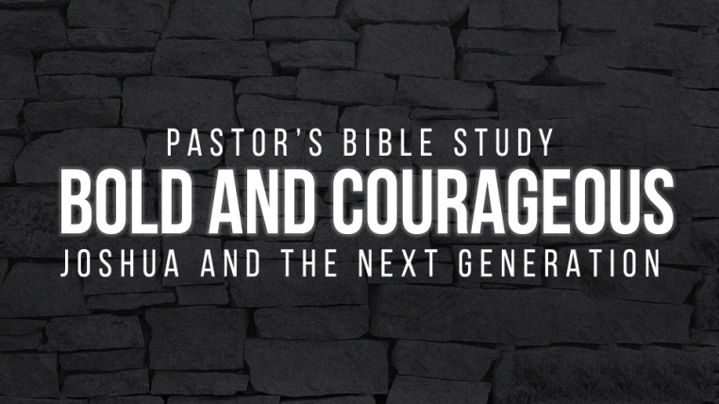
Episode 2: Goodbye to Moses: An Overview of Deuteronomy
- What does the title “Deuteronomy” mean?

- Deuteronomy is a book about transition and preparation. What transitions were about to take place, and how did Moses prepare them?

- Why did Israel refuse to go into the Promised Land?

  - Who did God say would not enter the Promised Land?

  - Who would enter the Promised Land?

- How long did it take before all the rebellious men of war were consumed in the wilderness?

- Why did Moses present the Ten Commandments to the people again?

- What was Deut. 6:4 and why was it so important to the faith of Israel? What does "shema" mean?

- Why was Moses not allowed to enter the Promised Land?

- What is a "valedictory" speech?

- Who is to be Israel’s new leader?

- What general warnings did Moses give to the people before they moved into the Promised Land? Concerning the Canaanites? Concerning obedience to the covenant?

- Chapter 33. In Moses' final blessing on Israel, who did he honor first? Who did he bless next?

- In Chapter 34, what did God show Moses at the top of Mount Nebo?

- In what land did Moses die?

- Where was he buried?

- How old was Moses when he died?

- What have been the biggest "moves” you have made in your life? (Work, home?) How did you prepare (or, how were you prepared for the move)?

