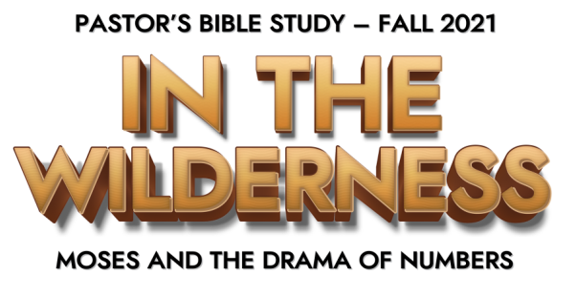
Episode 7: The Snake and the Cross—The Gospel Before the Gospel

¹⁶ “For God so loved the world, that he gave his only Son, that whoever believes in him should not perish but have eternal life. (John 3:16)

- Jesus and Nicodemus
  - Read John 3:1-21
  - Nicodemus didn’t get it, so Jesus made it more complicated.

- The Story of the Serpent: Numbers 21:4-9
  - The Context of Victory
    - Pre: Victory Over the king of Arad (Num. 21:1–4): The Canaanite king of Arad attacks the Israelites and takes some of them as prisoners. But the Israelites counter-attack, and God gives them total victory.
    - Post: Victory Over King Sihon (Num. 21:21–32): King Sihon of the Amorites refuses the Israelites’ peaceful request for passage and attacks them, but he suffers total destruction.
    - Post: Victory Over King Og (Num. 21:33–35): This giant warrior king of Bashan (Deut. 3:11) is killed by the Israelites, along with his sons and his entire army.
  - The Complaining Continues…Once again the people complained against God.
  - God’s punishment: So, (v.6)“ Then the Lord sent fiery serpents among the people, and they bit the people, so that many people of Israel died.”
  - The People’s Repentance: (v. 7) And the people came to Moses and said, “We have sinned, for we have spoken against the Lord and against you. Pray to the Lord, that he take away the serpents from us.”
  - Moses Prayed for the People (v.7)
  - God’s Bizarre Answer (v.8)
    - ⁸ And the Lord said to Moses, “Make a fiery serpent and set it on a pole, and everyone who is bitten, when he sees it, shall live”.

- Understanding the Bronze Serpent
  - The command to fashion and look upon the bronze snake was a ritual test of faith.
    - The Snake was a physical / visible sign pointing to an invisible / supernatural reality.
    - The Bronze Serpent was a symbol/ sign of the sin, contempt, rebellion, pain, suffering, and judgment of God on the people.
    - God’s demand was a ritual: if they want to live they are going to do as I say and turn their eyes from the snakes at their feet and look up at that image.” (turn away from Sin to God’s answer)
  - This was a test.
  - The children of Israel had to realize and accept that they were desperately in need of God to save them.

- The Snake and the Cross
  - John 3:14-15: ¹⁴ And as Moses lifted up the serpent in the wilderness, so must the Son of Man be lifted up, ¹⁵ that whoever believes in him may have eternal life.
  - Just as the Snake lifted up on a pole was salvation to the people dying in the wilderness, so the Son of Man lifted up on the cross is salvation to people dying in sin.
  - Redemption begins with Repentance.
    - Repentance is not just saying “I’m sorry.”
    - Repentance is trusting your life to God’s way.

- Lifting the Serpent—Lifting the Cross
  - v. 14“the Son of Man must be lifted up.”
  - The mission of the church is to lift up Christ just as Moses lifted up the snake in the wilderness.
  - Christ’s promise-- John 12: 32 ³² And I, when I am lifted up from the earth, will draw all people to myself.”

- Why didn’t Nicodemus Understand?
  - This is not common sense. That’s why Nicodemus didn’t get it at first.
  - The Bible says “ ¹⁸ the word of the cross is folly to those who are perishing, but to us who are being saved it is the power of God.”

The Holy Bible: English Standard Version. 2001 (Jn 3:16). Wheaton: Standard Bible Society.
Willmington, H. L. (1999). The Outline Bible (Nu 21:1–35). Wheaton, IL: Tyndale House Publishers.
The Holy Bible: English Standard Version. 2001 (Nu 21:8). Wheaton: Standard Bible Society.

