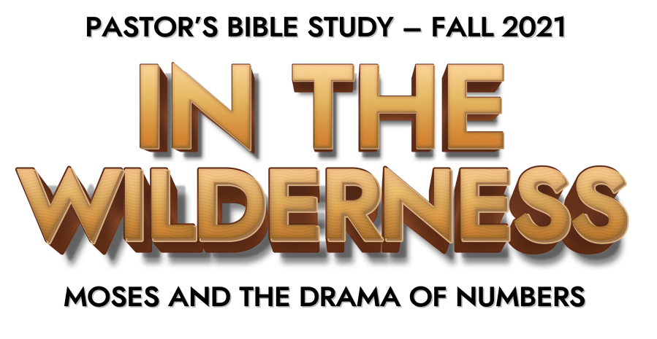
Episode 8: Prophets and Pagans—Balaam

***Corrected from Syllabus: Numbers 22:1-24:25***

CHAPTER 22

- Of what nation was Balak king? (4)

- What did Balak want Balaam to do? (5-6)

- What did God tell Balaam not to do? (12)

- How was Balak’s second approach to Balaam different from the first? (15-17)

- What did Balaam do that showed he was wavering? (18-19)

- When Balaam went with the princes of Moab what stood in his path? (22-24)

- What did the donkey do when it saw the angel the first time? (23)

- What did the donkey do when it saw the angel further on ahead? (25-30)

- What did the angel of the Lord tell Balaam to do? (35)

- Where did Balak take Balaam? (41)

- How did Balaam’s desire for wealth distract him from what God wanted him to do?

- Has God ever used an “unusual” messenger to get your attention?

- What temptations distract you most from God?

CHAPTERS 23 – 24

- How did Balaam wish to die? (10)

- Why was Balak frustrated? (11-12)

- On what mountain did they build seven altars the second time? (13-14)

- In what ways is God not like a man? (19-20)

- To what two animals did Balaam liken Israel? (21-24)

- On what mountain did Balak build seven altars the third time? (28-29)

- Balaam prophesied that Israel’s king would be greater than which king? (7)

- What was all that Balaam said he would say to Balak? (12-13)

- What six nations would be conquered or destroyed? (15-25)

- What does this passage tell us about trying to change the plans of God?

