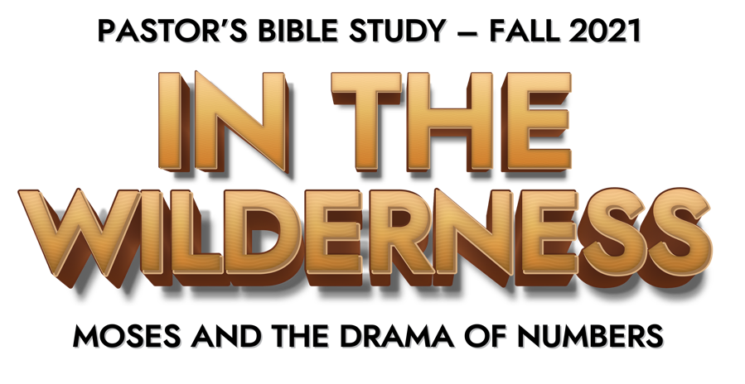
Many people mistake the Old Testament book of Numbers for a dry accounting of the tribes and census of Israel. The reality is that the book of Numbers is a dramatic story of survival in the wilderness. The original (Hebrew) title of the book is Be Midbar—“In the Wilderness,” and the book of Numbers is an adventure that does not disappoint.

This fall the Pastor’s Bible Study (PBS), led by Dr. Bob Fuller, will grapple with Moses and the people of Israel in the wilderness as they fight for their physical and spiritual survival.

Join Dr. Bob Fuller on Thursday mornings beginning September 9 at 9:30 a.m. in Covenant Hall, or virtually via live-stream through the FPC app or fpcsanantonio.org.
If you have any questions or to be placed with a group please contact Lellen Lane at lellenlane@aol.com, or call Lellen at (210) 860-1395.

Date | Title | Passage
September 9 | Welcome to the Wilderness | Exodus and Leviticus
September 16 | Statistics and Logistics: Numbers with a Purpose | 1:1-46, 2:1-34, 5:1-6:27; 7:1-8, 89; 9:15-23, 10:1-10
September 23 | People with a Purpose | 3:1-4, 49; 18:1-32; 6:1-21; 11:4-35; 6:22-27
September 30 | Complaints and Challenges | 10:11-12:16
October 7 | Rebellion of the Nation | 13:1-15:41; 16:1-50
October 14 | Changes at the Top | 20:1-21; 35; 27:12-23
October 21 | The Snake and the Cross: The Gospel before the Gospel | 21:1-35, John 3:1- 17; Psalm 22
October 28 | Prophets and Pagans: Balaam | 22:1-25
November 4 | Prophets and Pagans: Idolatry at Peor | 25:1-8; 31:1-54
November 11 | Preparing for Settlement | 26:1-65; 34:1-36:13
November 18 | Epic of the Wilderness | 33:1-56

