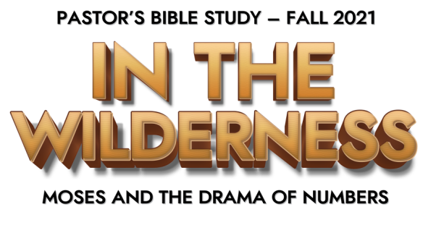
Episode 4: Complaints and Challenges

(Numbers 11–12)
- The Journey Begins…and the People Complain: The Context—First Time they had Moved in Two Years
- The Defiant People Complain (11:1–9, 31–35)
  - The people complained and the Lord struck them with Fire. (Num. 11:1–3)
    - Fire falls upon some of the Israelites for complaining bitterly against God at a place that is later called Taberah.
  - Moses Intercedes: ² Then the people cried out to Moses, and Moses prayed to the Lord, and the fire died down. (11:2) As on other occasions, Moses’ intercession halts God’s judgment (Ex. 32:11–14, 31–32; Num. 12:13–15; 14:11–25)
  - The “Rabble” Complains (11:4–9, 31–35): Some of the foreigners accompanying Israel begin to complain.
    - On the surface, the protest is merely about the monotony of the diet; underlying the complaint, however, is a yearning for the pleasures of Egypt (11:4–5) and a rejection of God’s plans.
- God is Angered (11:10) ¹⁰ Moses heard the people weeping throughout their clans, everyone at the door of his tent. And the anger of the Lord blazed hotly, and Moses was displeased.
  - Moses Complains (Num. 11:11–30)
    - The reason for his complaint (Num. 11:10–15): Moses tells God that the burden of leading a rebellious people is too heavy to bear and he prefers death instead!
    - God’s Complaint (11:23)And the Lord said to Moses, “Is the Lord’s hand shortened? Now you shall see whether my word will come true for you or not.”
- God’s Promises and Judgment
  - 11:16–23 The Lord promises to meet Moses’ need for assistance and the people’s desire for an alternative to the manna. But God’s apparent concession to the popular appetite will in fact prove to be a judgment, because they were in effect saying, Why did we come out of Egypt? (v. 20).
  - The Seventy and the Two (Num. 11:16–30)
    - The Seventy: God instructs Moses to summon 70 leaders to the Tabernacle. There God anoints 70 Israelite elders with his Spirit to assist Moses in leading the people. The leaders prophesy at this time, but that is the only time this happens to them. (Num. 11:16–25)
    - The Two (Num. 11:26–30):
      - Two of these elders, Eldad and Medad, are absent when the others meet together, but they begin prophesying in the camp. Moses tells Joshua not to stop them, saying, “I wish that all the Lord’s people were prophets, and that the Lord would put his Spirit upon them all!”
  - God’s Answer to Complaints— Quail and a Plague: The Good and the Bad (11:31-35)
- The disrespect of Miriam and Aaron (Num. 12:1–16)
  - The reasons for their disrespect (Num. 12:1–3): Moses Brother, Aaron, the high priest, and Moses’ sister Miriam, a prophetess (Ex. 15:20) criticize Moses for two reasons:
    - He has married a Cushite woman.
      - Nothing is known about “the Cushite woman” beyond this brief mention. She may be the same person as Zipporah (Ex. 2:16–22), though she is usually described as a Midianite. Since Cush normally refers to ancient Ethiopia, most interpreters think that “the Cushite woman” probably was Moses’ second wife, and that she came from Ethiopia.
      - Miriam and Aaron’s objection to “the Cushite woman” was most likely a pretense, and the real issue was their challenge to Moses’ supreme authority.
    - He has been given greater authority over the Israelites.
      - 12:1–16 Aaron, the high priest, and Moses’ sister Miriam, a prophetess (Ex. 15:20), contest his unique position. Once again their initial remarks, concerning Moses’ Cushite wife, are only cover for their real complaint: Has the Lord … spoken only through Moses? (Num. 12:2).
  - The results of their disrespect (Num. 12:4–16):
      - God sternly rebukes Miriam and Aaron. Miriam is struck with leprosy. Aaron begs Moses to pray for their sister, so her leprosy is healed.
      - Rejection of Moses prefigures the seriousness of rejecting Christ’s unique prophetic ministry (John 3:32–36; 5:23). 12:8
      - Moses’ unique access to God should have been evident all along to Miriam and Aaron; their obtuseness prompts the anger of God. (12:9–12)
      - As final proof of Moses’ status, his prayer for his sister’s healing is immediately answered. (12:13–16)

Crossway Bibles. (2008). The ESV Study Bible (p. 282). Wheaton, IL: Crossway Bibles.
Crossway Bibles. (2008). The ESV Study Bible (p. 282). Wheaton, IL: Crossway Bibles.
Crossway Bibles. (2008). The ESV Study Bible (p. 283). Wheaton, IL: Crossway Bibles.
Crossway Bibles. (2008). The ESV Study Bible (p. 284). Wheaton, IL: Crossway Bibles.

