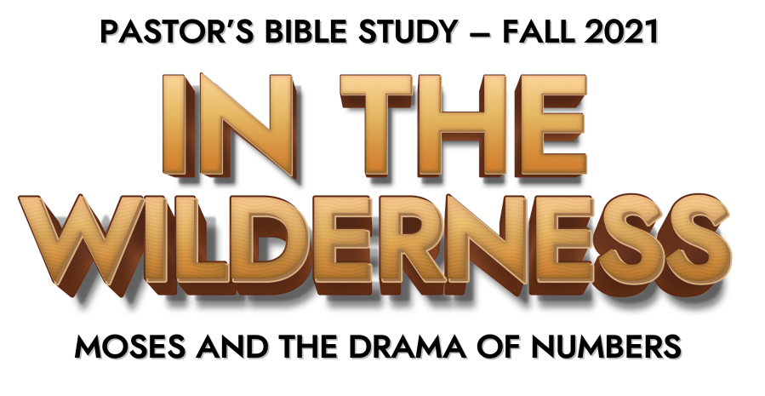

Episode 5: Rebellion of the Nation

Chapter 13

- How many men did Moses send to explore the land of Canaan? (4-15)

- What were the men to find out about the land? (17-20)

- What were the men to bring back? (20-24)

- How long did the men explore the land? (25)

- What report did the men give Moses? (26-29)

- Who encouraged Moses to take possession of the land? (30)

- Why were the rest of the men afraid to attack Canaan? (31-33)

Chapter 14

- Where did the whole congregation desire to return? (1-4)

- How did Joshua and Caleb respond? (6-9)

- What did the congregation want to do to Joshua and Caleb? (10)

- What did the Lord tell Moses that He would do? (11-12)

- Why did Moses intercede? (13-19)

- How did the Lord respond to the intercession of Moses? (20)

- Who would die in the wilderness? (22-29)

- Who would enter in the promised land? (30-31,38)

- How long would they wander in the wilderness? (32-34)

- What happened to those who searched out the land but brought back the report of unbelief? (36-37)

- What did the people decide to do after the plague? (39-40)

- What happened to these people? (41-45)

Chapter 15

- How did the offering of the Israelites compare with the offerings of the strangers who dwelled with them? (13-16)

- What type of sin is being forgiven in verses 24-29?

- What type of sin resulted in being cut off from the people? (30-31)

- What happened to the man who gathered sticks on the Sabbath? (32-36)

- Why were the Israelites to put tassels on the hems of their clothing? (38-40)

Chapter 16

- What did Korah, Dathan and Abiram do? (1-11)

- What happened to Korah and his followers? (28-35)

- What was the purpose of the memorial made from the incense burners? (37-40)

- How many people died in the plague in addition to the incident involving Korah? (49)

