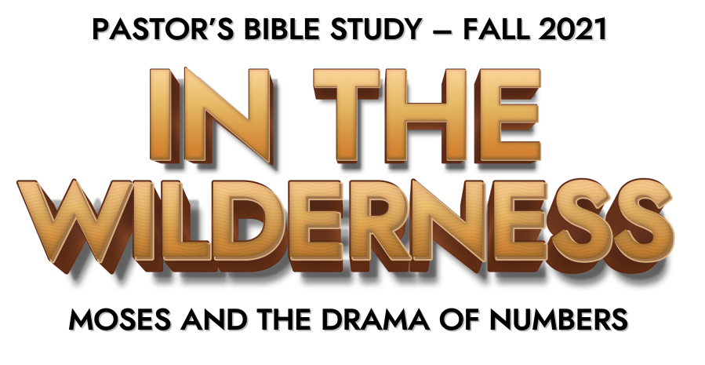

Episode 4: Complaints and Challenges

Chapter 11
- What did the Lord send when the people complained about their hardships? (1-3)

- What did the people desire rather than manna? (4-6)

- When was the manna provided? (9)

- What did Moses desire rather than carry all the people himself? (10-15)

- Who did God put His Spirit on to help Moses carry the burden of the people? (16-17)

- How much meat did the Lord say He would provide? (18-20)

- What question did the Lord ask Moses when he doubted God’s ability to provide so much meat? (23)

- How deep was the pile of quail that the Lord provided? (31)

- What did the Lord send while the meat was still between their teeth? (33)

Chapter 12

- Why did Miriam and Moses speak against Moses? (1-2)

- How meek was Moses? (3)

- How did the Lord speak to Moses? (8)

- What judgment fell on Miriam? (9-14)

