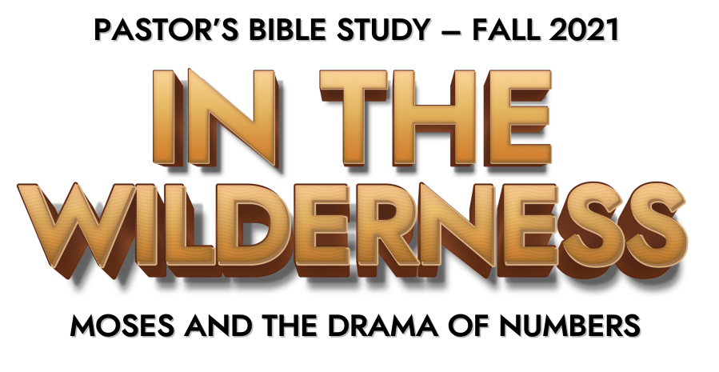

Episode 1: Welcome to the Wilderness

- When you think of the book of Numbers, what comes to mind?

- When you hear the word “wilderness,” what comes to mind?

- Describe your literal “wilderness” experience.

- Describe your spiritual “wilderness” experience. Where have you felt most uncomfortable, out of your element?

- When/ Where have you felt the most tested?

- How important is a leader when you are in the wilderness?

- How important was Moses to Israel’s wilderness journey?

- Who are the people who have led you through the “wilderness” of hardship and trial?

- What have you learned through Wilderness experiences?

