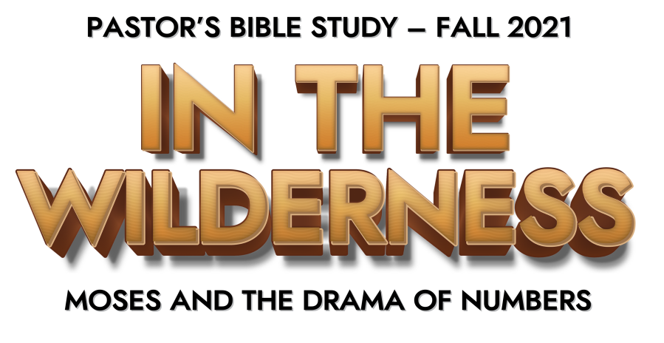

Episode 1: Welcome to the Wilderness

- Introduction
  - The English title “Numbers” (Gk. Arithmoi) is borrowed from the name of the book in the Greek translation of the OT, the Septuagint. The Hebrew title is “be midbar,” “IN THE WILDERNESS.”
  - In the Hebrew Mind and History, the Wilderness was not just a geographic location or environment. It was a symbol. It was a spiritual environment. It was a place of hardship and depravation, where a person could be pushed to the limits—and tempted to do whatever it takes to survive. Although God is sovereign over all times, places and kingdoms, the “wilderness” is a symbol for those places that are uncivilized and beyond God’s rule and protection. A place where the Elements of the Environment—both the Physical environment and the Spiritual Environment— try men’s souls.
  - John The Baptist: A voice cries: “In the wilderness prepare the way of the Lord; make straight in the desert a highway for our God.”
  - The Temptation of Jesus in the Wilderness.
  - The Wilderness is the place where we learn to depend on God. That was a lesson that Israel had to learn, and it was a lesson they had to learn the hard way. For forty years in the Wilderness, Israel learned how to depend on God.
- Moses—Your Wilderness Guide
  - At some point, around 1650 B.C., there was a significant political shift, and the Bible tells us that a new Pharaoh rose in Egypt, and this Pharaoh was afraid that the Israelites were too numerous.
  - “Know for certain that your offspring will be sojourners in a land that is not theirs and will be servants there, and they will be afflicted for four hundred years.” (Gen. 15:5–13)
  - Moses was born of Hebrew parents, hidden in the Nile River by his mother and sister, rescued by the daughter of Pharaoh. He was raised in Pharaoh’s own household.
  - Moses is an Egyptian name that means “To draw out.”
  - His mother served as his wet nurse—keeping the connection between Moses and his people.
  - Murdered an Egyptian taskmaster for beating a Hebrew slave.
  - Fled the palace, and the city, and Egypt, and ran into the wilderness of Midian to escape execution.
  - Moses lived in the Midianite wilderness for about forty years. During that period of time he got married and raised a family.
  - The Israelites groaned under their slavery, and cried out to God. Their cry for help rose up to God and the Lord appeared to Moses in the Burning Bush. “Take off your shoes, for you are on Holy Ground. I have heard my people’s cry, and I will send you to Pharaoh that you may bring my children out of the land of Egypt so that they may serve me. “
  - “I am who I am,” …tell them that “I am” has sent you. (Exodus 3:14)
  - God sent Moses and his brother Aaron to meet the Pharaoh—King of Egypt.
  - Ten Plagues.
  - Passover.
  - Approximately 600,000 men (some of whom were not Israelites), along with their wives and children left Egypt (Ex. 12:37-39) 430 years (to the day) after arriving.
  - Red Sea.
- The Exodus Story: Two-Part Story
  - It is first a story of liberation from bondage and into the service of the true God.
  - The second part of the story is the story of how God defined his relationship to the people through the giving of the law.
  - Three months after the escape of the Hebrew people from slavery in Egypt, the Israelites entered the wilderness and came to the foot of Mt. Sinai.
  - The Ten Commandments cemented the covenant relationship God made with his people.
  - Along with the Ten Commandments, God gave his people more specific moral laws about everything from gossip, to usury, to incest, to homosexuality, to witchcraft, as well as the ceremonial laws of worship and sacrifice and the civil laws directed to Israel when it was a political kingdom.
- NUMBERS
  - The book begins with Israel making final preparations to leave Sinai. It then records their triumphal setting out, before relating a series of disasters in which the people grumbled about the difficulty of the journey and the impossibility of conquering Canaan. This response leads to God delaying the entry to Canaan by forty years. The closing chapters of the book tell how the people at last set out again and reached the banks of the Jordan, poised to cross into the land promised to their forefathers.
  - The book of Numbers shows the reality of God’s presence with Israel in the cloud of fire over the tabernacle, but the repeated displays of unbelief by Israel delay the entry into Canaan and cost many lives.
  - Numbers does not paint an entirely gloomy picture: the book encourages its readers as well as warns them. By the end of the book the people of Israel have conquered formidable opponents in the Transjordan (the land east of the Jordan River), taken possession of their territory, and are poised to cross the Jordan and enter the Promised Land. In this way, the book shows how the promises to the patriarchs are being fulfilled.

