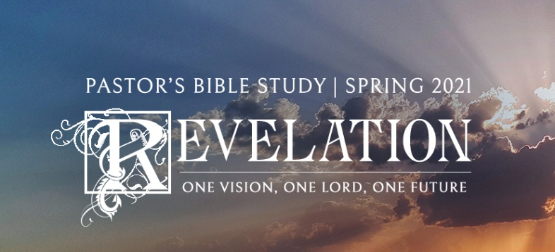

**Questions for Episode 21**

March 24/25, 2021

1. What is the most beautiful place you have ever been?
2. If you could change one thing about your city, what would you change?
3. What is one of the happiest or best memories you have?
4. In his vision, what did John see coming down out of heaven from God? (21:2)
5. What did the voice that John heard speaking from the throne of God announce? (21:3)
6. How did the voice from heaven describe the new world to come? (21:4-5)
7. What did the one on the throne promise to those who are thirsty? (21:6)
8. What did the one on the throne promise to those who overcome? (21:7)
9. In what way will the New Jerusalem reflect God's glory and holiness? (21:21-27)
10. What did John discover about the temple in the New Jerusalem? (21:22)
11. What kind of service will God's people perform in heaven?
12. What do you imagine it will be like to look into the face of the Lord?
13. Why do you think it is difficult to imagine how wonderful heaven will be?
14. How do you interpret the images "tree of life" and "river of life"?
15. In what ways does the new Jerusalem restore what God created in the Garden of Eden?
16. What does this passage tell us about God?
17. What promise did Christ make? (22:7)
18. What blessing did Christ promise us? (22:7)
19. Who will be entitled to citizenship in the new Jerusalem? (22:14)
20. Who will be barred from entering the heavenly city? (22:15)
21. What do we know for sure about Christ's return? (22:20)
22. How can we show respect for the revelation Jesus gave us in this book?
23. What does it mean that "the time is near" and that Christ is "coming soon"?
24. What is involved in responding to God's invitation to come to Him?