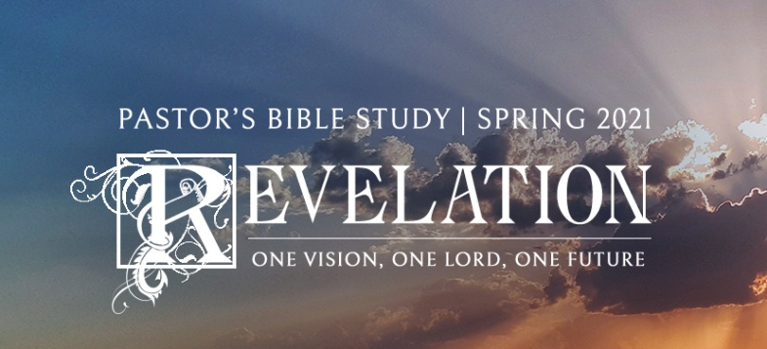

The New Heaven and the New Earth

Episode 21

Revelation 21-22

March 24/25, 2021

1. **Fifth Theme of Revelation: The New Creation of God.** (Creation not destroyed, but restored) (Genesis-Revelation).
2. **The EarTh as it Should Be:** The New Heaven, The New Earth and The New Jerusalem.
   1. Earth as it should be vs. the World as we know it.
   2. The New Heaven and the New Earth (21:1–8).
      1. What he sees (21:1–2).
         1. A new heaven and earth (21:1).
         2. The Holy City descending from heaven (21:2).
      2. What he hears (21:3–8).
         1. The words of the angel (21:3–4).
         2. He says God himself will mingle among his people (21:3).
         3. He says God himself will minister to his people (21:4).
      3. The words of the Almighty (21:5–8).
         1. He will be the Father to all the saved (21:5–7).
         2. He will be the foe to all the unsaved (21:8): They will be cast into the lake of fire.
      4. Description of the City (21:9–18, 19–21, 26).
         1. *The city itself* (21:9–11, 18b): It is filled with God’s glory and shines like a precious jewel and pure gold.
         2. *The gates and walls* (21:12–14, 18a, 21a).
         3. *The gates* (21:12b–13, 21a): There are twelve gates, each made of solid pearl, guarded by twelve angels. The names of the twelve tribes of Israel are written on the gates.
         4. *The walls* (21:12a, 14, 18a): The walls are made of jasper, supported by twelve foundations, on which are written the names of the twelve apostles.
         5. *The size and dimensions* (21:15–17).
            1. The city measures 1,400 miles long by 1,400 miles wide by 1,400 miles high (21:15–16).
            2. The walls are two hundred feet thick (21:17).
         6. *The foundations* (21:19–20): Each of the twelve foundations is inlaid with a different precious jewel.
         7. *The street* (21:21b): It is made of pure gold, like transparent glass.
         8. *The worship* (21:26): All nations bring their glory and honor to the temple.
      5. John describes what is not present in the New Creation (21:22–25, 27).
         1. There is no Temple there (21:22).
         2. There is no need of the sun (21:23–24).
         3. There are no closed gates (21:25).
         4. There is no impurity or evil (21:27).
      6. The Character of the New Creation (22:1–2, 3a–3b, 5a, 14, 17).
         1. Its river of life (22:1–2a).
         2. Its tree of life (22:2b, 14).
         3. Its throne (22:3b).
         4. Its purity (22:3a).
         5. Its divine light (22:5a).
         6. Its invitation to enter (22:17).
      7. The People of the City (22:3c–4, 5b).
         1. We will see Jesus (22:4).
         2. We will serve Jesus (22:3c).
         3. We will reign with Jesus (22:5b).
   3. Back to Genesis.
      1. The Bible teaches that one day God will recreate the whole universe.
      2. Scottish theologian Donald Macleod: *“What the Bible makes absolutely clear is that not only man's soul and body but eventually his whole environment will be transformed and revert to its Edenic condition: even, probably, to a condition more splendid than the original Paradise. That is the Christian vision: a new soul in a new body in a new universe, each in perfect harmony with the others, and man able at last to live out his full potential to the glory of God.” [1]*
      3. Genesis tells us several things about the world as God created it.
         1. It shows nature and humanity in harmony rather than conflict.
         2. It was a place where people were to live in harmony and community with each other.
         3. It was a place where humanity would exercise its God-given creativity, dominion and stewardship over creation, and further develop and cultivate the Garden for God’s greater glory.
         4. It was a place where Humanity and God would live together in communion—face to face.
      4. The fall was not simply a human problem—it was a cosmic problem.
      5. The work of Jesus Christ is *COSMIC* (meaning Universal).
         1. Colossians, 1:16 ***16****For by him all things were created, in heaven and on earth, visible and invisible, whether thrones or dominions or rulers or authorities—all things were created through him and for him.*
         2. ***19****For in him all the fullness of God was pleased to dwell,* ***20****and through him to reconcile to himself* ***all things****, whether on earth or in heaven, making peace by the blood of his cross.* [2]
         3. Notice that Christ’s work is not limited to human salvation, but includes *“all things.”* (*Ta panta).*
         4. In Revelation, the story of God’s creative activity returns full circle to the paradise of Genesis.
         5. Tim Lahaye: *Genesis shows humanity’s beginning in a beautiful place, Revelation shows the wonderful paradise to come. Genesis shows that human beings lost the chance to eat of the tree of life, Revelation shows that they will yet eat of that tree. Genesis tells of humanity’s first rebellion against God, Revelation promises an end to humanity’s rebellion against God. Genesis records the tragic sorrow that resulted from sin, Revelation promises “God will wipe every tear from their eyes.” … Genesis shows the beginning of a curse, Revelation shows a curse lifted… Genesis shows that Satan tells us that the word of God is false, Revelation shows us that the promises of God are true.*
3. **The MAcro Story and the Micro Story: The Resurrection and the Life.**
   1. John’s vision of the New Creation is the Macro Story. But there is a Micro Story as well.
   2. The Micro Story—The Personal Story.
   3. John 11:25-26 Jesus said…, *“I am the resurrection and the life. Whoever believes in me, though he die, yet shall he live,* ***26****and everyone who lives and believes in me shall never die.*
   4. “The Resurrection”— Our eternal state of dwelling with God.
      1. One day, when He returns, all those who have trusted him with their lives will be raised again, and we will be restored—body and soul— to live once again as new whole persons—a new body, in a new life in a re-made world.
      2. “Louis Zbinden: On the *Resurrection of the Body* from “Beliefs That Live.”
   5. “The Life”—The Intermediate State.
      * + 1. Here is how the Apostle Paul describes it.
          2. ***II Corinthians 5****For we know that if the tent that is our earthly home is destroyed, we have a building from God, a house not made with hands,* ***eternal in the heavens****.*
          3. And here is the key to understanding it.
          4. *We know that while we are at home in the body we are away from the Lord,* ***7****for we walk by faith, not by sight.* ***8****Yes, we are of good courage, and we would rather be* ***away from the body and at home with the Lord.***
          5. The Intermediate State is that point when we are both ***away from our bodies*** and ***with the Lord***.
          6. Heaven / Paradise: Jesus said to the thief on the cross, “Today you will be with me in paradise.” Heaven is a real place.
          7. Belief in heaven is not just about a place, it is about people. Heaven is not just about “where we are,” it is about “whom we are with.”
4. **Conclusion: Jesus and John.**
   1. Christ’s description of himself (22:13, 16): Jesus refers to himself as follows:
      1. The Alpha and the Omega (22:13a).
      2. The First and Last (22:13b).
      3. The Beginning and the End (22:13c).
      4. The root and offspring of David (22:16a).
      5. The bright morning star (22:16b).
   2. His promise to his people (22:6–7, 12, 20).
      1. He will come for us (22:6–7, 12a, 20).
      2. He will reward us (22:12b).
      3. The final promise of God’s word is that one day, the Kingdom transformation inaugurated by his BIRTH, LIFE, DEATH and RESURRECTION and ASCENSION will be brought to fulfillment in his **RETURN**.
      4. The fulfillment of all Messianic promises will be made visible in Christ’s return.
      5. Christ Jesus will rule on earth as He does in heaven.
      6. The victory that was made REAL in the Birth, Life, Death and Resurrection and Ascension of Jesus Christ is made VISIBLE in His RETURN.
   3. In Conclusion: What the author, John, says concerning himself (22:8–11, 18–19):
      1. He tries to worship the creature (22:8): John falls down and attempts to worship the angel who is showing him the New Jerusalem.
      2. He is told to worship the Creator (22:9): The angel tells him to worship God alone.
      3. He is told not to seal up the writings (22:10).
      4. All will continue to do as they have been (22:11).
      5. We are warned not to add to it (22:18).
      6. We are warned not to take from it (22:19).
   4. The Last Prayer: ***20****He who testifies to these things says, “Surely I am coming soon.” Amen. Come, Lord Jesus!* ***21****The grace of the Lord Jesus be with all. Amen.*

Come, Lord Jesus!

1. Macleod, Donald. *A Faith to Live By*
2. *The Holy Bible: English Standard Version*. 2001 (Col 1:15–20). Wheaton: Standard Bible Society.