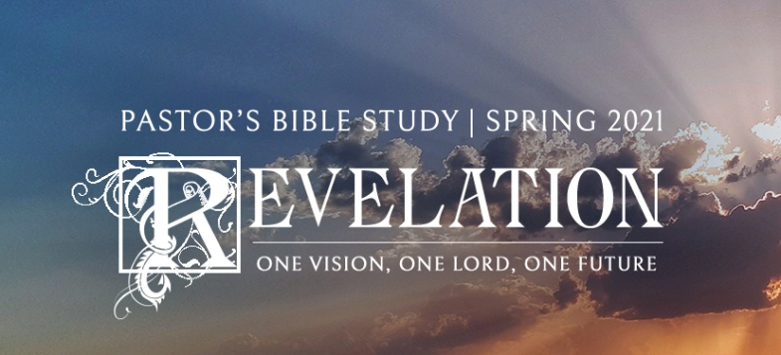

The Second Coming of Christ

Episode 20

Revelation 19:11-20:15

March 17 / 18, 2021

1. **The fourth theme of Revelation:** The Salvation of the Saints and the punishment of the unredeemed.

**II. The Return of Christ:** The ***Parousia*** (19:11-16) The Second Coming.

a. (v. 11)The real White Rider—not the Counterfeit (See Chapter 6)

b. “called Faithful and True”

c. The Righteous Judge and Warrior:

i. “in righteousness He judges and makes war.” (15 Now out of His mouth goes a sharp sword, that with it He should strike the nations. And He Himself will rule them with a rod of iron. He Himself treads the winepress of the fierceness and wrath of Almighty God.)

ii. Commander of the Armies of the Lord ( v.14 And the armies in heaven, clothed in fine linen, white and clean, followed Him on white horses. (See Joshua 5:14).

d. Eyes of Fire (v.12) (Burning, Convicting, Alive).

e. The True King: Many crowns (represent accomplishments, honors and authority).

i. “a name written that no one knew except Himself.”

ii. 16 And He has on *His* robe and on His thigh a name written: KING OF KINGS AND LORD OF LORDS.

f. References to the Incarnation:

i. v.13 He *was* clothed with a robe dipped in blood

ii. His name is called The Word of God (*logos*- John 1:1; this is the one of whom John wrote in his gospel).

**III. The Beast and His Armies Defeated**

a. Foregone Victory: vv. 17-18 (The invitation to the birds to devour the wicked is issued before the battle is even fought).

b. The Beast (AntiChrist) and the False Prophet (The AntiSpirit) are **captured** and **thrown alive** into the lake of fire.

c. In the final battle, the rest of the Beast’s army was killed by the hearing of the word of God (The sword coming out of his mouth). Just as He spoke their creation, he speaks their destruction.

**IV. The Millenium (20:1-10):** Satan Bound for 1000 years (see the attached handout for various theories).

a. Satan is bound (20:1-3)

i. Satan’s power is restrained, but he is not destroyed.

ii. He will be released again one more time (Why?).

b. While the Dragon is bound: The Reign of the Saints—those who died in Christ (4-6).

i. The Saints reign during the Thousand Years.

1. Those who had been martyred through the tribulations.

a. Those who had been beheaded for their witness to Jesus and for the word of God,

b. who had not worshiped the beast or his image,

c. and had not received *his* mark on their foreheads or on their hands.

2. The First Resurrection (The Resurrection of the Saints).

a. The dead in Christ are raised in the *first resurrection. (The Saints are raised to rule with Christ).*

b. D. James Kennedy: *“Born Once, Die Twice; Born Twice, Die Once”* (v. 6 Blessed and holy *is* he who has part in the first resurrection. Over such the second death has no power, but they shall be priests of God and of Christ, and shall reign with Him a thousand years).

c. The rest of the dead did not live again until the thousand years were finished. v.5 (The second resurrection).

**V. Satan’s Final Defeat (7-10).**

**VI. The Second (General) Resurrection and the Great Judgment (vv. 11-15).**

a. The Victorious Christ will come to judge the living and the dead throughout history.

i. (2 Timothy 4:1 *I charge you therefore before God and the Lord Jesus Christ, who will judge the living and the dead at His appearing and His kingdom*) Nowhere to run, nowhere to hide. “…from whose face the earth and the heaven fled away. And there was found no place for them.” There is no hiding from God’s Judgment.

ii. Hebrews 9:26-28 (26He then would have had to suffer often since the foundation of the world; but now, once at the end of the ages, He has appeared to put away sin by the sacrifice of Himself. 27 And as it is appointed for men to die once, but after this the judgment, 28 so Christ was offered once to bear the sins of many. To those who eagerly wait for Him He will appear a second time, apart from sin, for salvation.)

iii. The Living in Christ have been raised (given new life) through Baptism (see Romans 6:3-11; carried out literally).

b. The Second Resurrection (12 And I saw the dead, small and great, standing before God). Everybody else is raised for the judgment.

c. Judged according to what is written in the books “Books.”

i. The first “books” mentioned:

1. The books of works (The books of God’s Justice).

a. Everyone’s name and life is recorded in these volumes.

b. We will all be judged according to God’s justice. Each person will get what he or she deserves for all the deeds, good and evil, great and small, that we have ever done. *“And the dead were judged according to their works, by the things which were written in the books.”*

2. The Book of Life (The Book of God’s Mercy).

a. The Lamb’s Book of Life.

b. During the Tribulation, all people were marked one of two ways. Either they bore the mark of Christ on their foreheads, indicating that they trusted in Jesus for salvation, or they bore the mark of the beast, indicating that they had put their faith in the counterfeit salvation of the Antichrist. There will be no middle ground. Those who bore the mark of the lamb were persecuted murdered and impoverished by the antichrist, and now it was time for those who had it easy because they served the beast to receive comeuppance.

c. At the judgment, the Lord will rule on each life. If your name is written only in the books of works, then you will be judged according to God’s justice. You will get what you deserve for all the deeds, good and evil, great and small, that you have ever done. But if your name is written in the Lamb’s book of life, you will be judged according to God’s mercy. And all those who rely on their own righteousness will be cast into a lake of fire for all eternity because they will be found wanting- they ignored the warnings, they rejected his love. (15 And anyone not found written in the Book of Life was cast into the lake of fire). **This is the second death.**