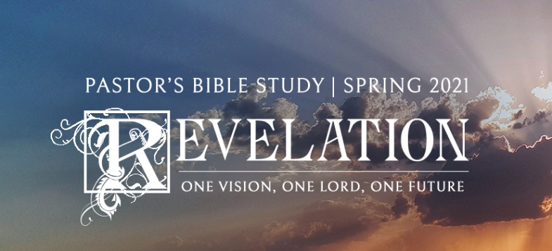

The Fall of the Harlot and the Rising Bride Episode 18

Revelation 18:1-24

February 24/25, 2021

THE FALL OF THE HARLOT AND THE RISING BRIDE

**I. BABYLON’S FATE (THE HARLOT’S FATE)**

|  |  |
| --- | --- |
| **Forces for Good** | **Forces for Evil** |
| **God the Father** | Anti-God= Satan |
| **God the Son, the Lamb** | The Antichrist, the first beast |
| **God, the Holy Spirit** | The anti-holy spirit, the second beast (the false prophet) |
| **The Church, the Bride of Christ** | The Harlot: the unbelievers who worship the first beast (= the anti-church) |
| **“Jerusalem,” the Lamb’s Bride** | “Babylon,” the lover/ harlot of the antichrist (the anti-Jerusalem). |

**a.** Babylon, as we said, is the anti-

church, together with its secular

power. In the early church Baby-

lon became a Christian code word

for Rome, which so exemplified

worldly opposition to true faith.

Such a usage would seem to ap-

pear in **1 Peter 5:13**. Even the

earliest Christian commentators,

going back to the second century

(or within 100 years of when John

wrote this), note that the **1 Peter**

**5:13** reference is a reference to

Rome. So the reference to Rome

as Babylon is a very old Christian way of speaking about Rome. Yet, as we have seen, the power of the anti-church reaches far beyond the geographical confines of even the old Roman Empire.

**b.** The angel pronounces Babylon’s fate *v.2 And he cried mightily with a loud voice, saying, "Babylon the great is fallen, is fallen, and has become a dwelling place of demons, a prison for every foul spirit, and a cage for every unclean and hated bird!*

**c. 18:5** -- **"Her sins have reached up to heaven"** (*Stink up to High Heaven*) is language which reminds us of the tower of Babel -- the original source of the name Babylon. Compare God's command in **Genesis 9:1** with the intent of the tower builders as stated in **Genesis 11:4**. In their pride they felt they could willfully rebel against God's express command, and in the process make themselves the envy of the world. **"God has remembered her iniquities"** is common Scriptural language indicating that judgment is about to take place. This is further confirmed in **verse 6 through 8** which also begin the list of reasons for judgment.

**d.** The Harlot lives in total denial of her sin and judgment: *v. 7 "In the measure that she glorified herself and lived luxuriously, in the same measure give her torment and sorrow; for she says in her heart, 'I sit as queen, and am no widow, and will not see sorrow.'*

**II. THE UNHOLY ALLIANCE** is thrown down: The (False) Church, Government, Big Business:

**a.** v.*3 "For all the nations have drunk of the wine of the wrath of her fornication, the kings of the earth have committed fornication with her, and the merchants of the earth have become rich through the abundance of her luxury."*

**b.** **Kings:** That the woman, the apostate church, rides on the beast with seven heads and ten horns, symbols of political power, indicates that the apostate church will operate in alliance with secular authority. *9 "The kings of the earth who committed fornication and lived luxuriously with her will weep and lament for her.”* The temple was under Roman control through the appointment of Caiaphas. Caiaphas’s leadership in the temple became a symbol of a single, symbolic, and physical focus of Roman and high priestly cooperation. He had a close relationship with the Roman administration. Cordial relations are implicit in his long tenure (some eighteen years) as high priest. The close cooperation between Caiaphas and the Roman authorities is implicit within the passion narratives of all four gospels. In the Johannine version of the arrest and trial of Jesus, events hint at Roman complicity as early as Jesus’ arrest: it speaks of a cohort and an officer in addition to a force associated with the high priesthood (18:1, 12).

**c.** **Merchants** *v. 11 "And the merchants of the earth will weep and mourn over her, for no one buys their merchandise anymore.”* Parallel to the Temple in Jerusalem. Consider the story of Jesus cleansing the temple in John 2:13-16. *13 Now the Passover of the Jews was at hand, and Jesus went up to Jerusalem.14 And He found in the temple those who sold oxen and sheep and doves, and the moneychangers doing business. 15 When He had made a whip of cords, He drove them all out of the temple, with the sheep and the oxen, and poured out* *the changers' money and overturned the tables.16 And He said to those who sold doves, "Take these things* *away! Do not make My Father's house a house of merchandise!”*

**d. The evident cause of Babylon’s destruction**: It seems clear that the ultimate source of Babylon’s de- struction is her own internal rot (just like Rome). This is to say that internal rot is the means that God uses to render judgment upon society and the church, having held it off for so long. A number of references here in chapter 18 pinpoint especially to self-destructive attitudes and activities: **18:7** – self-glorification, pride; **18:11-13** -- gross materialism, which includes trust in one's own means. These are always destructive, and thus we too are warned of the same attitudes.

**e. The Finality of Babylon’s Fall**: vv. 18:21-24. **18:23b-24** -- Here we have the explanation of why the anti- church has been so severely dealt with. Its evil traffic was world-wide and reached into high places. Its sorceries were a source of deception for the whole world. As Abel's blood cried from the ground because he was murdered for his faith, so the blood of the saints and prophets she killed cried out for God's perfect justice.

**III. THE MARRIAGE FEAST OF THE LAMB AND THE SECOND COMING OF CHRIST**

**a. Reformed Theology and the Second Coming (R.C. Sproul)**

1. The New Testament term most often used to point to Christ’s return is the ***Parousia****.* The Parousia refers to the “appearing,” “manifestation,” or “coming” of Jesus in glory at the end of the age. It refers to the church’s expectation of the promised Second Coming or Second Advent of Christ. The belief in the Parousia or presence of Christ in glory is firmly rooted in all strands of the NT, though the expectation can be referred to apart from the word (Rev 19:11 ff ; 1 Cor. 15:23 ff ; Mark 13:26; 14:62) or by use of other terms (e.g., *apokalypsis* in 1 Cor. 1:7; 1 Pet 1:7). Even in those books where the person of Christ does not loom large (like the letter of James), the Parousia of the Lord (God or Christ?) is referred to (Jas 5:7).
2. The Bible teaches that Jesus’ coming will be **both personal and visible**. Though His coming will be with power, it will include more than a visitation of His power. It will include His very person. His coming will be neither secret nor invisible. His appearance will be accompanied by clouds of glory in like manner to His departure at the Ascension. There will be a heavenly fanfare of audible shouting, accompanied by the voice of an archangel.
3. At the coming of Christ, the church will experience a **rapture**—being taken up in the air to meet Christ as He comes. The rapture will not be secret but open and manifest. Its purpose will not be to whisk the elect away from the earth for a while until Christ returns for a “second” Second Com- ing. The purpose of the rapture is to allow the saints to meet Jesus in the air as He returns and be included in His entourage during His triumphal descent from heaven, not as escaping refugees but seasoned veterans. His coming in this manner will be attended by the general resurrection, the final judgment, and the end of the world.

**b. Part One: The Marriage Feast of the Lamb and the Rapture (19:1-7)** v. 7 "Let us be glad and rejoice and give Him glory, for the marriage of the Lamb has come, and His wife has made herself ready."

1. “After an interval of betrothal, the groom comes with his friends to the bride’s home, from which he conveys her back to his own home or that of his parents. There the wedding feast is held and the marriage is consummated.”
2. Throughout the history of Israel (in the Old Testament) the wedding was announced.
3. The Son of God assumed Flesh and Blood and the Betrothal took place.
4. The Bride price was paid on Calvary.
5. Now, Christ coming to get the church and take her home.
6. The Return of Christ to collect his Bride is the Second Advent (Part One) as the Bridegroom. His Second Coming continues when He comes as the Rider on the white horse (in Chapter 20).